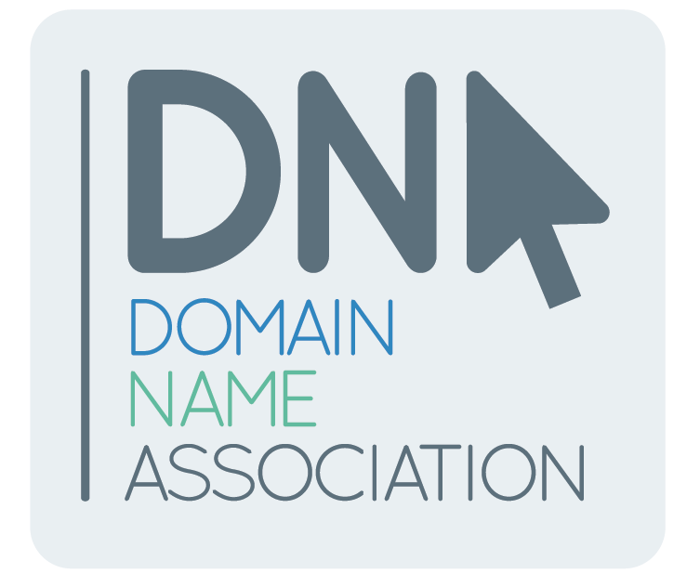

The Domain Name Association (DNA) offers these comments relating to ICANN’s recently announced gTLD Marketplace Health Index proposal.

The DNA believes the global gTLD industry will continue its aggressive growth to date, and it is imperative that this expansion occurs in a manner that incorporates the program’s goals of consumer choice, competition, innovation, safety and security. ‬‬‬‬

The DNA remains proactive in the domain name market with a focused intent on strengthening engagement of industry actors. As a result, the DNA, in conjunction with registries, registrars and others, established the Healthy Domain Initiative (HDI) in mid 2015. HDI objectives include:

- Establishing a network of industry partners focused on the creation and ongoing maintenance of a healthy domain ecosystem via effective communication and collaboration;
- Developing industry-focused policy guidelines, best practices and success metrics that result in tangible ways of identifying and promoting positive standards for healthy domains; and
- Demonstrating to the regulatory community a positive example of self-governing that would negate the likelihood of invasive regulation.

As a result of substantial progress within the last six months, the HDI initiative will aggressively continue to build on momentum to date by:

- Forming HDI working group with a diverse representation of registries, registrars, law enforcement, IP Interests, civil society, and other associated parties;
- Forming an initial best practices document (currently under review);
- Scheduling the inaugural HDI Summit on February 10, 2016, a gathering of interested parties that currently serve various mission-critical roles within our industry, that will facilitate a discussion on a domain name environment focused on health and safety; and
- Developing a public relations plan that will create awareness of the summit’s outcomes and ensure proactive and positive communication as a result of our efforts as HDI participants.

We look forward to the positive outcomes that HDI will bring to the domain name and Internet industry.

