IANA Secure Notification Process
Consultation on IANA Secure Notification Process

2013
Oscar Lovera

27/02/2013

1.- Content.

Updates Proposed by ICANN
In reviewing the contractual requirements, and based on the feedback and input ICANN has received to date in performance of the IANA functions, ICANN is proposing the following updates to its existing processes to better satisfy the need for secure notifications to IANA stakeholders:

- ICANN proposes to implement a new email-based mailing list service for service notices. This mailing list will be available for subscription by any interested parties.
- ICANN proposes to implement a new "service notices" section on the IANA website, which publishes both current and archived notices relating to outages, planned maintenance, and new developments. Publication of these notices will also include a syndication feed (such as using RSS or ATOM) to allow interested parties to subscribe.
- ICANN proposes to implement in its revised user documentation clearer guidance on what specific mechanisms will be used to communicate certain types of changes and notifications.
- ICANN proposes to implement additional information for TLD managers concerning emergency response inside the secured area of the Root Zone Management website.

2.- Contacts.
Proveedor de Certificados (PROCERT), C.A.
Oscar Lovera
General Manager
Av. Libertador, Multicentro Empresarial del Este.
Core B, Liberator Tower
13th floor, Office B-132,
Chacao Municipality, Caracas, Venezuela, POB 1063.
Master Phone: 58 +212 +2674880.
Fax: 58 +212 +2671270
E-mail: contacto@procert.net.ve and oscar.lovera@procert.net.ve
Website: www.procert.net.ve.

3.- PROCERT Proposal.
Based on the conditions contained in http://www.icann.org/en/news/public-comment/iana-secure-notification-12dec12-en.htm, PROCERT offers a notification system with internal management and administration, based on the use of electronic identity certificates to users. Notifications would be signed electronically reducing the risk of identity theft or impersonation.

All notices issued by the system would be stored centrally and against the database.

4.- System Features.
  - System has an administrator and can see more than a standard user.
  - Access to the system is via certified authentication, for which, each user must be assigned an electronic certificate to be issued by PROCERT CA The use of certificates guarantees the identity of the user and non-repudiation of the transaction.
  - A notification will be stored in the system database as default formats and predesigned by ICANN, and then be filled by a txt or a database, when sending such notifications to all users of the system.
  - Emails messages shall be signed electronically with a certificate issue by CA PROCERT for ICANN.
  - Notifications will be consulted by users previously established filters specified by ICANN. PROCERT configured such filters within the system.
  - The system can run manual or automatic shipments depending on the case and request NABCI staff.
  - The download and configuration of the system is remotely.
  - Language can be Java or. Net.
  - The support system is remote and is contained within the monthly payment and provides an estimated three (3) hours of monthly support.
  - The system is paid by monthly installments.
  - It includes the generation of certificates in the monthly payment of the system.
  - The certificates will be issued in compliance with the protocol V3 X-509, with Signature Algorithm SHA-256 and a key length of 2048 bits.
  - Certificates are not exportable.
  - The certificates have attributes for authentication and electronic signature.
  - Certificates have an associated identity validation process in order to ensure the authorship.
  - PROCERT can provides a mechanism for managing certificates lifecycle.
  - PROCERT can provides cryptographic tokens to store certificates. Tokens can be hardware or software.

PROCERT will present a scope of work if ICAAN accept and agree with the present proposal.

5.- Graphics.
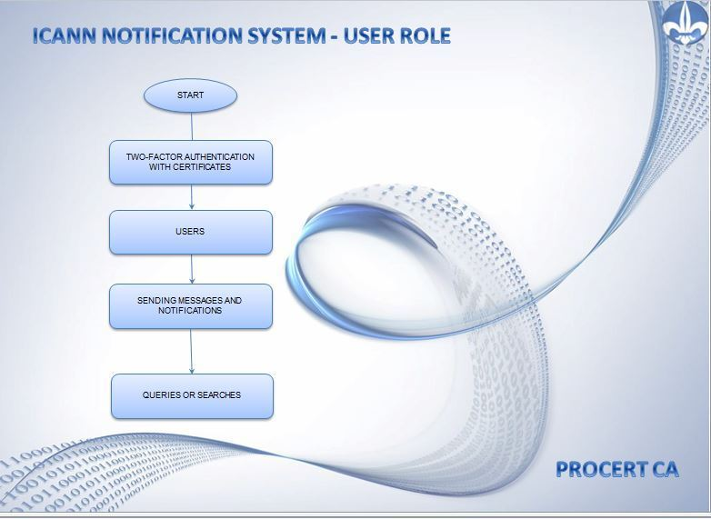
5.1. User Role.

5.2. Administration Role.
