Why are consumer metrics important?
2009 Affirmation of Commitments requires review of extent to which the gTLD expansion has promoted consumer trust, consumer choice and competition.
In Dec-2010, ICANN Board requested advice from ALAC, GAC, GNSO and ccNSO on establishing definitions, measures, and 3-year targets for those measures.
If adopted by the future Affirmation review team, this advice could be critical to measuring the success of the new gTLD program
Since the Costa Rica meeting, the WG reviewed all public comments and created the final version of the Consumer Trust, Consumer Choice and Competition Advice Letter.
The Consumer Metrics Working Group submitted the Final Advice letter to the GNSO Council for consideration.

Next Steps:
- GNSO Council review, deliberate, and consider the Advice letter
- 13 September: Request 20 minute session for Consumer Metrics WG Representative (10 min Presentation, 10 min discussion)
- 21 September: Determine proper path of GNSO Acceptance of Adivce Letter, create draft motion if necessary
- 09 October: Submit final materials for GNSO Council Motions and Documents deadline for Toronto Meeting
- 13 October: GNSO Council Saturday session agenda item
- 17 October: GNSO Council Public session final consideration for delivery to the ICANN Board
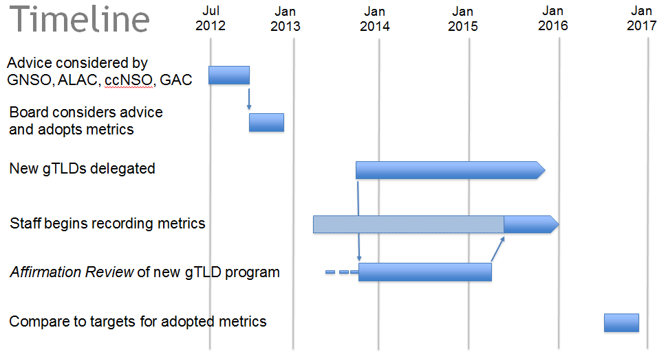
- November/December, ICANN Board review the advice for their consideration and next steps

