**Why are consumer metrics important?**

The 2009 Affirmation of Commitments requires review of extent to which the gTLD expansion has promoted consumer trust, consumer choice and competition.

In Dec-2010, ICANN Board requested advice from ALAC, GAC, GNSO and ccNSO on establishing definitions, measures, and 3-year targets for those measures.

If adopted by the Board, these metrics could be valuable to the future Affirmation of Commitments review team charged with evaluating the gTLD expansion program. Since the Costa Rica meeting and through Prague, the WG reviewed all public comments and created the final version of the Consumer Trust, Consumer Choice and Competition Advice Letter.

The Consumer Metrics Working Group now submits the Final Advice letter to the GNSO Council for consideration.

**Possible Next Steps:**

GNSO Council review, deliberate, and consider the Advice letter:

* 13 September: Request 15 minute agenda item at GNSO Council meeting for Consumer Metrics WG Representative (5 min Presentation, 10 min discussion) / Deliver Draft Motion
* 09 October: Submit final materials for GNSO Council Motions and Documents deadline for Toronto Meeting
* 13 October: GNSO Council Saturday session agenda item
* 17 October: GNSO Council Public session final consideration for delivery to the ICANN Board
* November/December, ICANN Board review the advice for their consideration and next steps

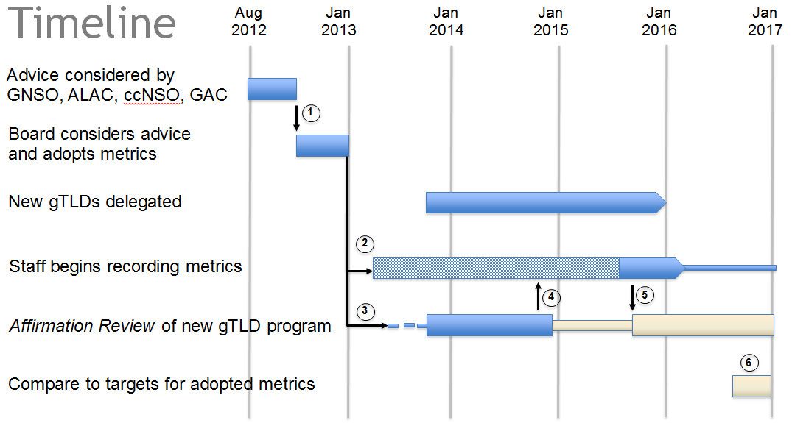

1. GNSO Council submits Advice Letter to the ICANN Board for Consideration
2. ICANN Board instructs ICANN to start collecting available baseline metrics of existing gTLDs and new gTLDs once delegated, until final metrics framework requirement is completed by the Review Team
3. ICANN Board initiates and approves the Consumer Trust, Consumer Choice and Compeition AoC Review Team (CTCCC)
4. CTCCC Review Team finalizes consumer metrics framework requirements and delivers to ICANN for implementation (note that CTCCC Review Team will remain engaged through implementation, but on a limited basis until delivery of the metrics framework
   1. #3 to #5 – in parallel to ICANN implementation of metrics framework, CTCCC Review Team may build the requirements necessary to conduct the review of the new gTLD Application & Evaluation processes
5. ICANN implements Consumer Metrics final product and delivers to CTCCC Review Team for examination of the new gTLD Program
6. 3 Year delegation mark for target comparison, as requested in the Dec-2010 ICANN Board resolution.

Note: time estimates may change given metric complexity and further sizing requirements of the metrics framework