Why are consumer metrics important?
2009 Affirmation of Commitments requires review of extent to which the gTLD expansion has promoted consumer trust, consumer choice and competition.
In Dec-2010, ICANN Board requested advice from ALAC, GAC, GNSO and ccNSO on establishing definitions, measures, and 3-year targets for those measures.
If adopted by the Board, these metrics could be valuable to the future Affirmation review team charged with evaluating the gTLD expansion program.
Since the Costa Rica meeting and through Prague, the WG reviewed all public comments and created the final version of the Consumer Trust, Consumer Choice and Competition Advice Letter.
The Consumer Metrics Working Group now submits the Final Advice letter to the GNSO Council for consideration.

Next Steps:
- GNSO Council review, deliberate, and consider the Advice letter:
- 13 September: Request 20 minute session for Consumer Metrics WG Representative (10 min Presentation, 10 min discussion)
- 21 September: Determine proper path of GNSO Acceptance of Adivce Letter, create draft motion if necessary
- 09 October: Submit final materials for GNSO Council Motions and Documents deadline for Toronto Meeting
- 13 October: GNSO Council Saturday session agenda item
- 17 October: GNSO Council Public session final consideration for delivery to the ICANN Board
- November/December, ICANN Board review the advice for their consideration and next steps

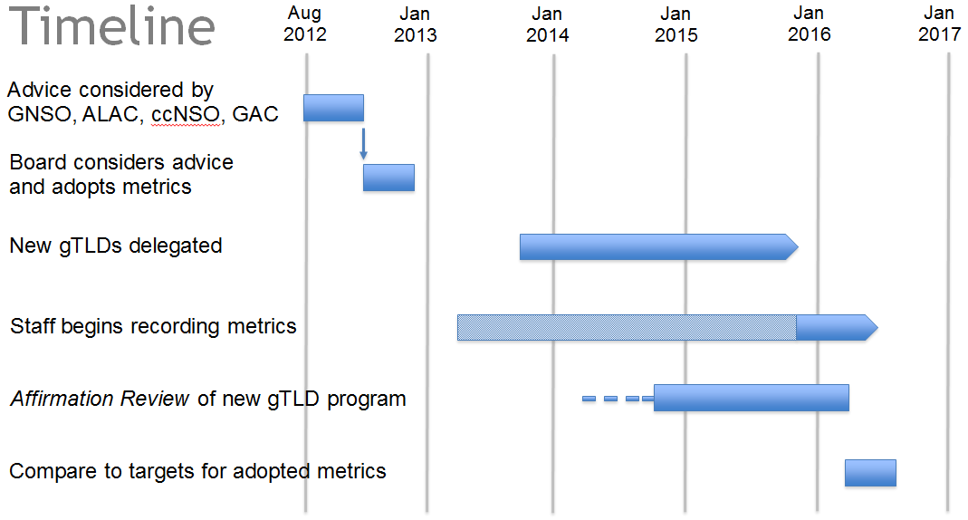
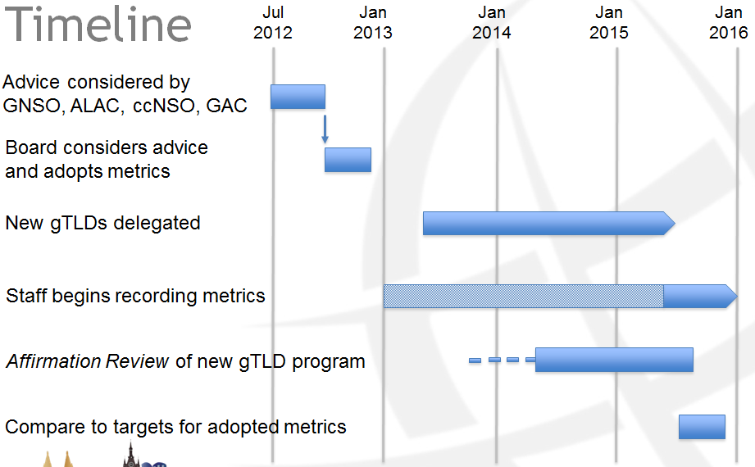

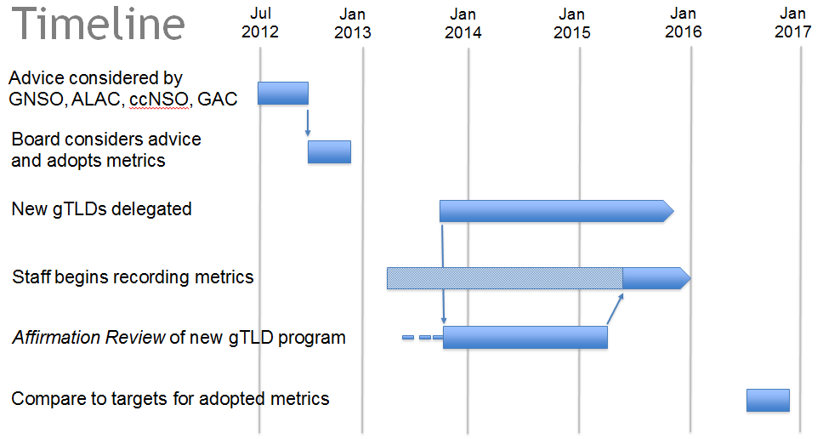

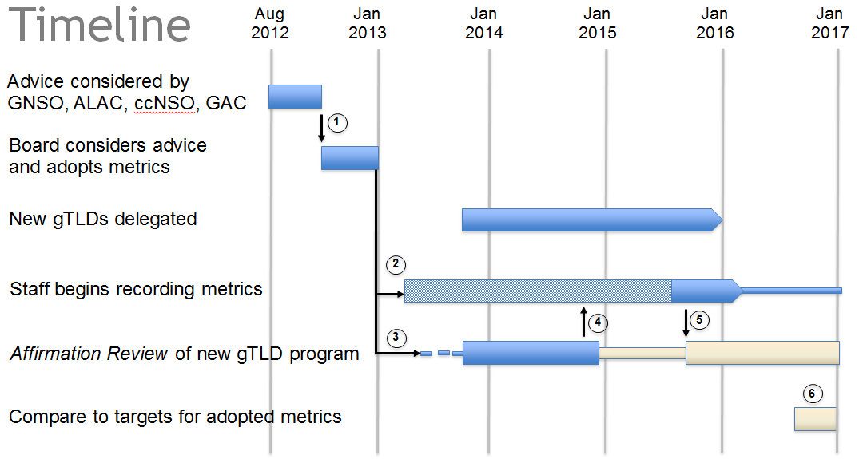

- GNSO Council submits Advice Letter to the ICANN Board for Consideration
- ICANN Board instructs ICANN to start collecting baseline metrics of existing gTLDs and new gTLDs once delegate and where possible until final metrics framework requirement are completed by the Review Team
- ICANN Board initiates and approves the Consumer Trust, Consumer Choice and Compeition AoC Review Team
- CTCCC Review Team finalizes metrics framework requirements and passes to ICANN for implementation (note that CTCCC Review Team will remain engaged through implementation, but on a limited basis until deliver of the metrics framework
- ICANN implements Consumer Metrics final product and delivers to CTCCC Review Team for examination of the new gTLD Program
- 3 Year delegation mark for target comparison

