DRAFT
Initial Report on the
Inter-Registrar Transfer Policy - Part C
Policy Development Process

STATUS OF THIS DOCUMENT
This is the Initial Report on IRTP Part C PDP, prepared by ICANN staff for submission to the GNSO Council on [DATE]. A Final Report will be prepared by ICANN staff following public comment.

SUMMARY
This report is submitted to the GNSO Council and posted for public comment as a required step in this GNSO Policy Development Process on Inter-Registrar Transfer Policy.

Table of Contents
1. Executive Summary 3
2. Objective and Next Steps 5
3. Background 6
4. Approach taken by the Working Group 15
5. Deliberations of the Working Group 17
6. Community Input 23
7. Conclusions and Next Steps 24
Annex A – IRTP Part C PDP WG Charter 25
Annex B – Template for Constituency & Stakeholder Group Statements 26
Annex C – Overview of ccTLD Processes for Change of Registrant 29
Annex D – Data Gathering Survey 36

Executive Summary
Background
- The Inter-Registrar Transfer Policy (IRTP) aims to provide a straightforward procedure for domain name holders to transfer their names from one ICANN-accredited registrar to another should they wish to do so. The policy also provides standardized requirements for registrar handling of such transfer requests from domain name holders. The policy is an existing community consensus policy that was implemented in late 2004 and is now being reviewed by the GNSO.
- The IRTP Part C Policy Development Process (PDP) is the third in a series of five PDPs that address areas for improvements in the existing transfer policy.
- The GNSO Council resolved at its meeting on 22 September 2012 to launch a PDP to address the following three issues:
  - "Change of Control" function, including an investigation of how this function is currently achieved, if there are any applicable models in the country-code name space that can be used as a best practice for the gTLD space, and any associated security concerns. It should also include a review of locking procedures, as described in Reasons for Denial #8 and #9, with an aim to balance legitimate transfer activity and security.
  - Whether provisions on time-limiting Form Of Authorization (FOA)s should be implemented to avoid fraudulent transfers out. For example, if a Gaining Registrar sends and receives an FOA back from a transfer contact, but the name is locked, the registrar may hold the FOA pending adjustment to the domain name status, during which time the registrant or other registration information may have changed.
  - Whether the process could be streamlined by a requirement that registries use IANA IDs for registrars rather than proprietary IDs.

- Deliberations of the Working Group
- The IRTP Part C Working Group started its deliberations on [DATE] where it was decided to continue the work primarily through first bi-weekly and then weekly conference calls, in addition to e-mail exchanges.
- TBC

WG (Initial) Recommendations
TBC

Stakeholder Group / Constituency Statements & Initial Public Comment Period
TBC

Conclusions and Next Steps
- The Working Group aims to complete this section of the report in the second phase of the PDP, following a second public comment period.

Objective and Next Steps
This Initial Report on the Inter-Registrar Transfer Policy (IRTP) Part C PDP is prepared as required by the GNSO Policy Development Process as stated in the ICANN Bylaws, Annex A (see http://www.icann.org/general/bylaws.htm#AnnexA). The Initial Report will be posted for public comment for 30 days, plus a 21 day reply period. The comments received will be analyzed and used for redrafting of the Initial Report into a Final Report to be considered by the GNSO Council for further action.

Background

3.1 Process background

- Consistent with ICANN's obligation to promote and encourage robust competition in the domain name space, the Inter-Registrar Transfer Policy (IRTP) aims to provide a straightforward procedure for domain name holders to transfer their names from one ICANN-accredited registrar to another should they wish to do so. The policy also provides standardized requirements for registrar handling of such transfer requests from domain name holders. The policy is an existing community consensus policy that was implemented in late 2004 and is now being reviewed by the GNSO.
- As part of that review, the GNSO Council formed a Transfers Working Group (TWG) to examine and recommend possible areas for improvements in the existing transfer policy. The TWG identified a broad list of over 20 potential areas for clarification and improvement (see http://www.icann.org/en/gnso/transfers-tf/report-12feb03.htm).
- The Council tasked a short term planning group to evaluate and prioritize the policy issues identified by the Transfers Working Group. In March 2008, the group delivered a report to the Council that suggested combining the consideration of related issues into five new PDPs (A – E) (see http://gnso.icann.org/drafts/transfer-wg-recommendations-pdp-groupings-19mar08.pdf).
- On 8 May 2008, the Council adopted the structuring of five additional inter-registrar transfers PDPs as suggested by the planning group (in addition to a recently concluded Transfer PDP 1 on four reasons for denying a transfer). It was decided that the five new PDPs would be addressed in a largely consecutive manner, with the possibility of overlap as resources would permit.
- The first PDP of the series of five, IRTP Part A PDP, was concluded in March 2009 with the publication of the Final Report. The Final Report of the second of the series, IRTP Part B, was published in May 2011
- In its meeting on 22 June 2011, the GNSO Council requested an Issue Report from Staff on the third of the PDP issue sets, and on the recommendation of the IRTP Part B WG, also added the issue of ‘Change of Control’ to the list of items to be considered. The Preliminary Issue Report was published for public comment on 25 July 2011. The Final Issue Report was delivered to the Council on 29 August 2011.
- The issues that IRTP Part C PDP addresses are:
  - "Change of Control" function, including an investigation of how this function is currently achieved, if there are any applicable models in the country-code name space that can be used as a best practice for the gTLD space, and any associated security concerns. It should also include a review of locking procedures, as described in Reasons for Denial #8 and #9, with an aim to balance legitimate transfer activity and security.
  - Whether provisions on time-limiting Form Of Authorization (FOA)s should be implemented to avoid fraudulent transfers out. For example, if a Gaining Registrar sends and receives an FOA back from a transfer contact, but the name is locked, the registrar may hold the FOA pending adjustment to the domain name status, during which time the registrant or other registration information may have changed.
  - Whether the process could be streamlined by a requirement that registries use IANA IDs for registrars rather than proprietary IDs.
- The GNSO Council resolved at its meeting on 22 September 2011 to launch a PDP on these three issues and adopted a Charter for a Working Group (see Annex A for the Working Group Charter).

3.2 Final Issue Background (excerpt from Final Issue Report)
- Please note that the following text has been excerpted from the IRTP Part C Final Issue Report and does not contain any new input from the Working Group.

“Change of Control” and Reasons for Denial #8 & #9 (Charter Question A)

a) "Change of Control" function, including an investigation of how this function is currently achieved, if there are any applicable models in the country-code name space that can be used as a best practice for the gTLD space, and any associated security concerns. It should also include a review of locking procedures, as described in Reasons for Denial #8 and #9, with an aim to balance legitimate transfer activity and security.

- In the context of its deliberations on whether special provisions are needed for a change of registrant near a change of registrar, which can be an indication of an inappropriate transfer for example as the result of a hijacking, the IRTP Part B Working Group discussed the issue of ‘Change of Control’. The WG noted that ‘the primary function of IRTP is to permit Registered Name Holders to move registrations to the Registrar of their choice, with all contact information intact’. However, it was also noted that the IRTP is widely used to affect a ‘change of control’, namely by moving the domain name to a new Registered Name Holder, in conjunction with a transfer to another registrar. For example, in the domain name aftermarket it is not uncommon to demonstrate control of a domain name registration through the ability to transfer the domain name registration to another registrar following which the registrant information is changed to the new registrant. Nevertheless, the concept of ‘change of control’ is not defined in the context of gTLDs.
- The IRTP Part B WG discussed the existing IRTP Reason for Denial #8 and #9, which allows the losing registrar to deny a transfer if it is within 60 days of being transferred or created. These IRTP Reasons for Denial are optional, although prohibitions on transfers during these time periods are required in many registry agreements (see for example sections 3.1.1. and 3.1.4. - http://www.icann.org/en/tlds/agreements/org/appendix-07-08dec06.htm). IRTP Reason for Denial #8 and #9 may be used by a registrar as a mechanism to prevent ‘registrar hopping’, which makes it more difficult to undo a transfer in case of conflict or an inappropriate transfer. At the same time, some members of the IRTP Part B WG noted that such locks have the ability to reduce the flexibility to move domain name registrations to a registrar of choice. In the example provided in the previous bullet point, if denial reason #9 were applied, it would restrict the new registrant from moving the domain name registration to his / her registrar of choice for 60 days after acquiring the registration. It is important to emphasize that IRTP Reason for Denial #8 and #9 only apply to a change of registrar, not a change of registrant.
- As a result of the different views in the WG and the lack of data on the number of domain name hijacking cases with resolution problems due to the registrar hopping practice vs. the number of legitimate transfers benefitting of a less stringent locking policy, the IRTP Part B Working Group did not come to consensus on making reasons for denial #8 and 9 required instead of optional. However, the deliberations on the issue of ‘change of control’ and IRTP Reasons for Denial #8 and #9 revealed a clear link between the two issues and the WG therefore recommended that the ‘issue of transfer 'hopping' after hijacking be considered in conjunction with the issue of the lacking "change of control" function while also taking a review of the domain locking options in IRTP into account’ as part of IRTP Part C.
- The IRTP Part B Working Group also noted that ‘Data on the frequency of hijacking cases is a pivotal part of this analysis. Mechanisms should be explored to develop accurate data around this issue in a way that meets the needs of registrars to protect proprietary information while at the same time providing a solid foundation for data-based policy-making. Data on legitimate transfer activity benefitting from the current locking policy wording needs to be collected’. Although a small aftermarket survey conducted by members of the IRTP Part B Working Group provided a limited insight into the incidence of hijacking (http://forum.icann.org/lists/gnso-irtp-b-jun09/msg00531.html), the IRTP Part B Working Group was not able to obtain any robust data on the incidence of hijacking. Further data gathering efforts would need to take into account the potential sensitivity in relation to sharing this kind of information by registrars.
- No definition or procedure currently exists within the IRTP or any other gTLD policy that defines a ‘change of control’. At the same time, many country code Top Level Domains (ccTLDs) do have a procedure or process for a ‘change of control’. For example, Nominet (.uk) uses the concept of registrant transfer (see http://www.nominet.com/registrants/maintain/transfer/), .EU calls it a ‘trade’ (see http://www.eurid.eu/en/eu-domain-names/trades-transfers) while .ie calls it a ‘transfer domain holder’ (see http://www.domainregistry.ie/index.php/mnumods/mnuxferdomholder). Further work on this issue would benefit from an analysis of the different approaches to ‘change of control’ in the ccTLD community as well as identifying potential benefits and/or possible negative consequences from applying a similar approaches in a gTLD context. If considered beneficial, consideration would also need to be given to whether a ‘change of control’ procedure should be defined in the context of the IRTP or whether a separate policy should be developed.
- An initial analysis of the processes used by the previously mentioned ccTLD operators learns that in the ccTLD context a ‘change of control’ can be handled by the registry operator (for example .uk) or via an accredited registrar (for example .eu). In the latter case, the registrant has to request the accredited registrar to initiate the request for a change of control, while in the case of .uk and .ie the request can be made directly to the registry by the registrant. In .eu, a trade automatically results in a one-year extension of the registration period, which is not the case with a registrant transfer in .uk or transfer domain holder in .ie. If a PDP is initiated and a Working Group decides that a ‘change of control’ function should be developed, similar considerations will need to be taken into account in order to determine what would be most appropriate in the context of gTLDs. Further input on other models used by ccTLD operators was requested as part of the public comment period on this Preliminary Issue Report, but no comments were submitted to this end.
- Further consideration might also be given to ‘change of control’ in relation to transfers ordered as a result of Uniform Dispute Resolution Policy (UDRP) proceedings. Currently there is no uniform practice for handling these: some registrars create a new account and move the name over and give control to the complainant; others provide the Auth-Info code for a transfer away. If a PDP is initiated, it would make sense to also consider ‘change of control’ in the context of transfers resulting from UDRP proceedings in order to ensure consistency.

Time-limiting Form of Authorization (Charter Question B)

b) Whether provisions on time-limiting Form Of Authorization (FOA)s should be implemented to avoid fraudulent transfers out. For example, if a Gaining Registrar sends and receives an FOA back from a transfer contact, but the name is locked, the registrar may hold the FOA pending adjustment to the domain name status, during which time the registrant or other registration information may have changed.

- In order to request an inter-registrar transfer, express authorization from either the Registered Name Holder or the Administrative Contact needs to be obtained. Such authorization must be made via a valid Standardized Form of Authorization (FOA). There are two different FOA's. The FOA labeled ‘Initial Authorization for Registrar Transfer’ must be used by the Gaining Registrar to request an authorization for a registrar transfer from the Transfer Contact. The FOA labeled ‘Confirmation of Registrar Transfer Request’ may be used by the Registrar of Record to request confirmation of the transfer from the Transfer Contact. The FOA referred to in the question above relates to the former one (‘Initial Authorization for Registrar Transfer’) as for the latter the IRTP specifies that the FOA ‘should be sent by the Registrar of Record to the Transfer Contact as soon as operationally possible, but must be sent not later than twenty-four (24) hours after receiving the transfer request from the Registry Operator. Failure by the Registrar of Record to respond within five (5) calendar days to a notification from the Registry regarding a transfer request will result in a default "approval" of the transfer’.
- There are no specifications in the IRTP in relation to the timing or limits of use of the ‘Initial Authorization for Registrar Transfer’ FOA. This issue was raised as part of the Transfer WG discussions in 2005 where it was suggested that ‘we should consider limiting how long a registrar may hold an FOA before submitting a transfer request. We’ve run into problems when a registrar requests a transfer a month or two after they have received the FOA. By that time, the registration information may have changed, and the new registrant doesn’t respond to a confirmation request. Perhaps FOAs should be effective only 5 or 10 days to avoid fraudulent transfers out’ (see http://forum.icann.org/lists/transfers-wg/msg00006.html).
- Data provided by ICANN Compliance (see IRTP Part B Final Report) suggests that a total of 13% of complaints for the period of July – November 2009 relate to ownership / WHOIS issues / stolen domain or hijacking issues. Further details on the exact nature of these complaints is not available which makes it difficult to determine to what extent this particular issue, or the previous one, occur and are captured in this data. It should also be noted that the complaints received by ICANN Compliance probably represent a small percentage of total number of complaints and should not be relied upon as the sole data source to determine the scale and nature of a particular issue or problem area. Further input or data on the incidence of this issue was requested as part of the public comment period on the preliminary Issue Report, but no such information was submitted.

IANA IDs for registrars (Charter Question C)

c) Whether the process could be streamlined by a requirement that registries use IANA IDs for registrars rather than proprietary IDs.

- When a registrar accredits with ICANN, an ID is assigned by ICANN to identify that particular registrar. See http://www.iana.org/assignments/registrar-ids/registrar-ids.xml for the most recent list. However, when a registrar accredits with a particular registry, that registry may also assign a proprietary ID to the registrar, which differs from the IANA ID.
- This issue of IANA vs. proprietary ID was raised as part of the Transfer WG discussions in 2005 where it was noted that ‘it would be an improvement for everyone to get rid of the proprietary registrar ids that differ from registry to registry’. The suggestion was to propose that ‘registries shall implement IANA ids in transfers instead’. (see http://forum.icann.org/lists/transfers-wg/msg00003.html)
- ICANN has insisted on the consistent use of the IANA ID for all registrars and it has streamlined and improved communication and other aspects significantly as a result. There have been many problems over the years when registrars change their names or when registries record the names slightly differently in their records. From ICANN’s perspective, using a common, unchanging number assigned by ICANN (through IANA) would prevent such issues.
- Further information on the scope or nature that the use of proprietary vs. IANA IDs poses was encouraged as part of the public comment period on the preliminary Issue Report. The gTLD Registries Stakeholder Group (RySG) pointed out that ‘registrar name changes often do make it difficult to ensure that the correct registrar is identified and use of the IANA ID may be helpful in confirming registrar identification’. The RySG also noted that ‘all registries that provide Monthly Registry Operator Reports to ICANN are required to provide both the registrar name and the IANA ID to identify registrar information in the Per Registrar Activity Report file so it is reasonable to think that all registries do maintain this information in their registration systems’.

Approach taken by the Working Group

The IRTP Part C Working Group started its deliberations on 8 November 2011 where it was decided to continue the work primarily through weekly conference calls, in addition to e-mail exchanges. As one of its first tasks, the Working Group prepared a work plan, which was updated on a regular basis. In order to facilitate the work of the constituencies and stakeholder groups, a template was developed that could be used to provide input in response for the request for constituency and stakeholder group statements (see Annex B). This template was also used to solicit input from other ICANN Supporting Organizations and Advisory Committees early on in the process.

Members of the IRTP Part C Working Group

The members of the Working group are:

Name | Affiliation* | Meetings Attended
Simonetta Batteiger | RrSG | TBC
Alain Berranger | NPOC
James Bladel (Co-Chair) | RrSG
Chris Chaplow | CBUC
Phil Corwin | CBUC
Hago Dafalla | NCSG
Paul Diaz | RySG
Avri Doria (Co-Chair) | NCSG & At-Large
Roy Dykes | RySG
Kevin Erdman | IPC
Rob Golding | RrSG
Volker Greimann | RrSG
Oliver Hope | RrSG
Erick Iriarte Ahon | NCUC
Zahid Jamil (Council Liaison) | CBUC
Bob Mountain | RrSG
Michele Neylon | RrSG
Mike O'Connor | ISPCP
Matt Serlin | RrSG
Barbara Knight | RySG
Jonathan Tenenbaum | RrSG
Rob Villeneuve | RrSG
Jacob Williams | Individual

The statements of interest of the Working Group members can be found at https://community.icann.org/display/gnsoirtppdpwg/4.+Members.

The attendance records can be found at https://community.icann.org/x/jrvbAQ.

The email archives can be found at http://forum.icann.org/lists/gnso-irtpc/.

*
RrSG – Registrar Stakeholder Group
RySG – Registry Stakeholder Group
CBUC – Commercial and Business Users Constituency
NCUC – Non Commercial Users Constituency
IPC – Intellectual Property Constituency
ISPCP – Internet Service and Connection Providers Constituency

Deliberations of the Working Group

This chapter provides an overview of the deliberations of the Working Group conducted both by conference call as well as e-mail threads. The points below are just considerations to be seen as background information and do not necessarily constitute any suggestions or recommendations by the Working Group. It should be noted that the Working Group will not make a final decision on which solution(s), if any, to recommend to the GNSO Council before a thorough review of the comments received during the public comment period on the Initial Report.

- Initial Fact-Finding and Research
In order to get a better understanding of the Inter-Registrar Transfer Policy, a training session was conducted by James Bladel (see http://gnso.icann.org/meetings/presentation-irtp-c-training-29nov11-en.pdf and http://gnso.icann.org/meetings/transcript-irtp-c-training-29nov11-en.pdf). In addition, the WG developed a number of use cases in order to obtain further information on how various scenarios such as change of registrar, change of registrant and change of registrar in combination with change of registrant are currently handled by various registrars.

- Working Group Deliberations

- Charter Question A
"Change of Control" function, including an investigation of how this function is currently achieved, if there are any applicable models in the country-code name space that can be used as a best practice for the gTLD space, and any associated security concerns. It should also include a review of locking procedures, as described in Reasons for Denial #8 and #9, with an aim to balance legitimate transfer activity and security.

How is this function currently achieved?
Following review of the IRTP Part C Final Issue Report and the use cases, the WG concluded that currently there does not exist a policy in relation to “change of control” or “change of registrant,” even though such a process is implied, for example, in the Uniform Dispute Resolution Policy. As a result, this process is handled in different ways by registrars. At the same time, the WG recognized that there might be benefits in having minimum requirements in relation to how such a “change of control” process should be handled by registrars as this would usefully clarify and simplify the process for registrants as well as potentially reducing problems currently encountered when the IRTP is used to enact a “change of control”. The WG also noted that the IRTP was developed to facilitate the transfer of domain name registrations between registrars and did not take into account possibly changes of control or the development of an aftermarket in which a change of control is part of most transactions.

Are there any applicable models in the country-code name space?
The Final Issue Report already identified a number of ccTLDs that have a dedicated process and/or policy to conduct a change of registrant, but further investigation by the WG in combination with discussions with the ccNSO confirmed that most, if not all, ccTLDs have such a process in place. Based on the feedback received from the ccNSO as well as feedback from the different registrars that also manage ccTLD registrations, the WG developed an overview of the main characteristics of the different approaches used by ccTLDs (see Annex C) to help inform the WG deliberations on this issue and identify elements that could also be of benefit in a gTLD context. In evaluating these different processes, the WG did take into account that there are certain elements that apply to ccTLDs but not to gTLDs such as dealing with only one jurisdiction and the different role the registry operator often fulfils with ccTLDs. Nevertheless, the WG identified the following features as of possible interest for further consideration in the context of a “change of control” process for gTLDs:
[TO BE COMPLETED]

Review of locking procedures, as described in Reasons for Denial #8 and #9
 IRTP provides for various reasons for which a registrar may deny a transfer including reason for denial #8 - The transfer was requested within 60 days of the creation date as shown in the registry Whois record for the domain name, and #9 - A domain name is within 60 days (or a lesser period to be determined) after being transferred (apart from being transferred back to the original Registrar in cases where both Registrars so agree and/or where a decision in the dispute resolution process so directs). "Transferred" shall only mean that an inter-registrar transfer has occurred in accordance with the procedures of this policy. The WG reviewed these specific reasons for denial as prescribed in the charter question and concluded that [TO BE COMPLETED].

Proposed “Change of Control” Process for gTLDs
Having concluded that there could be benefits in developing a standalone process for a “change of control”, the WG proceeded by developing a list of requirements that such a process should meet. These include:
[TO BE COMPLETED]
The WG also noted that any such process should not create an unfair advantage/disadvantage for any of the segments active in the domain name industry and noted that it should neither prevent innovation and differentiation amongst registrars.

Proposed Recommendation in Relation to Charter Question A
TO BE COMPLETED
Level of consensus for this recommendation: [TO BE COMPLETED]
Expected impact of the proposed recommendation: [TO BE COMPLETED]

- CHARTER QUESTION B
Whether provisions on time-limiting Form Of Authorization (FOA)s should be implemented to avoid fraudulent transfers out. For example, if a Gaining Registrar sends and receives an FOA back from a transfer contact, but the name is locked, the registrar may hold the FOA pending adjustment to the domain name status, during which time the registrant or other registration information may have changed.

What is the current situation?
There are no specifications in the IRTP in relation to the timing or limits of use of in relation to FOAs, but the survey conducted by the data gathering sub-team (see hereunder) found that a majority of respondents currently impose a time limit on FOAs.

Data Gathering
In order to obtain further data and get a better understanding of the current practices and potential issues identified in relation to this issue, a data gathering sub-team was formed. This sub-team developed a survey in order to obtain further input especially from the registrar community on issues encountered as a result of Forms of Authorization (FOA) not being time-limited. Hundred (100) responses were received to the survey. The results of the survey can be found in Annex D. Based on the survey results, the WG concluded that:
- A majority of respondents felt that FOAs should be time limited
- Most respondents felt that a time limit on an FOA would improve security but the vast majority of respondents had not experiences or heard of problems from current non-time limited FOAs
- The majority of respondents currently impose a time limit on FOAs
- The expected scope of effort involved in time limiting FOAs was considered ‘minimal’ to ‘some’

Proposed Recommendation in Relation to Charter Question B
TO BE COMPLETED
Level of consensus for this recommendation: [TO BE COMPLETED]
Expected impact of the proposed recommendation: [TO BE COMPLETED]

- Charter Question C
Whether the process could be streamlined by a requirement that registries use IANA IDs for registrars rather than proprietary IDs.

What is the current situation?
As outlined in the Final Issue Report, when a registrar accredits with ICANN, an ID is assigned by ICANN to identify that particular registrar. However, when a registrar accredits with a particular registry, that registry may also assign a proprietary ID to the registrar, which differs from the IANA ID. Based on the feedback received from the Registry Stakeholder Group, there are currently at least [only? – TO BE CONFIRMED] using proprietary IDs instead of the IANA assigned IDs. In the case of at least one of these registries, proprietary IDs are used in all registrar / registry communications. The primary driver behind the use of proprietary IDs vs. IANA IDs for these registries is security. The registries that currently use proprietary IDs have indicated that the use of proprietary IDs aids in the prevention of mining of Whois data, based on publicly available IANA IDs. In addition, it was pointed out that in certain cases registries deal with registrars that also sell ccTLDs for which there is no IANA ID. In those cases it is considered more efficient to have one single proprietary ID. At the same time, as also noted in the Final Issue Report and the public comments received, there have been problems to identify the registrar correctly when registrars change their names or when registries record the names slightly differently in their records. ICANN has insisted on the consistent use of the IANA ID for all registrars and it has streamlined and improved communication and other aspects significantly as a result. As outlined in the Final Issue Report, from ICANN’s perspective, using a common, unchanging number assigned by ICANN (through IANA) would prevent such issues.
It was also noted that even though the situation may be manageable today with ‘only’ 21 registry operators, with new gTLDs this situation may change drastically.

Data Gathering
The data gathering sub-team mentioned above also included questions in its survey in relation to the use of IANA IDs in order to get a better understanding of the issues identified with the use of proprietary IDs and what the possible challenges might be should the use of the IANA ID be required, possibly in combination with a proprietary ID. The results of the survey can be found in Annex D. Based on the survey results, the WG concluded that:
- The majority of respondents had not experienced problems with the use of proprietary registrar IDs
- The majority of respondents felt that standardization of IANA IDs would simplify transfers
- Many respondents were skeptical about whether ccTLD registries would adopt IANA IDs
- Respondents were split on whether to require registries to use IANA IDs exclusively
- The majority of respondents felt the effort to standardize IANA IDs would be ‘minimal’ to ‘some’

Proposed Recommendation in Relation to Charter Question C
TO BE COMPLETED
Level of consensus for this recommendation: [TO BE COMPLETED]
Expected impact of the proposed recommendation: [TO BE COMPLETED]

Community Input

This section features issues and aspects of the IRTP Part C PDP reflected in the statements from the GNSO stakeholder groups / constituencies; other ICANN Supporting Organizations and Advisory Committees; and comments received during the public comment period.

  - Initial Public Comment Period and Request for Input

A public comment forum was opened upon initiation of the Working Group activities. The public comment period ran from 21 November to 22 December 2011. One (1) community submission was received. A summary of the contribution received can be found here: http://www.icann.org/en/public-comment/report-comments-irtp-c-charter-03jan12-en.pdf. The WG also requested all GNSO Stakeholder Groups and Constituencies to submit their statements on the IRTP Part C issues by circulating the SG/Constituency template (see Annex B). One contribution was received from the gTLD Registry Stakeholder Group. In addition, the WG also reached out to the country code Names Supporting Organization (ccNSO), the At-Large Advisory Committee (ALAC), the Governmental Advisory Committee (GAC) and the Security and Stability Advisory Committee (SSAC) for input, but no comments have been received so far. The IRTP Part C WG reviewed and discussed the contributions received thoroughly with the assistance of a public comment review tool developed for that purpose. Where relevant and appropriate, information and suggestions derived from the contributions received were considered as part of the WG deliberations and have been included in section 5.

Conclusions and Next Steps
The Working Group aims to complete this section of the report in the second phase of the PDP, following a public comment period on this Initial Report.

Annex A – IRTP Part C PDP WG Charter
The Working Group shall consider the following questions as outlined in the Final Issue Report (http://gnso.icann.org/issues/issue-report-irtp-c-29aug11-en.pdf) and make recommendations to the GNSO Council:

a) "Change of Control" function, including an investigation of how this function is currently achieved, if there are any applicable models in the country-code name space that can be used as a best practice for the gTLD space, and any associated security concerns. It should also include a review of locking procedures, as described in Reasons for Denial #8 and #9, with an aim to balance legitimate transfer activity and security.

b) Whether provisions on time-limiting Form Of Authorization (FOA)s should be implemented to avoid fraudulent transfers out. For example, if a Gaining Registrar sends and receives an FOA back from a transfer contact, but the name is locked, the registrar may hold the FOA pending adjustment to the domain name status, during which time the registrant or other registration information may have changed.

c) Whether the process could be streamlined by a requirement that registries use IANA IDs for registrars rather than proprietary IDs.

The Working Group shall follow the rules outlined in the GNSO Working Group Guidelines http://gnso.icann.org/council/annex-1-gnso-wg-guidelines-07apr11-en.pdf.

Annex B – Template for Constituency & Stakeholder Group Statements

The GNSO Council has formed a Working Group of interested stakeholders and Stakeholder Group / Constituency representatives, to collaborate broadly with knowledgeable individuals and organizations, in order to consider recommendations for a number of issues related to the Inter-Registrar Transfer Policy (IRTP).

Part of the working group’s effort will be to incorporate ideas and suggestions gathered from Stakeholder Groups and Constituencies through this Stakeholder Group / Constituency Statement. Inserting your Stakeholder Group’s / Constituency’s response in this form will make it much easier for the Working Group to summarize the responses. This information is helpful to the community in understanding the points of view of various stakeholders. However, you should feel free to add any information you deem important to inform the working group’s deliberations, even if this does not fit into any of the questions listed below.

For further background information on this issue, please review the GNSO Issue Report on IRTP Part C.

Process
- Please identify the member(s) of your stakeholder group / constituency who is (are) participating in this working group
- Please identify the members of your stakeholder group / constituency who participated in developing the perspective(s) set forth below.
- Please describe the process by which your stakeholder group / constituency arrived at the perspective(s) set forth below.

Questions
Please provide your stakeholder group’s / constituency’s views on the IRTP Part C Charter Questions:

- "Change of Control" function, including an investigation of how this function is currently achieved, if there are any applicable models in the country-code name space that can be used as a best practice for the gTLD space, and any associated security concerns. It should also include a review of locking procedures, as described in Reasons for Denial #8 and #9, with an aim to balance legitimate transfer activity and security.

- Whether provisions on time-limiting Form Of Authorization (FOA)s should be implemented to avoid fraudulent transfers out. For example, if a Gaining Registrar sends and receives an FOA back from a transfer contact, but the name is locked, the registrar may hold the FOA pending adjustment to the domain name status, during which time the registrant or other registration information may have changed.

- Whether the process could be streamlined by a requirement that registries use IANA IDs for registrars rather than proprietary IDs.

In addition, the Working Group has identified the following specific issues / questions it would like to receive further input on:

- In relation to Charter Question A, the Issue Report notes that ‘data on the frequency of hijacking cases is a pivotal part of this analysis. Mechanisms should be explored to develop accurate data around this issue in a way that meets the needs of registrars to protect proprietary information while at the same time providing a solid foundation for data-based policy making. Data on legitimate transfer activity benefitting from the current locking policy wording needs to be collected’.
- In addition to the ccTLDs described in the Issue Report that do have a procedure or process for a ‘change of control’ (.ie, .eu and .uk) are there any other ccTLDs that have similar procedures or processes which the WG should review in the context of charter question A? Furthermore, the WG would be interested to receive feedback on the experiences with these or other ccTLD procedures or processes for a ‘change of control’ as well as identifying potential benefits and/or possible negative consequences from applying similar approaches in a gTLD context.
- In relation to Charter Question B and C, the WG would be interested in further input or data in relation to the incidence of this issue to determine its scope and the most appropriate way to address it.
- In relation to Charter Question C, Registries and Registrars are asked to provide specific information as to where proprietary IDs are currently being used by registries and whether the use of IANA IDs instead would be preferred / beneficial.

Annex C – Overview of ccTLD Processes for Change of Registrant
General Comments:

- ccTLD level is easier as it only deals with one jurisdication. For example, certain verification processes (ID, notarization) might be easy to manage / handle in one jurisdication, but might be difficult to apply and/or implement when dealing with multiple jurisdictions.
- ccTLDs operate a ‘thick’ Whois model
- All ccTLDs appear to have a process for change of registrant

ccTLD | Name | Characteristics | Further information | Comments / Questions
.UK | Registrant Transfer | - Losing registrant logs into their account with the registry and initiates the ownership change.  - The new registrant will then receive an email with a link to approve the request.  - Handled by registry operator (not via registrars or EPP)  - Change of registrant can be combined with change of registrar | http://www.nominet.org.uk/registrants/maintain/transfer/  http://www.nominet.org.uk/registrants/maintain/transfer/Process/ | Considered moderate (see email Matt Serlin)
.EU | Trade | - Handled by accredited registrar  - Automatic one-year extension  - Needs to be confirmed within 14 days by both parties | http://www.eurid.eu/en/eu-domain-names/trades-transfers | Considered moderate (see email Matt Serlin)
.IE | Transfer Domain Holder | - Handled by registry operator  - A signed fax on headed paper from the current Administrative Contact must be submitted to initiate the transfer | http://www.domainregistry.ie/index.php/mnumods/mnuxferdomholder
.ES | Transmisión de dominio | - Two processes – one for ‘ordinary’ changes of control and one for ‘special’ cases (as the result of death, company take-over)  - Process can be initiated by registrar, registrant or admin contact  - If initiated by registrar, request needs to be confirmed by registrant or admin contact  - New registrant needs to confirm transfer and accept registration terms and conditions  - In case of a ‘special’ transfer, an ID needs to be provided. | http://www.dominios.es/transfer-procedure/article/267
.NL  .MX  .DE |  | - The current registrar can send a domain update command to the registry and update any domain information (contacts or DNS) |  | Considered easiest process (see email Matt Serlin)
.GR |  | - The losing registrant provides the auth code to the new domain holder. Transfer and ownership changes can be done at the same time |  | Considered easiest process (see email Matt Serlin)
.FR | Trade | - The registrar submits a ‘trade’ EPP command  - The registry then sends an email to the gaining and losing domain owner with a link to approve the request  - Once both parties approve the request, the registrar receives a poll message stating that the trade is complete  - A transfer and trade can be done together |  | Considered moderate (see email Matt Serlin)
.SE  .AU |  | - Documents required through a random audit by the registry  - The current registrar must have the losing domain owner sign a document agreeing to the change of ownership.  - The registrar then submits a domain update command to the registry |  | Considered moderate (see email Matt Serlin)
.BR |  | - The losing registrant must sign documentation agreeing to the change.  - The original copies of the documentation must be submitted to the registry |  | Considered hardest (see email Matt Serlin)
.KR |  | - The current and new domain registrants will be required to sign ownership change documents and provide a copy of their Korean Registration certificates or, if the current or new holder is an individual, a copy of their Korean personal identification |  | Considered hardest (see email Matt Serlin)
.EG  .JO  .OM |  | - The losing registrant and new registrant must sign and notarize original documentation agreeing to the change.  - The original documents are then submitted to the registry to process |  | Considered hardest (see email Matt Serlin)
.NZ | Change of Registrant | - The current registrar can send a domain update command to the registry and update any domain information (contacts or DNS)  - Minimum expectations for registrars to handle process appropriately apply (see http://dnc.org.nz/content/changeofregistrant.html). For example, ‘the registrar must be sure that the person requesting that a change of registrant […] is in fact authorized to do so. An example of possible checks include: […]’.  - Right to reverse transfer to original state in case of fraud |  | Considered easiest process (see email Matt Serlin)
.BE |  | - Registry went recently from a model that was very secure but not user-friendly to an easier transfer policy using auth-codes (“trade” model). Their registrar partners showed a significant increase in satisfaction with the new policy (and the change does not seem to have resulted in an increase in hijacking complaints).
.KY |  | - Do not allow registrants / registrars to transfer ownership. Only registry can enact such changes (do not want a secondary market).
.CA |  | - Post-transfer validation process. If registrant does not meet eligibility criteria, then registration is suspended and/or cancelled. Not different from ‘normal’ registration and validation process.
.NO |  | - Change of registrant is treated as a new registration.  - Have recently automated the process; before, everything was done on paper.

Annex D – Data Gathering Survey
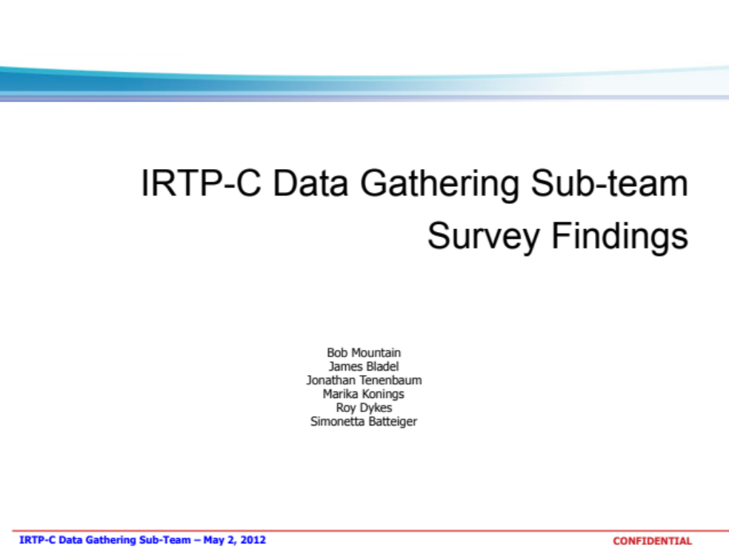
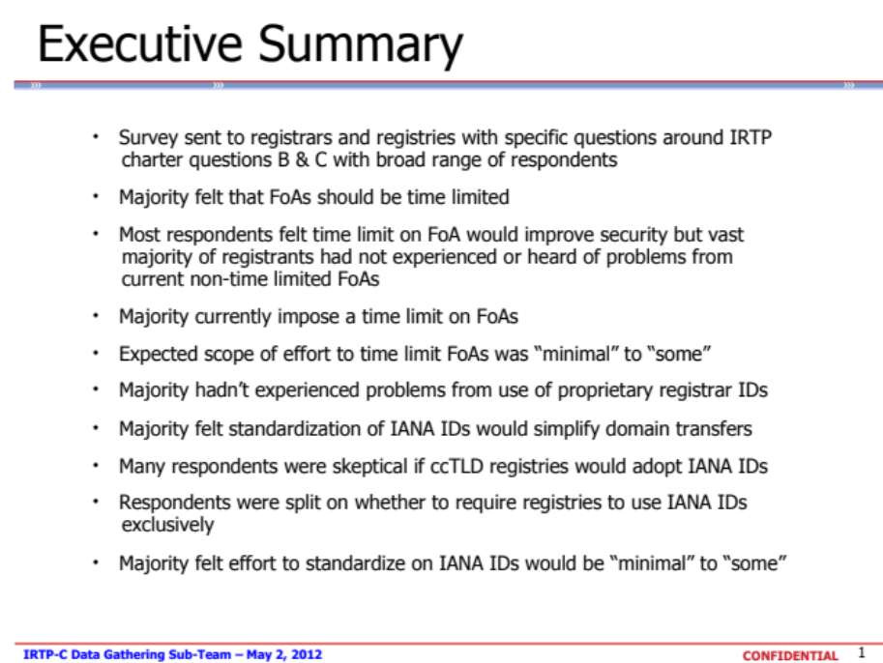
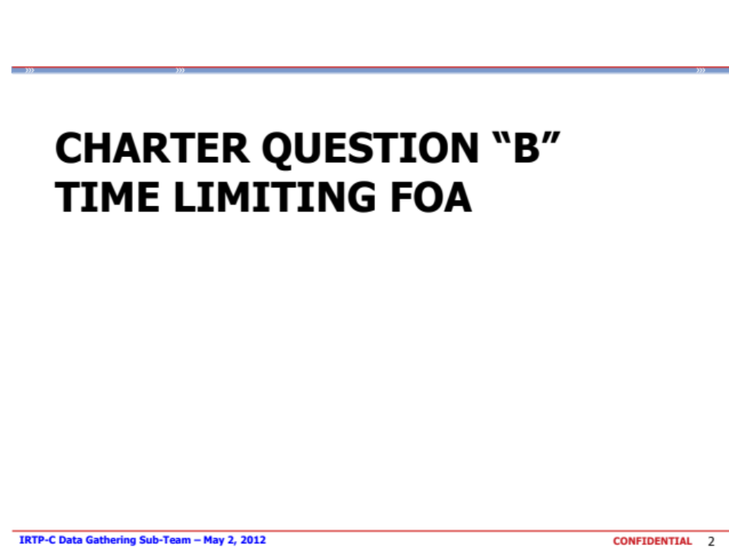
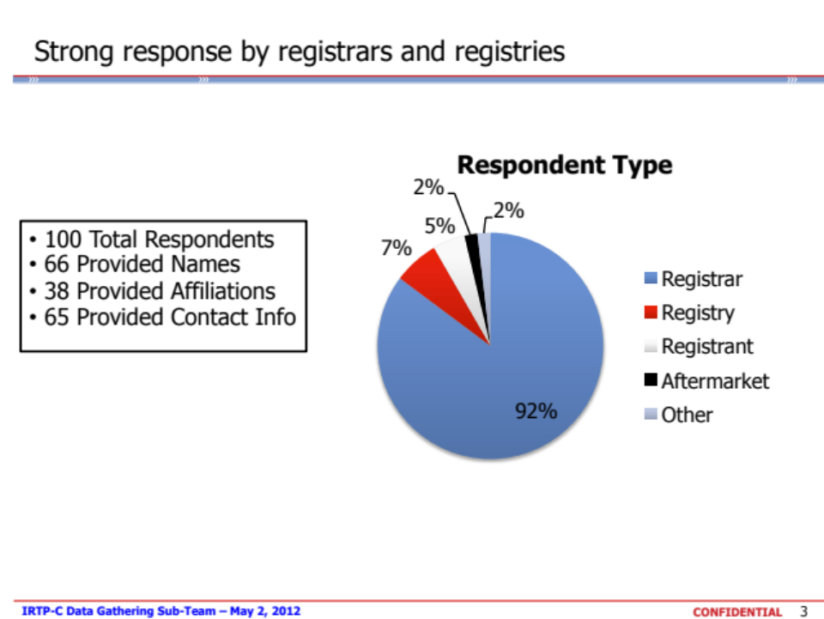
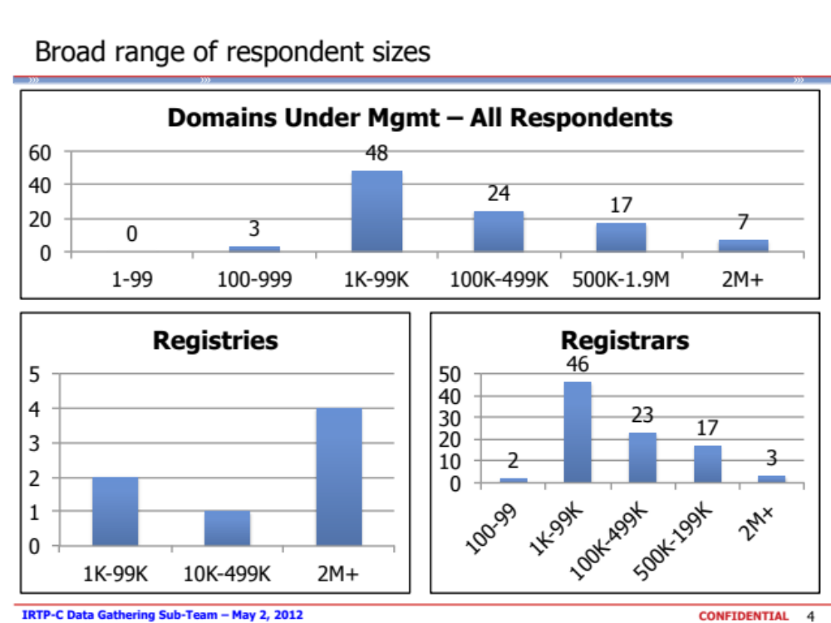

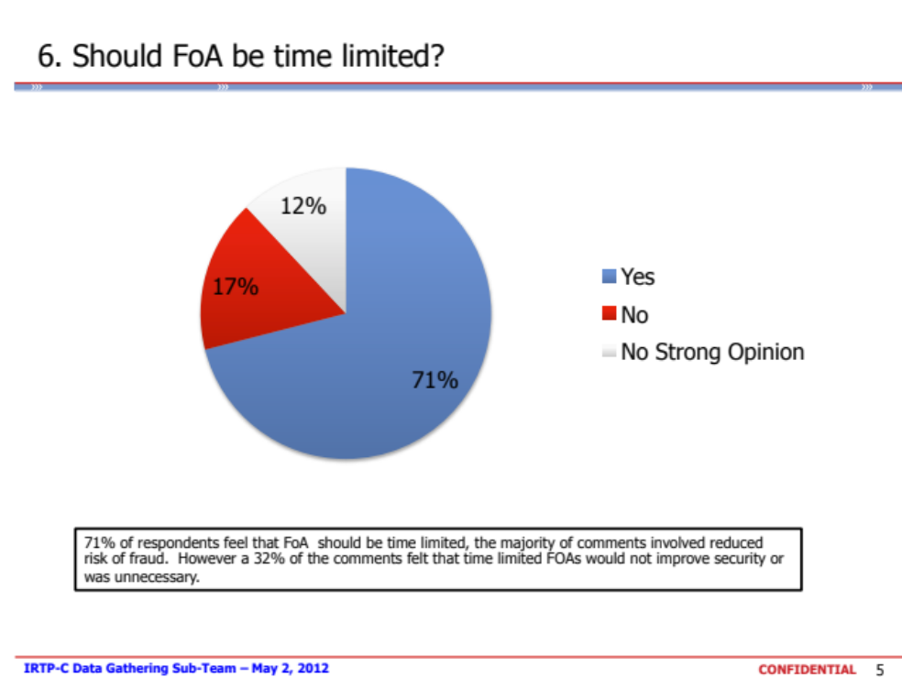
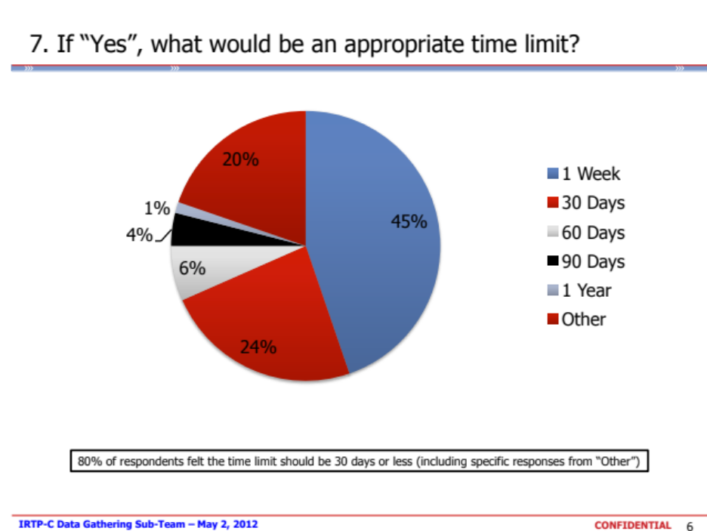
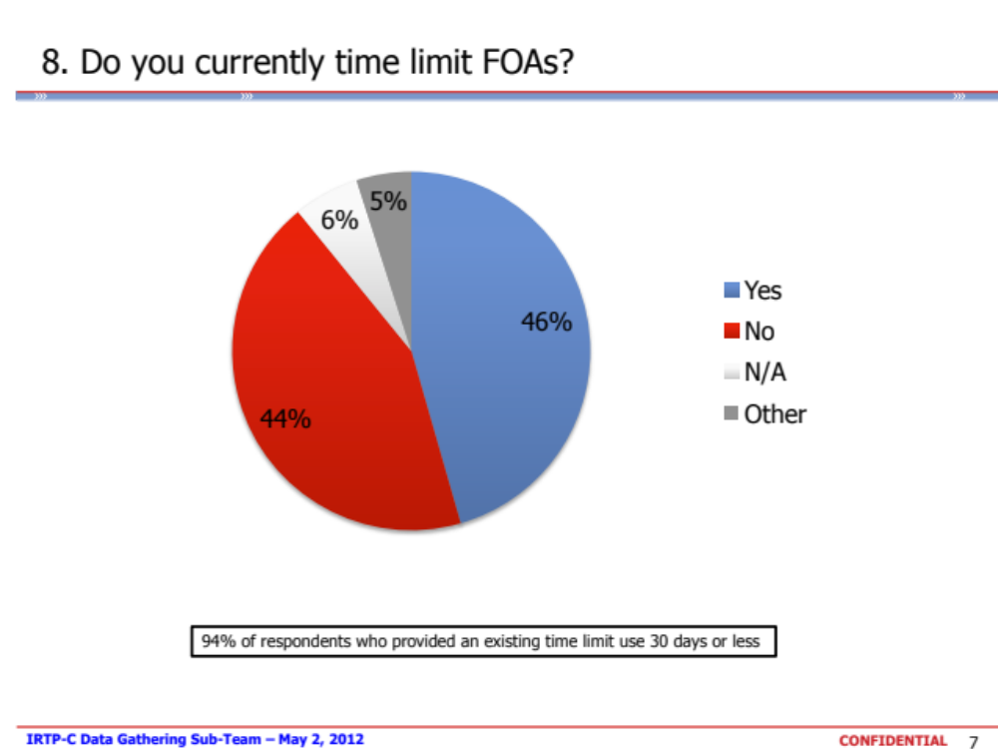
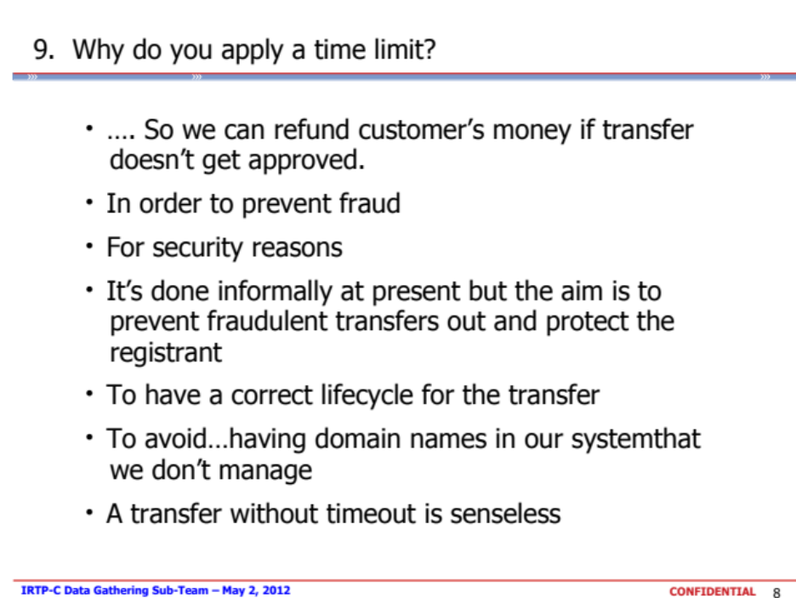
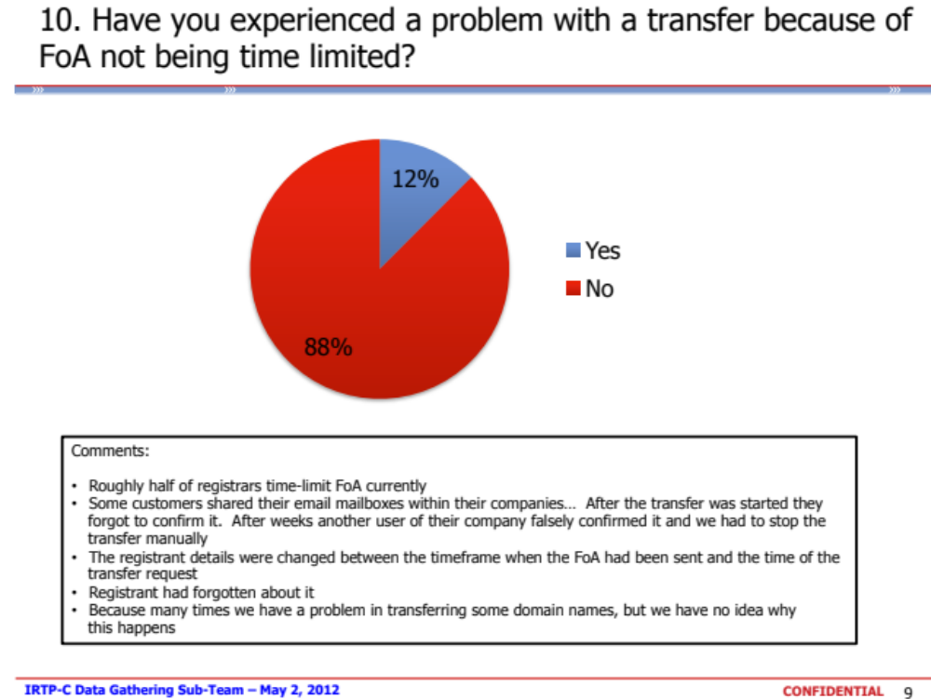
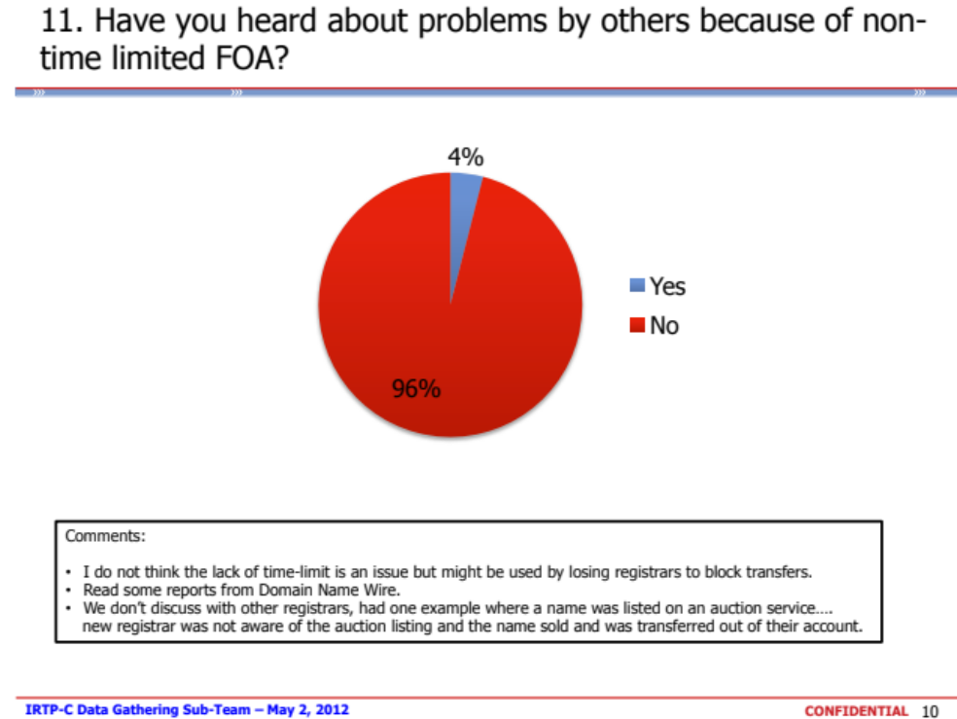
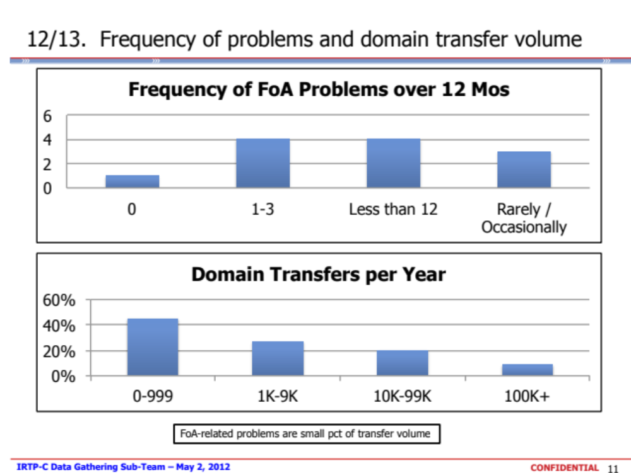
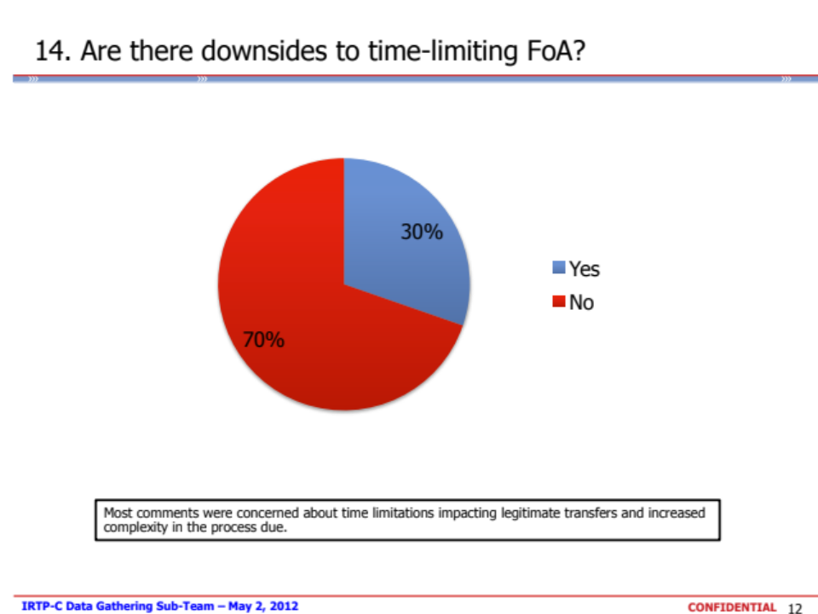
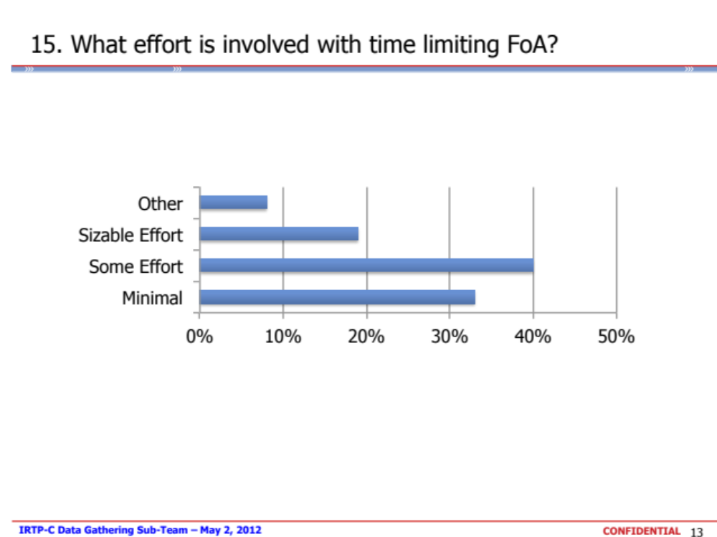
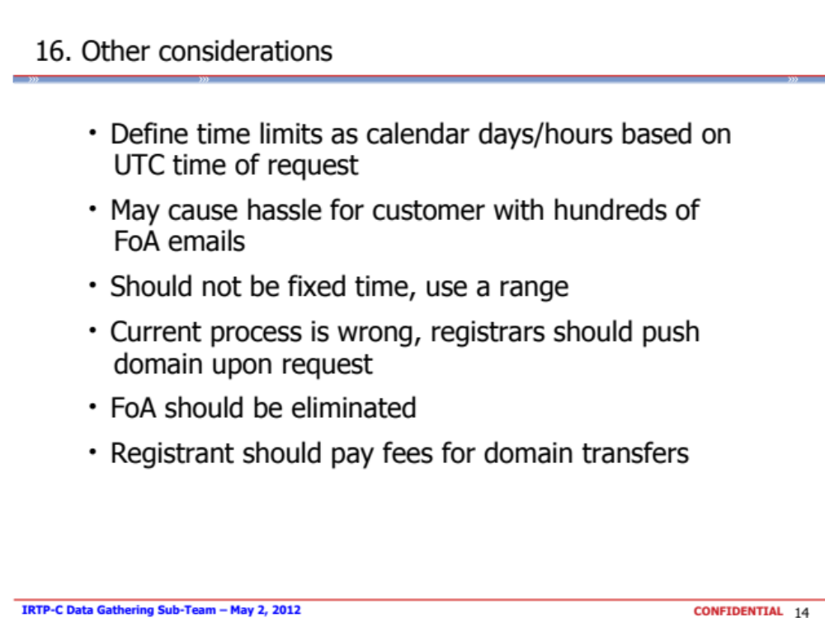
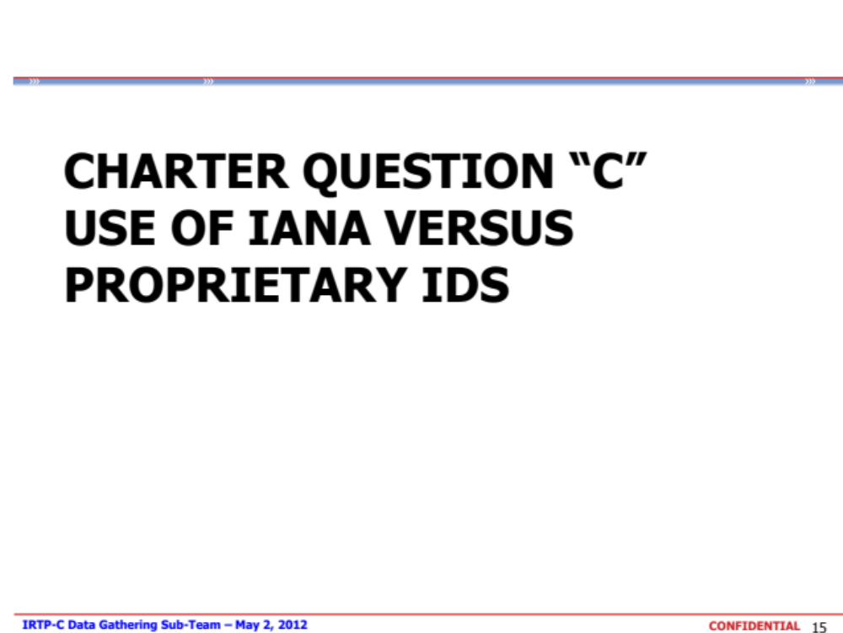
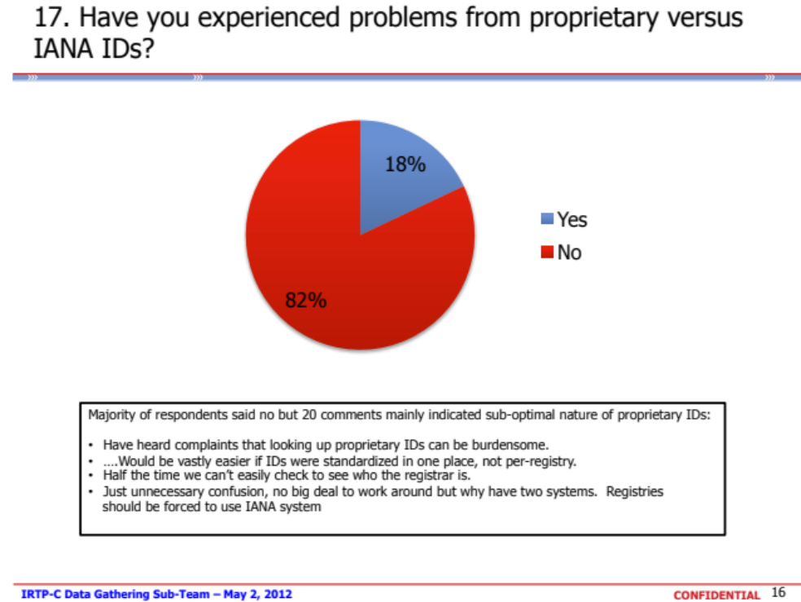
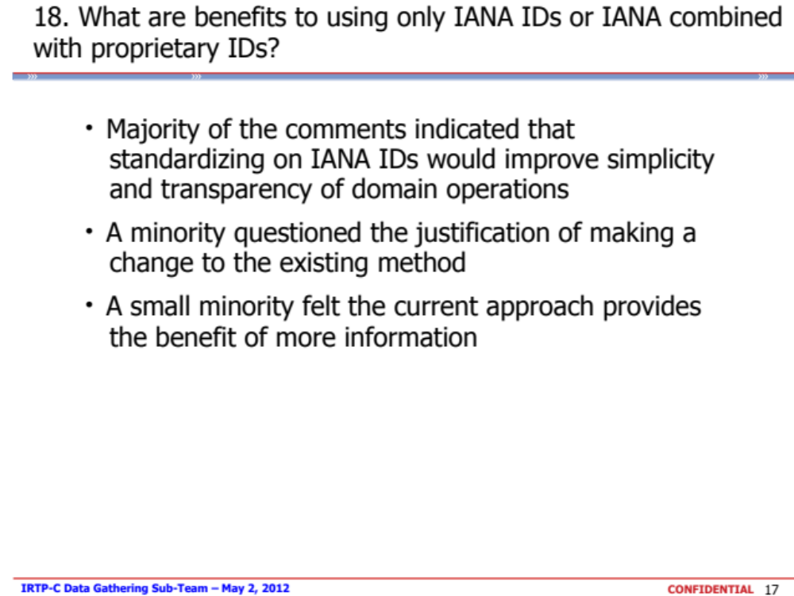
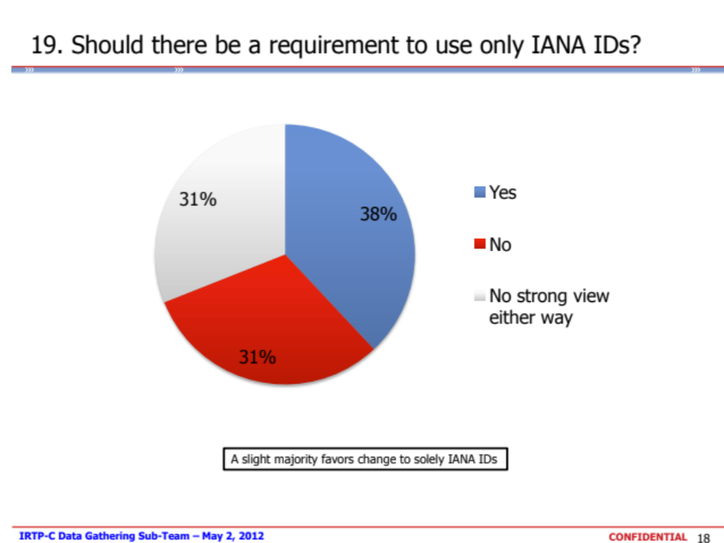
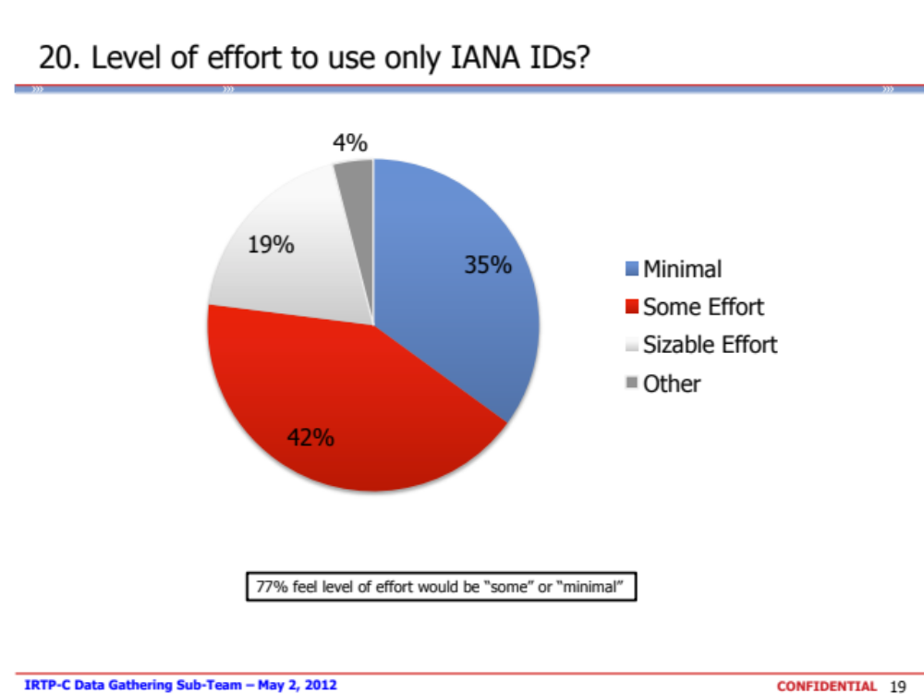
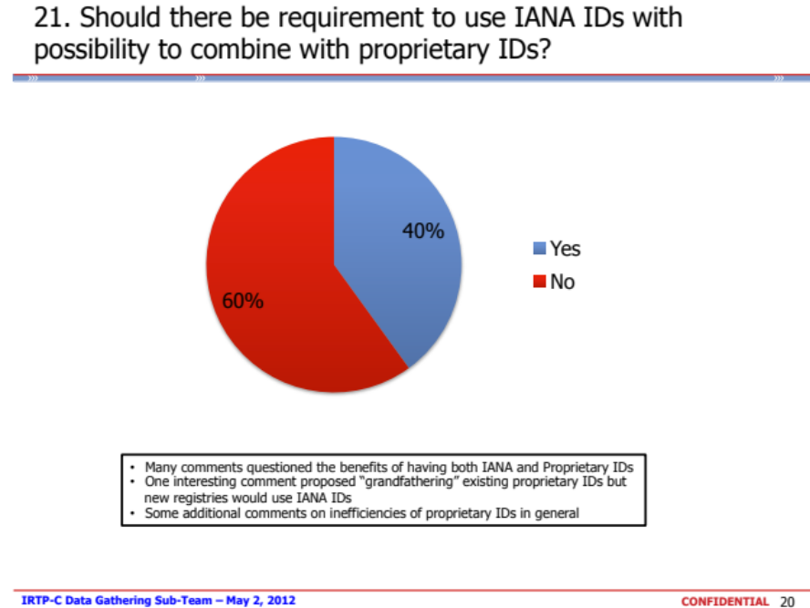
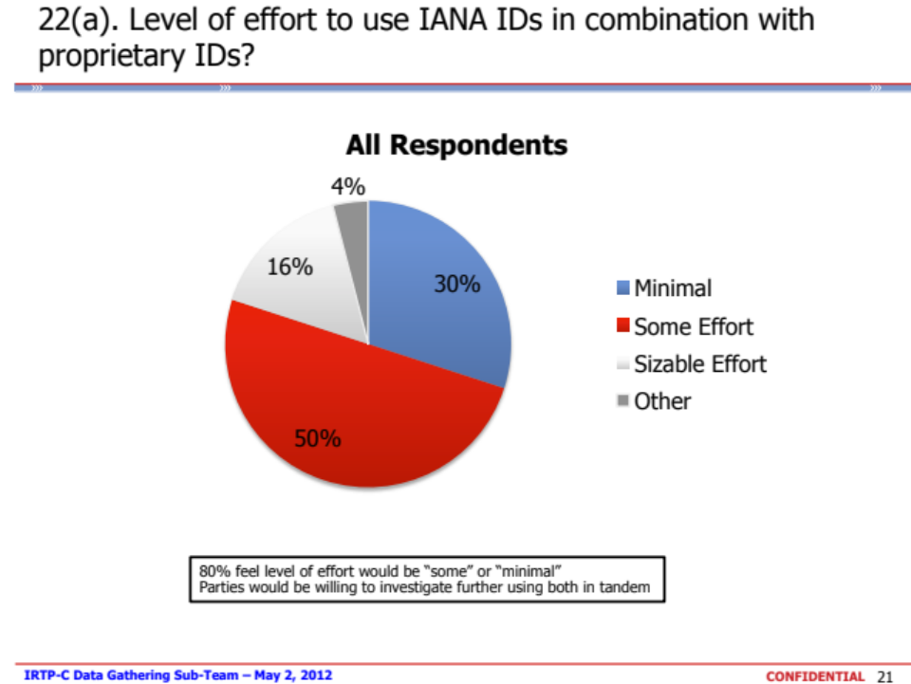
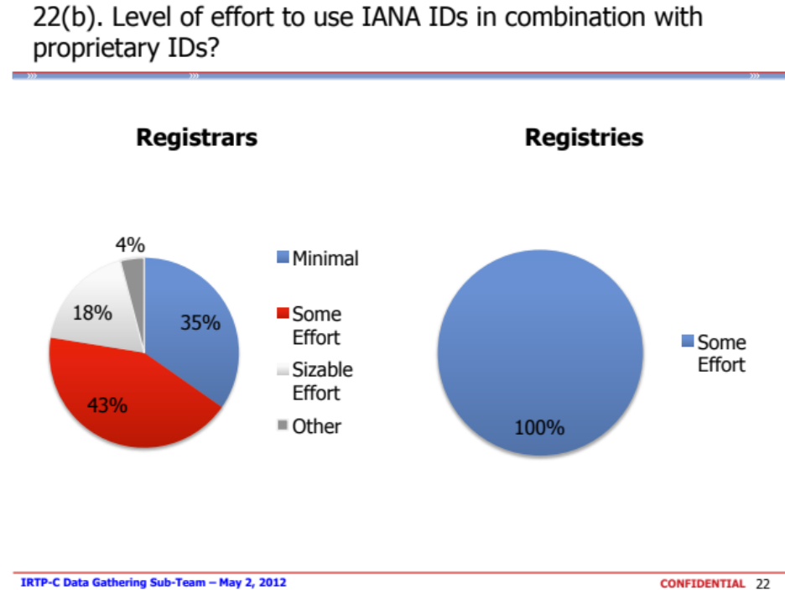
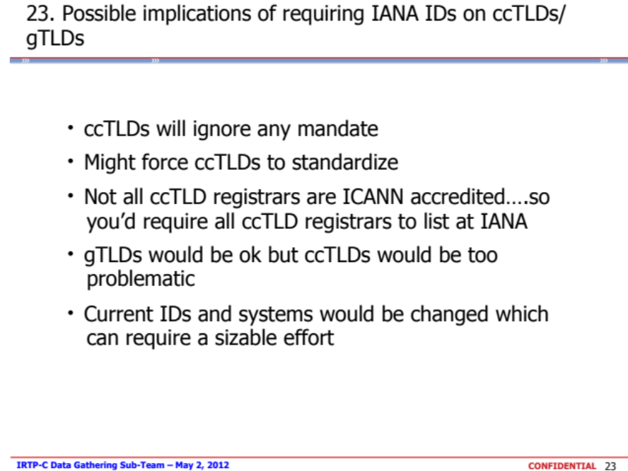
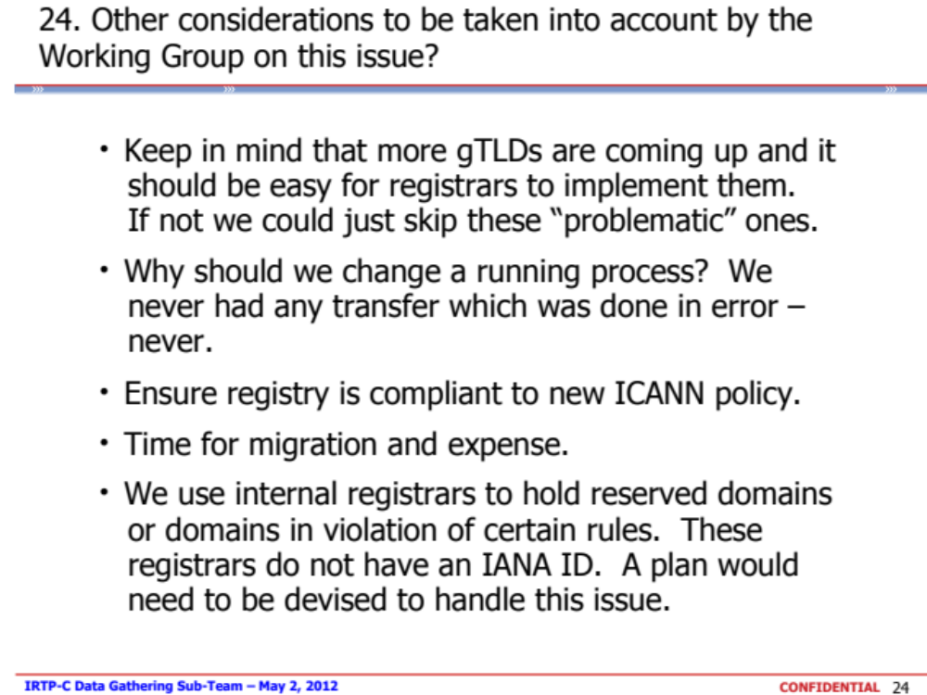

Registrar of Record may deny a transfer request if ‘The transfer was requested within 60 days of the creation date as shown in the registry Whois record for the domain name’.
Registrar of Record may deny a transfer request if ‘A domain name is within 60 days (or a lesser period to be determined) after being transferred (apart from being transferred back to the original Registrar in cases where both Registrars so agree and/or where a decision in the dispute resolution process so directs). "Transferred" shall only mean that an inter-registrar transfer has occurred in accordance with the procedures of this policy’.
Multiple inter-registrar transfers of the same domain name registration in a very short period of time
Various registrars lock a domain name registration for a sixty-day period following a change of registrant to prevent hijacking and/or unauthorized transfer of a domain name registration, but this is a registrar lock, which is not linked to the IRTP.
Domain hijacking refers to the wrongful taking of control of a domain name from the rightful name holder (see http://www.icann.org/announcements/hijacking-report-12jul05.pdf).
Recommendation #4: The WG notes that the primary function of IRTP is to permit Registered Name Holders to move registrations to the Registrar of their choice, with all contact information intact. The WG also notes that IRTP is widely used to affect a "change of control," moving the domain name to a new Registered Name Holder. The IRTP Part B WG recommends requesting an Issue Report to examine this issue, including an investigation of how this function is currently achieved, if there are any applicable models in the country-code name space that can be used as a best practice for the gTLD space, and any associated security concerns. The policy recommendations should include a review of locking procedures, as described in Reasons for Denial #8 and #9, with an aim to balance legitimate transfer activity and security. Recommendations should be made based on the data needs identified in the IRTP Part B workgroup discussions and should be brought to the community for public comment. The WG would like to strongly encourage the GNSO Council to include these issues (change of control and 60-day post-transfer lock) as part of the next IRTP PDP and ask the new working group to find ways to quantify their recommendations with data.
It should be noted that the GNSO Council will consider shortly whether or not to initiate a PDP on the review of the UDRP. If a PDP is initiated and a PDP is initiated on IRTP Part C, co-ordination between the two efforts in relation to this specific issue (transfers as a result of UDRP proceedings) might be appropriate.
Registrants presumably file complaints directly with registrars and/or registries prior to escalating the issue to ICANN.
Changed from CBUC to ISPCP on [Date]
See ‘Transfers of a Domain Name to a New Holder’ (http://archive.icann.org/en/udrp/udrp-policy-24oct99.htm)
Based on the experience with the use cases, the WG concluded that even moderately experienced registrants struggle with this process today as it is considered difficult and confusing as it varies between registrars how a “change of control” can be conducted.
One such problems identified relates to the fact that bad actors are able to transfer the domain name to an unaware registrant without their knowledge, while the registrar / registrant may be held liable for any malicious activity that is conducted using that particular registration.
See http://www.iana.org/assignments/registrar-ids/registrar-ids.xml for the most recent list.
From the Final Issue Report: “the IRTP is widely used to affect a ‘change of control’, namely by moving the domain name to a new Registered Name Holder, in conjunction with a transfer to another registrar. For example, in the domain name aftermarket it is not uncommon to demonstrate control of a domain name registration through the ability to transfer the domain name registration to another registrar following which the registrant information is changed to the new registrant. Nevertheless, the concept of ‘change of control’ is not defined in the context of gTLDs”.

