Final Report on the
Inter-Registrar Transfer Policy - Part C
Policy Development Process

STATUS OF THIS DOCUMENT
This is the Final Report on IRTP Part C PDP, prepared by ICANN staff for submission to the GNSO Council on [DATE].

SUMMARY
This report is submitted to the GNSO Council as a required step in this GNSO Policy Development Process on the Inter-Registrar Transfer Policy Part C.

Table of Contents
1. Executive Summary 3
2. Objective and Next Steps 11
3. Background 12
4. Approach taken by the Working Group 21
5. Deliberations of the Working Group 23
6. Community Input 37
7. Conclusions and Next Steps 39
Annex A – IRTP Part C PDP WG Charter 45
Annex B – Template for Constituency & Stakeholder Group Statements 46
Annex C – Overview of ccTLD Processes for Change of Registrant 49
Annex D – Data Gathering Survey 56
Annex E - STANDARDIZED FORM OF AUTHORIZATION | DOMAIN NAME TRANSFER (GAINING REGISTRAR) 69
Annex F – PRE-AUTHORIZED FORM OF AUTHORIZATION | DOMAIN NAME TRANSFER (LOSING REGISTRAR) 71
Annex G - Case Studies 72

Executive Summary
Background
- The Inter-Registrar Transfer Policy (IRTP) aims to provide a straightforward procedure for domain name holders to transfer their names from one ICANN-accredited registrar to another should they wish to do so. The policy also provides standardized requirements for registrar handling of such transfer requests from domain name holders. The policy is an existing community consensus policy that was implemented in late 2004 and is now being reviewed by the GNSO.
- The IRTP Part C Policy Development Process (PDP) is the third in a series of five PDPs that address areas for improvements in the existing transfer policy.
- The GNSO Council resolved at its meeting on 22 September 2012 to launch a PDP to address the following three issues:
  - "Change of Control" function, including an investigation of how this function is currently achieved, if there are any applicable models in the country-code name space that can be used as a best practice for the gTLD space, and any associated security concerns. It should also include a review of locking procedures, as described in Reasons for Denial #8 and #9, with an aim to balance legitimate transfer activity and security.
  - Whether provisions on time-limiting Form Of Authorization (FOA)s should be implemented to avoid fraudulent transfers out. For example, if a Gaining Registrar sends and receives an FOA back from a transfer contact, but the name is locked, the registrar may hold the FOA pending adjustment to the domain name status, during which time the registrant or other registration information may have changed.
  - Whether the process could be streamlined by a requirement that registries use IANA IDs for registrars rather than proprietary IDs.
- The IRTP Part C Working Group published its Initial Report on 4 June 2012 in conjunction with the opening of a public comment forum (see section 6 for further details).
- Following review of the comments received and continued deliberations, the WG has now finalized its report and submits it to the GNSO Council for its consideration.

- Deliberations of the Working Group
- The IRTP Part C Working Group started its deliberations on 8 November 2011 where it was decided to continue the work primarily through weekly conference calls, in addition to e-mail exchanges.
- Section 5 provides an overview of the deliberations of the Working Group conducted both by conference call as well as e-mail threads.

WG Recommendations
- Recommendation for Charter Question A:
Recommendation #1 – The IRTP Part C WG recommends the adoption of change of registrant consensus policy, which outlines the rules and requirements for a change of registrant of a domain name registration. Such a policy should follow the requirements and steps as outlined hereunder in the section ‘proposed change of registrant process for gTLDs’.

Proposed “Change of Registrant” Process for gTLDs
Having concluded that there are benefits in developing a standalone process for a “change of control” or “change of registrant”, the WG recommends the following requirements that such a change of registrant process should meet. These include:
- Both the Prior Registrant and the New Registrant need to authorize the change of registrant. Such authorization could also be provided by the Prior Registrant in the form of pre-approval or via a proxy. However such preapprovals must be secured using a generally accepted method of authentication. As a non-limiting example, Registrars may want to consider “out of band” authentication based on information that cannot be learned from within the registrar account or publicly available resources such as Whois. The Working Group recommends that the IRTP Part C Implementation Review Team is consulted by ICANN staff as it develops the implementation plan to ensure this recommendation is implemented in accordance with the intention of the Working Group.
- A change of registrant cannot take place simultaneously with a change of registrar although they can be made to appear that way to registrants in a registrars users interface. If both changes need to be made, it is suggested, but not required, that the change of registrar (IRTP) be completed prior to initiating the change of registrant in order to avoid triggering the proposed 60-day inter-registrar transfer lock (see below).
- The WG also noted that any such process should not create an unfair advantage/disadvantage for any of the segments active in the domain name industry and noted that it should not prevent innovation and differentiation amongst registrars.

The Working Group also discussed extensively whether there should be any restrictions in place that would prevent a change of registrar immediately following a change of registrant (see the Initial Report) and recommends that a domain name cannot be transferred to another registrar for 60 days to protect registrants against possible harms arising from domain hijacking. However the option to opt out of this restriction (with standard notice to all registrants of the associated risks) is provided in order to meet the needs of registrants who are concerned about the negative effect on movability of domain name registrations. If a registrar chooses to offer an option for registrants to opt out, the process to remove this restriction must use a generally accepted method of authentication.

As a result of these deliberations, the WG has developed the following proposed process for a change of registrant:
STEP 0: If the Prior and New Registrants are transferring the domain to a new registrar in conjunction with this Change of Registrant process, it is suggested that they first complete the Inter-Registrar Transfer in order to avoid triggering the default 60-day lock associated with the Change of Registrant process. Note that the Inter Registrar Transfer policy is revised so as to not permit changes to Registrant information at the same time as an inter-registrar transfer. The Gaining Registrar must validate this prior to completing the transfer. (see also Note H hereunder).

STEP 1: Both Registrants authorize the change
- Either the Prior or Gaining Registrant produces and transmits Change of Registrant Credentials to the other Registrant
- The other Registrant acknowledges the receipt of credentials and authorizes the transfer

STEP 2: Registrar determines that both Prior and New Registrant have authorized the Change of Registrant and that the domain is eligible for Change of Registrant (i.e. there are no locks or other restrictions on the domain)

STEP 3: Registrar changes registrant

STEP 4: Registrar notifies Prior and New Registrant of the change that has taken place

STEP 5: Registrar places a lock on the domain to prevent Inter-Registrar transfers of the domain for 60 days, unless the Prior Registrant has opted out of this requirement after having received a standard notice as to the associated risks.

NOTES:
Note A: Change of Registrant is defined as a material change to any of the following:
- Name
- Organization
- Primary Contact Method (registrant and/or administrative contact email address)

In the case of minor updates or corrections, the registrar, in its judgement, may waive this requirement at the request of the registrant using a generally accepted method of authentication. As a non-limiting example, Registrars may want to consider “out of band” authentication based on information that cannot be learned from within the registrar account or publicly available resources such as Whois. The Working Group recommends that the IRTP Part C Implementation Review Team is consulted by ICANN staff as it develops the implementation plan to ensure this recommendation is implemented in accordance with the intention of the Working Group.

Note B: In order to be eligible for a change of registrant, the domain name registration should not be:
- Subject to UDRP
- Locked by the Registrar (with a clear mechanism for clearing the lock)
- Expired

Note C: A change of registrant can only be requested by the registrant or an authorized representative of the registrant.

Note D: Change of Registrant Credentials could be a PIN, password, string or code, including AuthInfo codes. However Registrars should note that AuthInfo codes are also generated and used in the Inter-Registrar Transfer process. A registrar can use the same AuthInfo code for the Change of Registrant process, but there may be operational and security issues that they should address if they choose to do this without resetting and reissuing the AuthInfo code first.

Note E: The Inter-Registrar Transfer Process and this Change of Registrant Process are separate and distinct – however they can be made to appear the same to Registrants if that is desirable. The key distinction between these two processes is that the first (IRTP) happens between Registrars, while this Change of Registrant (COR) process happens within a Registrar.

Note F: This process is also used in cases where the Gaining and Losing Registrants are the same – e.g. the case where a Registrant is updating information in response to a WDRP reminder.

Note G: The 60-day lock is used to “contain” the changes of Registrants within a single Registrar in order to facilitate recovery of domains that have been hijacked.

Note H: It is not currently possible to validate that Registrant information is identical during an Inter Registrar Transfer in thin registries. Thus, implementation of these policy changes in thin-registry gTLDs is contingent on either a) the implementation of uniform WHOIS data access provisions being discussed in the current round of RAA negotiations, b) an outcome of a PDP process that mandates thick WHOIS across all registries or c) some other mechanism which provides secure and reliable sharing of Registrant data between Registrars in thin-registry TLDs.

Note I: It is recommended that the change of registrant policy is incorporated as a hybrid policy, whereby the IRTP would become a Transfer Policy in which one Part or Section details the policy for a change of registrar, and another Part or Section details the policy for a change of registrant.

- Recommendation Charter Question B:
Recommendation #2: The WG concludes that FOAs, once obtained by a registrar, should be valid for no longer than 60 days. Following expiration of the FOA, the registrar must re-authorize (via new FOA) the transfer request. Registrars should be permitted to allow registrants to opt-into an automatic renewal of FOAs, if desired.

In addition to the 60-day maximum validity restriction, FOAs should expire if there is a change of registrant, or if the domain name expires, or if the transfer is executed, or if there is a dispute filed for the domain name. In order to preserve the integrity of the FOA, there cannot be any opt-in or opt-out provisions for these reasons for expiration.

As recommended and approved as a result of the IRTP Part B PDP, Losing Registrars under IRTP-B are now required to send an FOA to a Prior Registrant. The WG advises that Losing Registrars have the option to send a modified version of this FOA to a Prior Registrant in the event that the transfer is automated where the FOA would be advisory in nature.

Finally, during the course of its deliberations on this topic, the WG notes that the use of EPP Authorization Info (AuthInfo) codes has become the de facto mechanism for securing domain transfers and thereby replaced some of the reasons for the creation of the standard FOA. The WG recommends that the next IRTP PDP examines whether the universal adoption and implementation of EPP AuthInfo codes has eliminated the need for FOAs.

- Recommendation Charter Question C:
Recommendation #3: The WG recommends that all gTLD Registry Operators be required to publish the Registrar of Record's IANA ID in the TLD's WHOIS. Existing gTLD Registry operators that currently use proprietary IDs can continue to do so, but they must also publish the Registrar of Record's IANA ID. This recommendation should not prevent the use of proprietary IDs by gTLD Registry Operators for other purposes, as long as the Registrar of Record's IANA ID is also published in the TLD's Whois.

- Additional Recommendation
Recommendation #4: As recommended as part of the revised GNSO Policy Development Process, the IRTP Part C Working Group strongly encourages the GNSO Council to create an IRTP Part C Implementation Review Team consisting of individual IRTP Part C Working Group members who would remain available to provide feedback on the implementation plan for the recommendations directly to ICANN staff. The Working Group suggests that consideration be given to including recognised security experts (such as interested members of the SSAC) in the implementation team.

Stakeholder Group / Constituency Statements, Initial Public Comment Period and Public Comment Forum on Initial Report
- A public comment forum was opened upon initiation of the Working Group activities. The public comment period ran from 21 November to 22 December 2011. One (1) community submission was received.
- The WG also requested all GNSO Stakeholder Groups and Constituencies to submit their statements on the IRTP Part C issues by circulating the SG/Constituency template (see Annex B). One contribution was received from the gTLD Registry Stakeholder Group.
- In addition, the WG also reached out to the country code Names Supporting Organization (ccNSO), the Governmental Advisory Committee (GAC) and the Security and Stability Advisory Committee (SSAC) for input, but no comments were received. The At-Large Advisory Committee (ALAC) submitted a statement in response to the public comment forum on the Initial Report.
- Following the publication of the Initial Report on 4 June 2012, a public comment forum was opened. In addition, the WG held a public workshop at the ICANN meeting in Prague to solicit input. Based on the input received, the WG developed a public comment review tool, which it used to review and respond to all the contributions received.
- The IRTP Part C WG reviewed and discussed all the contributions received. Where relevant and appropriate, information and suggestions derived from the contributions received were considered as part of the WG deliberations and have been included in section 5.

Conclusions and Next Steps
- The Working Group now submits this Final Report and its recommendations to the GNSO Council for its consideration.
- The Working Group suggests that the drafting team charged with writing the charter for the next IRTP working group consider the possibility of consolidating all remaining IRTP issues into one PDP.

Objective and Next Steps
This Final Report on the Inter-Registrar Transfer Policy (IRTP) Part C PDP is prepared as required by the GNSO Policy Development Process as stated in the ICANN Bylaws, Annex A (see http://www.icann.org/general/bylaws.htm#AnnexA). This Final Report is based on the Initial Report of 4 June 2012 and has been updated to reflect the review and analysis of the comments received by the IRTP Part C PDP Working Group in addition to further deliberations. This report is submitted to the GNSO Council for its consideration. The conclusions and recommendations for next steps on the five issues included in this PDP are outlined in Section 7.

Background

3.1 Process background
- Consistent with ICANN's obligation to promote and encourage robust competition in the domain name space, the Inter-Registrar Transfer Policy (IRTP) aims to provide a straightforward procedure for domain name holders to transfer their names from one ICANN-accredited registrar to another should they wish to do so. The policy also provides standardized requirements for registrar handling of such transfer requests from domain name holders. The policy is an existing community consensus policy that was implemented in late 2004 and is now being reviewed by the GNSO.
- As part of that review, the GNSO Council formed a Transfers Working Group (TWG) to examine and recommend possible areas for improvements in the existing transfer policy. The TWG identified a broad list of over 20 potential areas for clarification and improvement (see http://www.icann.org/en/gnso/transfers-tf/report-12feb03.htm).
- The Council tasked a short term planning group to evaluate and prioritize the policy issues identified by the Transfers Working Group. In March 2008, the group delivered a report to the Council that suggested combining the consideration of related issues into five new PDPs (A – E) (see http://gnso.icann.org/drafts/transfer-wg-recommendations-pdp-groupings-19mar08.pdf).
- On 8 May 2008, the Council adopted the structuring of five additional inter-registrar transfers PDPs as suggested by the planning group (in addition to a recently concluded Transfer PDP 1 on four reasons for denying a transfer). It was decided that the five new PDPs would be addressed in a largely consecutive manner, with the possibility of overlap as resources would permit.
- The first PDP of the series of five, IRTP Part A PDP, was concluded in March 2009 with the publication of the Final Report. The Final Report of the second of the series, IRTP Part B, was published in May 2011
- In its meeting on 22 June 2011, the GNSO Council requested an Issue Report from Staff on the third of the PDP issue sets, and on the recommendation of the IRTP Part B WG, also added the issue of ‘Change of Control’ to the list of items to be considered. The Preliminary Issue Report was published for public comment on 25 July 2011. The Final Issue Report was delivered to the Council on 29 August 2011.
- The issues that IRTP Part C PDP addresses are:
  - "Change of Control" function, including an investigation of how this function is currently achieved, if there are any applicable models in the country-code name space that can be used as a best practice for the gTLD space, and any associated security concerns. It should also include a review of locking procedures, as described in Reasons for Denial #8 and #9, with an aim to balance legitimate transfer activity and security.
  - Whether provisions on time-limiting Form Of Authorization (FOA)s should be implemented to avoid fraudulent transfers out. For example, if a Gaining Registrar sends and receives an FOA back from a transfer contact, but the name is locked, the registrar may hold the FOA pending adjustment to the domain name status, during which time the registrant or other registration information may have changed.
  - Whether the process could be streamlined by a requirement that registries use IANA IDs for registrars rather than proprietary IDs.
- The GNSO Council resolved at its meeting on 22 September 2011 to launch a PDP on these three issues and adopted a Charter for a Working Group (see Annex A for the Working Group Charter).
- The IRTP Part C Working Group published its Initial Report on 4 June 2012 in conjunction with the opening of a public comment forum (see section 6 for further details).
- Following review of the comments received and continued deliberations, the WG has now finalized its report and submits it to the GNSO Council for its consideration.

3.2 Final Issue Background (excerpt from Final Issue Report)
- Please note that the following text has been excerpted from the IRTP Part C Final Issue Report and does not contain any new input from the Working Group.

“Change of Control” and Reasons for Denial #8 & #9 (Charter Question A)

a) "Change of Control" function, including an investigation of how this function is currently achieved, if there are any applicable models in the country-code name space that can be used as a best practice for the gTLD space, and any associated security concerns. It should also include a review of locking procedures, as described in Reasons for Denial #8 and #9, with an aim to balance legitimate transfer activity and security.

- In the context of its deliberations on whether special provisions are needed for a change of registrant near a change of registrar, which can be an indication of an inappropriate transfer for example as the result of a hijacking, the IRTP Part B Working Group discussed the issue of ‘Change of Control’. The WG noted that ‘the primary function of IRTP is to permit Registered Name Holders to move registrations to the Registrar of their choice, with all contact information intact’. However, it was also noted that the IRTP is widely used to affect a ‘change of control’, namely by moving the domain name to a new Registered Name Holder, in conjunction with a transfer to another registrar. For example, in the domain name aftermarket it is not uncommon to demonstrate control of a domain name registration through the ability to transfer the domain name registration to another registrar following which the registrant information is changed to the new registrant. Nevertheless, the concept of ‘change of control’ is not defined in the context of gTLDs.
- The IRTP Part B WG discussed the existing IRTP Reason for Denial #8 and #9, which allows the losing registrar to deny a transfer if it is within 60 days of being transferred or created. These IRTP Reasons for Denial are optional, although prohibitions on transfers during these time periods are required in many registry agreements (see for example sections 3.1.1. and 3.1.4. - http://www.icann.org/en/tlds/agreements/org/appendix-07-08dec06.htm). IRTP Reason for Denial #8 and #9 may be used by a registrar as a mechanism to prevent ‘registrar hopping’, which makes it more difficult to undo a transfer in case of conflict or an inappropriate transfer. At the same time, some members of the IRTP Part B WG noted that such locks have the ability to reduce the flexibility to move domain name registrations to a registrar of choice. In the example provided in the previous bullet point, if denial reason #9 were applied, it would restrict the new registrant from moving the domain name registration to his / her registrar of choice for 60 days after acquiring the registration. It is important to emphasize that IRTP Reason for Denial #8 and #9 only apply to a change of registrar, not a change of registrant.
- As a result of the different views in the WG and the lack of data on the number of domain name hijacking cases with resolution problems due to the registrar hopping practice vs. the number of legitimate transfers benefitting of a less stringent locking policy, the IRTP Part B Working Group did not come to consensus on making reasons for denial #8 and 9 required instead of optional. However, the deliberations on the issue of ‘change of control’ and IRTP Reasons for Denial #8 and #9 revealed a clear link between the two issues and the WG therefore recommended that the ‘issue of transfer 'hopping' after hijacking be considered in conjunction with the issue of the lacking "change of control" function while also taking a review of the domain locking options in IRTP into account’ as part of IRTP Part C.
- The IRTP Part B Working Group also noted that ‘Data on the frequency of hijacking cases is a pivotal part of this analysis. Mechanisms should be explored to develop accurate data around this issue in a way that meets the needs of registrars to protect proprietary information while at the same time providing a solid foundation for data-based policy-making. Data on legitimate transfer activity benefitting from the current locking policy wording needs to be collected’. Although a small aftermarket survey conducted by members of the IRTP Part B Working Group provided a limited insight into the incidence of hijacking (http://forum.icann.org/lists/gnso-irtp-b-jun09/msg00531.html), the IRTP Part B Working Group was not able to obtain any robust data on the incidence of hijacking. Further data gathering efforts would need to take into account the potential sensitivity in relation to sharing this kind of information by registrars.
- No definition or procedure currently exists within the IRTP or any other gTLD policy that defines a ‘change of control’. At the same time, many country code Top Level Domains (ccTLDs) do have a procedure or process for a ‘change of control’. For example, Nominet (.uk) uses the concept of registrant transfer (see http://www.nominet.com/registrants/maintain/transfer/), .EU calls it a ‘trade’ (see http://www.eurid.eu/en/eu-domain-names/trades-transfers) while .ie calls it a ‘transfer domain holder’ (see http://www.domainregistry.ie/index.php/mnumods/mnuxferdomholder). Further work on this issue would benefit from an analysis of the different approaches to ‘change of control’ in the ccTLD community as well as identifying potential benefits and/or possible negative consequences from applying a similar approaches in a gTLD context. If considered beneficial, consideration would also need to be given to whether a ‘change of control’ procedure should be defined in the context of the IRTP or whether a separate policy should be developed.
- An initial analysis of the processes used by the previously mentioned ccTLD operators learns that in the ccTLD context a ‘change of control’ can be handled by the registry operator (for example .uk) or via an accredited registrar (for example .eu). In the latter case, the registrant has to request the accredited registrar to initiate the request for a change of control, while in the case of .uk and .ie the request can be made directly to the registry by the registrant. In .eu, a trade automatically results in a one-year extension of the registration period, which is not the case with a registrant transfer in .uk or transfer domain holder in .ie. If a PDP is initiated and a Working Group decides that a ‘change of control’ function should be developed, similar considerations will need to be taken into account in order to determine what would be most appropriate in the context of gTLDs. Further input on other models used by ccTLD operators was requested as part of the public comment period on this Preliminary Issue Report, but no comments were submitted to this end.
- Further consideration might also be given to ‘change of control’ in relation to transfers ordered as a result of Uniform Dispute Resolution Policy (UDRP) proceedings. Currently there is no uniform practice for handling these: some registrars create a new account and move the name over and give control to the complainant; others provide the Auth-Info code for a transfer away. If a PDP is initiated, it would make sense to also consider ‘change of control’ in the context of transfers resulting from UDRP proceedings in order to ensure consistency.

Time-limiting Form of Authorization (Charter Question B)

b) Whether provisions on time-limiting Form Of Authorization (FOA)s should be implemented to avoid fraudulent transfers out. For example, if a Gaining Registrar sends and receives an FOA back from a transfer contact, but the name is locked, the registrar may hold the FOA pending adjustment to the domain name status, during which time the registrant or other registration information may have changed.

- In order to request an inter-registrar transfer, express authorization from either the Registered Name Holder or the Administrative Contact needs to be obtained. Such authorization must be made via a valid Standardized Form of Authorization (FOA). There are two different FOA's. The FOA labeled ‘Initial Authorization for Registrar Transfer’ must be used by the Gaining Registrar to request an authorization for a registrar transfer from the Transfer Contact. The FOA labeled ‘Confirmation of Registrar Transfer Request’ may be used by the Registrar of Record to request confirmation of the transfer from the Transfer Contact. The FOA referred to in the question above relates to the former one (‘Initial Authorization for Registrar Transfer’) as for the latter the IRTP specifies that the FOA ‘should be sent by the Registrar of Record to the Transfer Contact as soon as operationally possible, but must be sent not later than twenty-four (24) hours after receiving the transfer request from the Registry Operator. Failure by the Registrar of Record to respond within five (5) calendar days to a notification from the Registry regarding a transfer request will result in a default "approval" of the transfer’.
- There are no specifications in the IRTP in relation to the timing or limits of use of the ‘Initial Authorization for Registrar Transfer’ FOA. This issue was raised as part of the Transfer WG discussions in 2005 where it was suggested that ‘we should consider limiting how long a registrar may hold an FOA before submitting a transfer request. We’ve run into problems when a registrar requests a transfer a month or two after they have received the FOA. By that time, the registration information may have changed, and the new registrant doesn’t respond to a confirmation request. Perhaps FOAs should be effective only 5 or 10 days to avoid fraudulent transfers out’ (see http://forum.icann.org/lists/transfers-wg/msg00006.html).
- Data provided by ICANN Compliance (see IRTP Part B Final Report) suggests that a total of 13% of complaints for the period of July – November 2009 relate to ownership / WHOIS issues / stolen domain or hijacking issues. Further details on the exact nature of these complaints is not available which makes it difficult to determine to what extent this particular issue, or the previous one, occur and are captured in this data. It should also be noted that the complaints received by ICANN Compliance probably represent a small percentage of total number of complaints and should not be relied upon as the sole data source to determine the scale and nature of a particular issue or problem area. Further input or data on the incidence of this issue was requested as part of the public comment period on the preliminary Issue Report, but no such information was submitted.

IANA IDs for registrars (Charter Question C)

c) Whether the process could be streamlined by a requirement that registries use IANA IDs for registrars rather than proprietary IDs.

- When a registrar accredits with ICANN, an ID is assigned by ICANN to identify that particular registrar. See http://www.iana.org/assignments/registrar-ids/registrar-ids.xml for the most recent list. However, when a registrar accredits with a particular registry, that registry may also assign a proprietary ID to the registrar, which differs from the IANA ID.
- This issue of IANA vs. proprietary ID was raised as part of the Transfer WG discussions in 2005 where it was noted that ‘it would be an improvement for everyone to get rid of the proprietary registrar ids that differ from registry to registry’. The suggestion was to propose that ‘registries shall implement IANA ids in transfers instead’. (see http://forum.icann.org/lists/transfers-wg/msg00003.html)
- ICANN has insisted on the consistent use of the IANA ID for all registrars and it has streamlined and improved communication and other aspects significantly as a result. There have been many problems over the years when registrars change their names or when registries record the names slightly differently in their records. From ICANN’s perspective, using a common, unchanging number assigned by ICANN (through IANA) would prevent such issues.
- Further information on the scope or nature that the use of proprietary vs. IANA IDs poses was encouraged as part of the public comment period on the preliminary Issue Report. The gTLD Registries Stakeholder Group (RySG) pointed out that ‘registrar name changes often do make it difficult to ensure that the correct registrar is identified and use of the IANA ID may be helpful in confirming registrar identification’. The RySG also noted that ‘all registries that provide Monthly Registry Operator Reports to ICANN are required to provide both the registrar name and the IANA ID to identify registrar information in the Per Registrar Activity Report file so it is reasonable to think that all registries do maintain this information in their registration systems’.

Approach taken by the Working Group

The IRTP Part C Working Group started its deliberations on 8 November 2011 where it was decided to continue the work primarily through weekly conference calls, in addition to e-mail exchanges. As one of its first tasks, the Working Group prepared a work plan, which was updated on a regular basis. In order to facilitate the work of the constituencies and stakeholder groups, a template was developed that could be used to provide input in response for the request for constituency and stakeholder group statements (see Annex B). This template was also used to solicit input from other ICANN Supporting Organizations and Advisory Committees early on in the process.

Members of the IRTP Part C Working Group

The members of the Working group are:

Name | Affiliation* | Meetings Attended (Total # of Meetings: 27)
Simonetta Batteiger | RrSG | 22
Alain Berranger | NPOC | 5
James Bladel (Co-Chair) | RrSG | 25
Chris Chaplow | CBUC | 19
Phil Corwin | CBUC | 23
Hago Dafalla | NCSG | 7
Paul Diaz | RySG | 2
Avri Doria (Co-Chair) | NCSG & At-Large | 24
Roy Dykes | RySG | 11
Kevin Erdman | IPC | 22
Rob Golding | RrSG | 19
Angie Graves | CBUC | 15
Volker Greimann | RrSG | 3
Oliver Hope | RrSG | 0
Erick Iriarte Ahon | NCUC | 3
Zahid Jamil (Council Liaison) | CBUC | 8
Bob Mountain | RrSG | 22
Michele Neylon | RrSG | 19
Mike O'Connor | ISPCP | 26
Matt Serlin | RrSG | 17
Barbara Knight | RySG | 20
Jonathan Tenenbaum | RrSG | 20
Rob Villeneuve | RrSG | 13
Jacob Williams | Individual | 2

The statements of interest of the Working Group members can be found at https://community.icann.org/display/gnsoirtppdpwg/4.+Members.

The attendance records can be found at https://community.icann.org/x/jrvbAQ.

The email archives can be found at http://forum.icann.org/lists/gnso-irtpc/.

*
RrSG – Registrar Stakeholder Group
RySG – Registry Stakeholder Group
CBUC – Commercial and Business Users Constituency
NCUC – Non Commercial Users Constituency
IPC – Intellectual Property Constituency
ISPCP – Internet Service and Connection Providers Constituency

Deliberations of the Working Group

This chapter provides an overview of the deliberations of the Working Group conducted both by conference call as well as e-mail threads. The points below are just considerations to be seen as background information and do not necessarily constitute any suggestions or recommendations by the Working Group, apart from those specifically labelled ‘recommendation’.

- Initial Fact-Finding and Research
In order to get a better understanding of the Inter-Registrar Transfer Policy, a training session was conducted by James Bladel (see http://gnso.icann.org/meetings/presentation-irtp-c-training-29nov11-en.pdf and http://gnso.icann.org/meetings/transcript-irtp-c-training-29nov11-en.pdf). In addition, the WG developed a number of use cases in order to obtain further information on how various scenarios such as change of registrar, change of registrant and change of registrar in combination with change of registrant are currently handled by various registrars.

- Working Group Deliberations

- Charter Question A
"Change of Control" function, including an investigation of how this function is currently achieved, if there are any applicable models in the country-code name space that can be used as a best practice for the gTLD space, and any associated security concerns. It should also include a review of locking procedures, as described in Reasons for Denial #8 and #9, with an aim to balance legitimate transfer activity and security.

How is this function currently achieved?
Following review of the IRTP Part C Final Issue Report and the use cases, the WG concluded that currently there does not exist a policy in relation to “change of control” or “change of registrant,” even though such a process is implied, for example, in the Uniform Dispute Resolution Policy. As a result, this process is handled in different ways by registrars. At the same time, the WG recognized that there might be benefits in having minimum requirements in relation to how such a “change of control” process should be handled by registrars as this would usefully clarify and simplify the process for registrants as well as potentially reducing problems currently encountered when the IRTP is used to enact a “change of control”. The WG also noted that the IRTP was developed to facilitate the transfer of domain name registrations between registrars and did not take into account possibly changes of control or the development of an aftermarket in which a change of control is part of most transactions.

Are there any applicable models in the country-code name space?
The Final Issue Report already identified a number of ccTLDs that have a dedicated process and/or policy to conduct a change of registrant, but further investigation by the WG in combination with discussions with the ccNSO confirmed that most, if not all, ccTLDs have such a process in place. Based on the feedback received from the ccNSO as well as feedback from the different registrars that also manage ccTLD registrations, the WG developed an overview of the main characteristics of the different approaches used by ccTLDs (see Annex C) to help inform the WG deliberations on this issue and identify elements that could also be of benefit in a gTLD context. In evaluating these different processes, the WG did take into account that there are certain elements that apply to ccTLDs but not to gTLDs such as dealing with only one jurisdiction and the different role the registry operator often fulfils with ccTLDs.

In general, the WG found that there is significant variation in the way Change of Registrant is implemented by ccTLDs. Some ccTLD operators require the Registrant to initiate this process with the registry directly, while others require the Registrar to conduct the change. In some instances, authorization was obtained by the Registry, in other the Registrar was responsible. Additionally, because some ccTLDs have eligibility requirements, there were differences in whether the new Registrant's eligibility was confirmed as a part of this process, or external to it. The relative ease of use for each ccTLD Change of Registrant process was assessed, with some scoring high (.NL, .MX, .DE), others rated as more difficult (.EU, .FR, .UK) and others identified as very difficult (.BR, .KR, .EG) (se Annex C for further details). Based upon this investigation and discussions with the ccNSO, the WG observed that:
- The ccTLD space contains a variety of examples for Change of Registrant procedures, with the majority supporting this function.
- ccTLDs vary on whether this is a Registry- or Registrar-centric function.
- Due to the concept of "thin" gTLDs, the Registry cannot exclusively control a gTLD equivalent process. The registrar must be involved or exclusively manage the function.
- Eligibility tests, which may be applicable to sTLDs or new "Community TLDs", can be a part of this process or a stand-alone procedure. For ccTLDs that test eligibility, the process appeared to be no different from those used for initial registrations.
- Some ccTLDs notify the old and new registrant, while others require confirmation or authorization.
- Some ccTLD had recently changed its process to offer more flexibility, and in their opinion, as shared during the meeting between the WG and the ccNSO, this change had been positively received by registrars and registrants.

Review of locking procedures, as described in Reasons for Denial #8 and #9
The IRTP provides for various reasons for which a registrar may deny a transfer including reason for denial #8 - The transfer was requested within 60 days of the creation date as shown in the registry Whois record for the domain name, and #9 - A domain name is within 60 days (or a lesser period to be determined) after being transferred (apart from being transferred back to the original Registrar in cases where both Registrars so agree and/or where a decision in the dispute resolution process so directs). "Transferred" shall only mean that an inter-registrar transfer has occurred in accordance with the procedures of this policy.
The WG reviewed these specific reasons for denial as prescribed in the charter question and concluded that reason for denial #9 should also apply to a change of registrant, i.e. following a change of registrant, it should not be possible to initiate a change of registrar for a 60-day time period. As explained below in further detail, the WG has also described the circumstances under which registrants may waive this requirement.

Change of Registrant – a separate policy or part of the IRTP?
The WG discussed as part of its Initial Report whether a change of registrant policy as outlined above should become part of the existing IRTP or should be established as a separate consensus policy or a hybrid approach should be followed. The WG would like to express a preference for the creation of a hybrid policy, whereby the IRTP would become a Transfer Policy whereby one Part or Section details the policy for a change of registrar, and another Part of Section details the policy for a change of registrant. However, if as part of the implementation process there are strong arguments for why a different approach should be followed, the WG suggests that those arguments are reviewed by the IRTP Part C Implementation Review Team (see recommendation #4 in section 7 for further details).

Recommendation for Charter Question A:
Recommendation #1 – The IRTP Part C WG recommends the adoption of change of registrant consensus policy, which outlines the rules and requirements for a change of registrant of a domain name registration. Such a policy should follow the requirements and steps as outlined hereunder in the section ‘proposed change of registrant process for gTLDs’.

Proposed “Change of Registrant” Process for gTLDs
Having concluded that there are benefits in developing a standalone process for a “change of control” or “change of registrant”, the WG recommends the following requirements that such a change of registrant process should meet. These include:
- Both the Prior Registrant and the New Registrant need to authorize the change of registrant. Such authorization could also be provided by the Prior Registrant in the form of pre-approval or via a proxy. However such preapprovals must be secured using a generally accepted method of authentication. As a non-limiting example, Registrars may want to consider “out of band” authentication based on information that cannot be learned from within the registrar account or publicly available resources such as Whois. The Working Group recommends that the IRTP Part C Implementation Review Team is consulted by ICANN staff as it develops the implementation plan to ensure this recommendation is implemented in accordance with the intention of the Working Group.
- A change of registrant cannot take place simultaneously with a change of registrar although they can be made to appear that way to registrants in a registrars users interface. If both changes need to be made, it is suggested, but not required, that the change of registrar (IRTP) be completed prior to initiating the change of registrant in order to avoid triggering the proposed 60-day inter-registrar transfer lock (see below).
- The WG also noted that any such process should not create an unfair advantage/disadvantage for any of the segments active in the domain name industry and noted that it should not prevent innovation and differentiation amongst registrars.

The Working Group also discussed extensively whether there should be any restrictions in place that would prevent a change of registrar immediately following a change of registrant (see the Initial Report) and recommends that a domain name cannot be transferred to another registrar for 60 days to protect registrants against possible harms arising from domain hijacking. However the option to opt out of this restriction (with standard notice to all registrants of the associated risks) is provided in order to meet the needs of registrants who are concerned about the negative effect on movability of domain name registrations. If a registrar chooses to offer an option for registrants to opt out, the process to remove this restriction must use a generally accepted method of authentication.

As a result of these deliberations, the WG has developed the following proposed process for a change of registrant:
STEP 0: If the Prior and New Registrants are transferring the domain to a new registrar in conjunction with this Change of Registrant process, it is suggested that they first complete the Inter-Registrar Transfer in order to avoid triggering the default 60-day lock associated with the Change of Registrant process. Note that the Inter Registrar Transfer policy is revised so as to not permit changes to Registrant information at the same time as an inter-registrar transfer. The Gaining Registrar must validate this prior to completing the transfer. (see also Note H hereunder).

STEP 1: Both Registrants authorize the change
- Either the Prior or Gaining Registrant produces and transmits Change of Registrant Credentials to the other Registrant
- The other Registrant acknowledges the receipt of credentials and authorizes the transfer

STEP 2: Registrar determines that both Prior and New Registrant have authorized the Change of Registrant and that the domain is eligible for Change of Registrant (i.e. there are no locks or other restrictions on the domain)

STEP 3: Registrar changes registrant

STEP 4: Registrar notifies Prior and New Registrant of the change that has taken place

STEP 5: Registrar places a lock on the domain to prevent Inter-Registrar transfers of the domain for 60 days, unless the Prior Registrant has opted out of this requirement after having received a standard notice as to the associated risks.

NOTES:
Note A: Change of Registrant is defined as a material change to any of the following:
- Name
- Organization
- Primary Contact Method (registrant and/or administrative contact email address)

In the case of minor updates or corrections, the registrar, in its judgement, may waive this requirement at the request of the registrant using a generally accepted method of authentication. As a non-limiting example, Registrars may want to consider “out of band” authentication based on information that cannot be learned from within the registrar account or publicly available resources such as Whois. The Working Group recommends that the IRTP Part C Implementation Review Team is consulted by ICANN staff as it develops the implementation plan to ensure this recommendation is implemented in accordance with the intention of the Working Group.

Note B: In order to be eligible for a change of registrant, the domain name registration should not be:
- Subject to UDRP
- Locked by the Registrar (with a clear mechanism for clearing the lock)
- Expired

Note C: A change of registrant can only be requested by the registrant or an authorized representative of the registrant.

Note D: Change of Registrant Credentials could be a PIN, password, string or code, including AuthInfo codes. However Registrars should note that AuthInfo codes are also generated and used in the Inter-Registrar Transfer process. A registrar can use the same AuthInfo code for the Change of Registrant process, but there may be operational and security issues that they should address if they choose to do this without resetting and reissuing the AuthInfo code first.

Note E: The Inter-Registrar Transfer Process and this Change of Registrant Process are separate and distinct – however they can be made to appear the same to Registrants if that is desirable. The key distinction between these two processes is that the first (IRTP) happens between Registrars, while this Change of Registrant (COR) process happens within a Registrar.

Note F: This process is also used in cases where the Gaining and Losing Registrants are the same – e.g. the case where a Registrant is updating information in response to a WDRP reminder.

Note G: The 60-day lock is used to “contain” the changes of Registrants within a single Registrar in order to facilitate recovery of domains that have been hijacked.

Note H: It is not currently possible to validate that Registrant information is identical during an Inter Registrar Transfer in thin registries. Thus, implementation of these policy changes in thin-registry gTLDs is contingent on either a) the implementation of uniform WHOIS data access provisions being discussed in the current round of RAA negotiations, b) an outcome of a PDP process that mandates thick WHOIS across all registries or c) some other mechanism which provides secure and reliable sharing of Registrant data between Registrars in thin-registry TLDs.

Note I: It is recommended that the change of registrant policy is incorporated as a hybrid policy, whereby the IRTP would become a Transfer Policy in which one Part or Section details the policy for a change of registrar, and another Part or Section details the policy for a change of registrant.

Level of consensus for this recommendation: The WG recorded unanimous consensus support for this recommendation.

Expected impact of the recommendation:
- The WG expects that adopting the proposed process for a change of registrant as outlined in the section ‘proposed change of control process for gTLDs’ will usefully clarify and standardize how a change of registrant can be conducted and as a result help reduce issues encountered when the IRTP is used to enact a change of registrant as well as reduce registrant confusion over how to complete a change of registrant.
- The WG expects that enhanced user education and information will be required in order to make all stakeholders familiar with this process, including some of the restrictions that are proposed (e.g. according to the recommendation a change of registrar will not be possible for 60-days, hence if both changes are desired, a change of registrar should be conducted prior to a change of registrant)

- CHARTER QUESTION B
Whether provisions on time-limiting Form Of Authorization (FOA)s should be implemented to avoid fraudulent transfers out. For example, if a Gaining Registrar sends and receives an FOA back from a transfer contact, but the name is locked, the registrar may hold the FOA pending adjustment to the domain name status, during which time the registrant or other registration information may have changed.

What is the current situation?
There are no specifications in the IRTP in relation to the timing or limits of use of in relation to FOAs, but the survey conducted by the data gathering sub-team (see hereunder) found that a majority of respondents currently impose a time limit on FOAs.

Data Gathering
In order to obtain further data and get a better understanding of the current practices and potential issues identified in relation to this issue, a data gathering sub-team was formed. This sub-team developed a survey in order to obtain further input especially from the registrar community on issues encountered as a result of Forms of Authorization (FOA) not being time-limited. Hundred (100) responses were received to the survey. The results of the survey can be found in Annex D. Based on the survey results, the WG concluded that:
- A majority of respondents felt that FOAs should be time limited
- Most respondents felt that a time limit on an FOA would improve security but the vast majority of respondents had not experiences or heard of problems from current non-time limited FOAs
- The majority of respondents currently impose a time limit on FOAs
- The expected scope of effort involved in time limiting FOAs was considered ‘minimal’ to ‘some’

Form of Authorization
A Form of Authorization or FOA is intended to authorize the specific transfer of a domain name. The IRTP notes that:
“For each instance where a Registered Name Holder requests to transfer a domain name registration to a different Registrar, the Gaining Registrar shall:
2.1 Obtain express authorization from either the Registered Name Holder or the Administrative Contact (hereafter, "Transfer Contact"). Hence, a transfer may only proceed if confirmation of the transfer is received by the Gaining Registrar from the Transfer Contact.
2.1.1 The authorization must be made via a valid Standardized Form of Authorization (FOA)…."

This Standardized FOA for the Gaining Registrar can be found in Annex E, the pre-authorized FOA for the losing registrar can be found in Annex F.

The FOA should not to be confused with the AuthInfo Code which is a unique code generated on a per-domain basis and is used for authorization or confirmation of a transfer request. Some registrars offer facilities for registrants to generate and manage their own AuthInfo code. In other cases, the registrant will need to contact the registrar directly to obtain it. The registrar must provide the registrant with the AuthInfo code within 5 calendar days of the request.

Findings
The WG notes that one of the primary functions of IRTP is to ensure that the domain transfer process evolves to meet new and previously unforeseen threats to the domain transfer process. Currently there is no time limit once a Form of Authorization (FOA) has been completed by a registrant. As such, there is a risk that an unexpired FOA could be used in a subsequent and unauthorized domain transfer. Many registrars have voluntarily implemented a time limit to their FOAs. The WG also notes that based on numerous responses to a survey, a very small percentage of registrars report ever having experienced or heard of problems with a domain transfer due to the lack of time limitations of an FOA. At the same time, the expected scope of effort involved in time limiting FOAs was considered ‘minimal’ to ‘some’

Recommendation Charter Question B:
Recommendation #2: The WG concludes that FOAs, once obtained by a registrar, should be valid for no longer than 60 days. Following expiration of the FOA, the registrar must re-authorize (via new FOA) the transfer request. Registrars should be permitted to allow registrants to opt-into an automatic renewal of FOAs, if desired.

In addition to the 60-day maximum validity restriction, FOAs should expire if there is a change of registrant, or if the domain name expires, or if the transfer is executed, or if there is a dispute filed for the domain name. In order to preserve the integrity of the FOA, there cannot be any opt-in or opt-out provisions for these reasons for expiration.

As recommended and approved as a result of the IRTP Part B PDP, Losing Registrars under IRTP-B are now required to send an FOA to a Prior Registrant. The WG advises that Losing Registrars have the option to send a modified version of this FOA to a Prior Registrant in the event that the transfer is automated where the FOA would be advisory in nature.

Finally, during the course of its deliberations on this topic, the WG notes that the use of EPP Authorization Info (AuthInfo) codes has become the de facto mechanism for securing domain transfers and thereby replaced some of the reasons for the creation of the standard FOA. The WG recommends that the next IRTP PDP examines whether the universal adoption and implementation of EPP AuthInfo codes has eliminated the need for FOAs.

Level of consensus for this recommendation: The WG recorded unanimous consensus support for this recommendation.

Expected impact of the proposed recommendation:
- The WG expects that by introducing the notion of renewing an FOA as proposed above, it is possible to accommodate the registrant (and registrars) that would like to:
  - "Pre-authorize" a transfer for months or even years (presumably with suitable security around that process)
  - Provide a framework that they can explicitly enter into agreements to "auto-renew" the FOA indefinitely if they so choose
  - Support a variety of manual or auto-renew processes that can vary across registrars.
- In addition, the WG expects that this recommendation will provide enhanced security for the vast majority of registrants who are simply using the name to conduct their day-to-day affairs.

- Charter Question C
Whether the process could be streamlined by a requirement that registries use IANA IDs for registrars rather than proprietary IDs.

What is the current situation?
As outlined in the Final Issue Report, when a registrar accredits with ICANN, an ID is assigned by ICANN to identify that particular registrar. However, when a registrar accredits with a particular registry, that registry may also assign a proprietary ID to the registrar, which differs from the IANA ID. Based on the feedback received from the Registry Stakeholder Group, there are currently at least two gTLD Registry Operators using proprietary IDs instead of the IANA assigned IDs. In the case of at least one of these registries, proprietary IDs are used in all registrar / registry communications. The primary driver behind the use of proprietary IDs vs. IANA IDs for these registries is security. The registries that currently use proprietary IDs have indicated that the use of proprietary IDs aids in the prevention of mining of Whois data, based on publicly available IANA IDs. In addition, it was pointed out that in certain cases registries deal with registrars that also sell ccTLDs for which there is no IANA ID. In those cases it is considered more efficient to have one single proprietary ID. At the same time, as also noted in the Final Issue Report and the public comments received, there have been problems to identify the registrar correctly when registrars change their names or when registries record the names slightly differently in their records. ICANN has insisted on the consistent use of the IANA ID for all registrars and it has streamlined and improved communication and other aspects significantly as a result. As outlined in the Final Issue Report, from ICANN’s perspective, using a common, unchanging number assigned by ICANN (through IANA) would prevent such issues.
It was also noted that even though the situation may be manageable today with ‘only’ 21 registry operators, with new gTLDs this situation may change drastically.

Data Gathering
The data gathering sub-team mentioned above also included questions in its survey in relation to the use of IANA IDs in order to get a better understanding of the issues identified with the use of proprietary IDs and what the possible challenges might be should the use of the IANA ID be required, possibly in combination with a proprietary ID. The results of the survey can be found in Annex D. Based on the survey results, the WG concluded that:
- The majority of respondents had not experienced problems with the use of proprietary registrar IDs
- The majority of respondents felt that standardization of IANA IDs would simplify transfers
- Many respondents were skeptical about whether ccTLD registries would adopt IANA IDs
- Respondents were split on whether to require registries to use IANA IDs exclusively
- The majority of respondents felt the effort to standardize IANA IDs would be ‘minimal’ to ‘some’

Findings
The WG notes that under the current system, Registrars are assigned one ID from ICANN (IANA ID) and another Proprietary ID by some Registries. While most Registrars hadn’t reported problems from the use of proprietary IDs in our survey, the majority felt that standardization on IANA IDs would simplify the domain transfer process. The WG also notes that the impending release of new TLDs will introduce potentially hundreds of new proprietary IDs

Recommendation Charter Question C:
Recommendation #3: The WG recommends that all gTLD Registry Operators be required to publish the Registrar of Record's IANA ID in the TLD's WHOIS. Existing gTLD Registry operators that currently use proprietary IDs can continue to do so, but they must also publish the Registrar of Record's IANA ID. This recommendation should not prevent the use of proprietary IDs by gTLD Registry Operators for other purposes, as long as the Registrar of Record's IANA ID is also published in the TLD's Whois.

Level of consensus for this recommendation: The WG recorded unanimous consensus support for this recommendation.

Expected impact of the proposed recommendation:
- The WG expects that standardizing use of IANA IDs could simplify the domain name transfer process

Community Input

This section features issues and aspects of the IRTP Part C PDP reflected in the statements from the GNSO stakeholder groups / constituencies; other ICANN Supporting Organizations and Advisory Committees; and comments received during the public comment period.

  - Initial Public Comment Period and Request for Input
A public comment forum was opened upon initiation of the Working Group activities. The public comment period ran from 21 November to 22 December 2011. One (1) community submission was received. A summary of the contribution received can be found here: http://www.icann.org/en/public-comment/report-comments-irtp-c-charter-03jan12-en.pdf. The WG also requested all GNSO Stakeholder Groups and Constituencies to submit their statements on the IRTP Part C issues by circulating the SG/Constituency template (see Annex B). One contribution was received from the gTLD Registry Stakeholder Group. In addition, the WG also reached out to the country code Names Supporting Organization (ccNSO), the At-Large Advisory Committee (ALAC), the Governmental Advisory Committee (GAC) and the Security and Stability Advisory Committee (SSAC) for input, but no comments have been received so far. The IRTP Part C WG reviewed and discussed the contributions received thoroughly with the assistance of a public comment review tool developed for that purpose. Where relevant and appropriate, information and suggestions derived from the contributions received were considered as part of the WG deliberations and have been included in section 5.

  - Public Comment Forum on the Initial Report

Following the publication of the Initial Report on 4 June 2012, a public comment forum was opened to which three (3) community contributions were received (see report of public comments). In addition, the WG held a public workshop at the ICANN meeting in Prague to solicit input. Based on the input received, the WG developed a public comment review tool, which it used to review and respond to all the contributions received. In addition, there were appropriate, the report has been updated based on the comments received.

Conclusions and Next Steps
Taking into account the Working Group Deliberations (see Chapter 5) and the Public Comments received (see Chapter 6), the Working Group would like to put forward the following recommendations for consideration by the GNSO Council to address each of the Charter Questions. All the recommendations listed below have full consensus support from the Working Group.

Recommendation for Charter Question A:
Recommendation #1 – The IRTP Part C WG recommends the adoption of change of registrant consensus policy, which outlines the rules and requirements for a change of registrant of a domain name registration. Such a policy should follow the requirements and steps as outlined hereunder in the section ‘proposed change of registrant process for gTLDs’.

Proposed “Change of Registrant” Process for gTLDs
Having concluded that there are benefits in developing a standalone process for a “change of control” or “change of registrant”, the WG recommends the following requirements that such a change of registrant process should meet. These include:
- Both the Prior Registrant and the New Registrant need to authorize the change of registrant. Such authorization could also be provided by the Prior Registrant in the form of pre-approval or via a proxy. However such preapprovals must be secured using a generally accepted method of authentication. As a non-limiting example, Registrars may want to consider “out of band” authentication based on information that cannot be learned from within the registrar account or publicly available resources such as Whois. The Working Group recommends that the IRTP Part C Implementation Review Team is consulted by ICANN staff as it develops the implementation plan to ensure this recommendation is implemented in accordance with the intention of the Working Group.
- A change of registrant cannot take place simultaneously with a change of registrar although they can be made to appear that way to registrants in a registrars users interface. If both changes need to be made, it is suggested, but not required, that the change of registrar (IRTP) be completed prior to initiating the change of registrant in order to avoid triggering the proposed 60-day inter-registrar transfer lock (see below).
- The WG also noted that any such process should not create an unfair advantage/disadvantage for any of the segments active in the domain name industry and noted that it should not prevent innovation and differentiation amongst registrars.

The Working Group also discussed extensively whether there should be any restrictions in place that would prevent a change of registrar immediately following a change of registrant (see the Initial Report) and recommends that a domain name cannot be transferred to another registrar for 60 days to protect registrants against possible harms arising from domain hijacking. However the option to opt out of this restriction (with standard notice to all registrants of the associated risks) is provided in order to meet the needs of registrants who are concerned about the negative effect on movability of domain name registrations. If a registrar chooses to offer an option for registrants to opt out, the process to remove this restriction must use a generally accepted method of authentication.

As a result of these deliberations, the WG has developed the following proposed process for a change of registrant:
STEP 0: If the Prior and New Registrants are transferring the domain to a new registrar in conjunction with this Change of Registrant process, it is suggested that they first complete the Inter-Registrar Transfer in order to avoid triggering the default 60-day lock associated with the Change of Registrant process. Note that the Inter Registrar Transfer policy is revised so as to not permit changes to Registrant information at the same time as an inter-registrar transfer. The Gaining Registrar must validate this prior to completing the transfer. (see also Note H hereunder).

STEP 1: Both Registrants authorize the change
- Either the Prior or Gaining Registrant produces and transmits Change of Registrant Credentials to the other Registrant
- The other Registrant acknowledges the receipt of credentials and authorizes the transfer

STEP 2: Registrar determines that both Prior and New Registrant have authorized the Change of Registrant and that the domain is eligible for Change of Registrant (i.e. there are no locks or other restrictions on the domain)

STEP 3: Registrar changes registrant

STEP 4: Registrar notifies Prior and New Registrant of the change that has taken place

STEP 5: Registrar places a lock on the domain to prevent Inter-Registrar transfers of the domain for 60 days, unless the Prior Registrant has opted out of this requirement after having received a standard notice as to the associated risks.

NOTES:
Note A: Change of Registrant is defined as a material change to any of the following:
- Name
- Organization
- Primary Contact Method (registrant and/or administrative contact email address)

In the case of minor updates or corrections, the registrar, in its judgement, may waive this requirement at the request of the registrant using a generally accepted method of authentication. As a non-limiting example, Registrars may want to consider “out of band” authentication based on information that cannot be learned from within the registrar account or publicly available resources such as Whois. The Working Group recommends that the IRTP Part C Implementation Review Team is consulted by ICANN staff as it develops the implementation plan to ensure this recommendation is implemented in accordance with the intention of the Working Group.

Note B: In order to be eligible for a change of registrant, the domain name registration should not be:
- Subject to UDRP
- Locked by the Registrar (with a clear mechanism for clearing the lock)
- Expired

Note C: A change of registrant can only be requested by the registrant or an authorized representative of the registrant.

Note D: Change of Registrant Credentials could be a PIN, password, string or code, including AuthInfo codes. However Registrars should note that AuthInfo codes are also generated and used in the Inter-Registrar Transfer process. A registrar can use the same AuthInfo code for the Change of Registrant process, but there may be operational and security issues that they should address if they choose to do this without resetting and reissuing the AuthInfo code first.

Note E: The Inter-Registrar Transfer Process and this Change of Registrant Process are separate and distinct – however they can be made to appear the same to Registrants if that is desirable. The key distinction between these two processes is that the first (IRTP) happens between Registrars, while this Change of Registrant (COR) process happens within a Registrar.

Note F: This process is also used in cases where the Gaining and Losing Registrants are the same – e.g. the case where a Registrant is updating information in response to a WDRP reminder.

Note G: The 60-day lock is used to “contain” the changes of Registrants within a single Registrar in order to facilitate recovery of domains that have been hijacked.

Note H: It is not currently possible to validate that Registrant information is identical during an Inter Registrar Transfer in thin registries. Thus, implementation of these policy changes in thin-registry gTLDs is contingent on either a) the implementation of uniform WHOIS data access provisions being discussed in the current round of RAA negotiations, b) an outcome of a PDP process that mandates thick WHOIS across all registries or c) some other mechanism which provides secure and reliable sharing of Registrant data between Registrars in thin-registry TLDs.

Note I: It is recommended that the change of registrant policy is incorporated as a hybrid policy, whereby the IRTP would become a Transfer Policy whereby one Part or Section details the policy for a change of registrar, and another Part of Section details the policy for a change of registrant.

Recommendation Charter Question B:
Recommendation #2: The WG concludes that FOAs, once obtained by a registrar, should be valid for no longer than 60 days. Following expiration of the FOA, the registrar must re-authorize (via new FOA) the transfer request. Registrars should be permitted to allow registrants to opt-into an automatic renewal of FOAs, if desired.

In addition to the 60-day maximum validity restriction, FOAs should expire if there is a change of registrant, or if the domain name expires, or if the transfer is executed, or if there is a dispute filed for the domain name. In order to preserve the integrity of the FOA, there cannot be any opt-in or opt-out provisions for these reasons for expiration.

As recommended and approved as a result of the IRTP Part B PDP, Losing Registrars under IRTP-B are now required to send an FOA to a Prior Registrant. The WG advises that Losing Registrars have the option to send a modified version of this FOA to a Prior Registrant in the event that the transfer is automated where the FOA would be advisory in nature.

Finally, during the course of its deliberations on this topic, the WG notes that the use of EPP Authorization Info (AuthInfo) codes has become the de facto security mechanism in our industry and thereby replaced some of the reasons for the creation of the standard FOA. The WG recommends that the next IRTP PDP examines whether the universal adoption and implementation of EPP AuthInfo codes has eliminated the need of FOAs.

Recommendation Charter Question C:
Recommendation #3: The WG recommends that all gTLD Registry Operators be required to publish the Registrar of Record's IANA ID in the TLD's WHOIS. Existing gTLD Registry operators that currently use proprietary IDs can continue to do so, but they must also publish the Registrar of Record's IANA ID. This recommendation should not prevent the use of proprietary IDs by gTLD Registry Operators for other purposes, as long as the Registrar of Record's IANA ID is also published in the TLD's Whois.

Additional Recommendation
Recommendation #4: As recommended as part of the revised GNSO Policy Development Process, the IRTP Part C Working Group strongly encourages the GNSO Council to create an IRTP Part C Implementation Review Team consisting of individual IRTP Part C Working Group members who would remain available to provide feedback on the implementation plan for the recommendations directly to ICANN staff. The Working Group suggests that consideration be given to including recognised security experts (such as interested members of the SSAC) in the implementation team.

Annex A – IRTP Part C PDP WG Charter
The Working Group shall consider the following questions as outlined in the Final Issue Report (http://gnso.icann.org/issues/issue-report-irtp-c-29aug11-en.pdf) and make recommendations to the GNSO Council:

a) "Change of Control" function, including an investigation of how this function is currently achieved, if there are any applicable models in the country-code name space that can be used as a best practice for the gTLD space, and any associated security concerns. It should also include a review of locking procedures, as described in Reasons for Denial #8 and #9, with an aim to balance legitimate transfer activity and security.

b) Whether provisions on time-limiting Form Of Authorization (FOA)s should be implemented to avoid fraudulent transfers out. For example, if a Gaining Registrar sends and receives an FOA back from a transfer contact, but the name is locked, the registrar may hold the FOA pending adjustment to the domain name status, during which time the registrant or other registration information may have changed.

c) Whether the process could be streamlined by a requirement that registries use IANA IDs for registrars rather than proprietary IDs.

The Working Group shall follow the rules outlined in the GNSO Working Group Guidelines http://gnso.icann.org/council/annex-1-gnso-wg-guidelines-07apr11-en.pdf.

Annex B – Template for Constituency & Stakeholder Group Statements

The GNSO Council has formed a Working Group of interested stakeholders and Stakeholder Group / Constituency representatives, to collaborate broadly with knowledgeable individuals and organizations, in order to consider recommendations for a number of issues related to the Inter-Registrar Transfer Policy (IRTP).

Part of the working group’s effort will be to incorporate ideas and suggestions gathered from Stakeholder Groups and Constituencies through this Stakeholder Group / Constituency Statement. Inserting your Stakeholder Group’s / Constituency’s response in this form will make it much easier for the Working Group to summarize the responses. This information is helpful to the community in understanding the points of view of various stakeholders. However, you should feel free to add any information you deem important to inform the working group’s deliberations, even if this does not fit into any of the questions listed below.

For further background information on this issue, please review the GNSO Issue Report on IRTP Part C.

Process
- Please identify the member(s) of your stakeholder group / constituency who is (are) participating in this working group
- Please identify the members of your stakeholder group / constituency who participated in developing the perspective(s) set forth below.
- Please describe the process by which your stakeholder group / constituency arrived at the perspective(s) set forth below.

Questions
Please provide your stakeholder group’s / constituency’s views on the IRTP Part C Charter Questions:

- "Change of Control" function, including an investigation of how this function is currently achieved, if there are any applicable models in the country-code name space that can be used as a best practice for the gTLD space, and any associated security concerns. It should also include a review of locking procedures, as described in Reasons for Denial #8 and #9, with an aim to balance legitimate transfer activity and security.

- Whether provisions on time-limiting Form Of Authorization (FOA)s should be implemented to avoid fraudulent transfers out. For example, if a Gaining Registrar sends and receives an FOA back from a transfer contact, but the name is locked, the registrar may hold the FOA pending adjustment to the domain name status, during which time the registrant or other registration information may have changed.

- Whether the process could be streamlined by a requirement that registries use IANA IDs for registrars rather than proprietary IDs.

In addition, the Working Group has identified the following specific issues / questions it would like to receive further input on:

- In relation to Charter Question A, the Issue Report notes that ‘data on the frequency of hijacking cases is a pivotal part of this analysis. Mechanisms should be explored to develop accurate data around this issue in a way that meets the needs of registrars to protect proprietary information while at the same time providing a solid foundation for data-based policy making. Data on legitimate transfer activity benefitting from the current locking policy wording needs to be collected’.
- In addition to the ccTLDs described in the Issue Report that do have a procedure or process for a ‘change of control’ (.ie, .eu and .uk) are there any other ccTLDs that have similar procedures or processes which the WG should review in the context of charter question A? Furthermore, the WG would be interested to receive feedback on the experiences with these or other ccTLD procedures or processes for a ‘change of control’ as well as identifying potential benefits and/or possible negative consequences from applying similar approaches in a gTLD context.
- In relation to Charter Question B and C, the WG would be interested in further input or data in relation to the incidence of this issue to determine its scope and the most appropriate way to address it.
- In relation to Charter Question C, Registries and Registrars are asked to provide specific information as to where proprietary IDs are currently being used by registries and whether the use of IANA IDs instead would be preferred / beneficial.

Annex C – Overview of ccTLD Processes for Change of Registrant
General Comments:

- ccTLD level is easier as it only deals with one jurisdication. For example, certain verification processes (ID, notarization) might be easy to manage / handle in one jurisdication, but might be difficult to apply and/or implement when dealing with multiple jurisdictions.
- ccTLDs operate a ‘thick’ Whois model
- All ccTLDs appear to have a process for change of registrant

ccTLD | Name | Characteristics | Further information | Comments / Questions
.UK | Registrant Transfer | - Losing registrant logs into their account with the registry and initiates the ownership change.  - The new registrant will then receive an email with a link to approve the request.  - Handled by registry operator (not via registrars or EPP)  - Change of registrant can be combined with change of registrar | http://www.nominet.org.uk/registrants/maintain/transfer/  http://www.nominet.org.uk/registrants/maintain/transfer/Process/ | Considered moderate (see email Matt Serlin)
.EU | Trade | - Handled by accredited registrar  - Automatic one-year extension  - Needs to be confirmed within 14 days by both parties | http://www.eurid.eu/en/eu-domain-names/trades-transfers | Considered moderate (see email Matt Serlin)
.IE | Transfer Domain Holder | - Handled by registry operator  - A signed fax on headed paper from the current Administrative Contact must be submitted to initiate the transfer | http://www.domainregistry.ie/index.php/mnumods/mnuxferdomholder
.ES | Transmisión de dominio | - Two processes – one for ‘ordinary’ changes of control and one for ‘special’ cases (as the result of death, company take-over)  - Process can be initiated by registrar, registrant or admin contact  - If initiated by registrar, request needs to be confirmed by registrant or admin contact  - New registrant needs to confirm transfer and accept registration terms and conditions  - In case of a ‘special’ transfer, an ID needs to be provided. | http://www.dominios.es/transfer-procedure/article/267
.NL  .MX  .DE |  | - The current registrar can send a domain update command to the registry and update any domain information (contacts or DNS) |  | Considered easiest process (see email Matt Serlin)
.GR |  | - The losing registrant provides the auth code to the new domain holder. Transfer and ownership changes can be done at the same time |  | Considered easiest process (see email Matt Serlin)
.FR | Trade | - The registrar submits a ‘trade’ EPP command  - The registry then sends an email to the gaining and losing domain owner with a link to approve the request  - Once both parties approve the request, the registrar receives a poll message stating that the trade is complete  - A transfer and trade can be done together |  | Considered moderate (see email Matt Serlin)
.SE  .AU |  | - Documents required through a random audit by the registry  - The current registrar must have the losing domain owner sign a document agreeing to the change of ownership.  - The registrar then submits a domain update command to the registry |  | Considered moderate (see email Matt Serlin)
.BR |  | - The losing registrant must sign documentation agreeing to the change.  - The original copies of the documentation must be submitted to the registry |  | Considered hardest (see email Matt Serlin)
.KR |  | - The current and new domain registrants will be required to sign ownership change documents and provide a copy of their Korean Registration certificates or, if the current or new holder is an individual, a copy of their Korean personal identification |  | Considered hardest (see email Matt Serlin)
.EG  .JO  .OM |  | - The losing registrant and new registrant must sign and notarize original documentation agreeing to the change.  - The original documents are then submitted to the registry to process |  | Considered hardest (see email Matt Serlin)
.NZ | Change of Registrant | - The current registrar can send a domain update command to the registry and update any domain information (contacts or DNS)  - Minimum expectations for registrars to handle process appropriately apply (see http://dnc.org.nz/content/changeofregistrant.html). For example, ‘the registrar must be sure that the person requesting that a change of registrant […] is in fact authorized to do so. An example of possible checks include: […]’.  - Right to reverse transfer to original state in case of fraud |  | Considered easiest process (see email Matt Serlin)
.BE |  | - Registry went recently from a model that was very secure but not user-friendly to an easier transfer policy using auth-codes (“trade” model). Their registrar partners showed a significant increase in satisfaction with the new policy (and the change does not seem to have resulted in an increase in hijacking complaints).
.KY |  | - Do not allow registrants / registrars to transfer ownership. Only registry can enact such changes (do not want a secondary market).
.CA |  | - Post-transfer validation process. If registrant does not meet eligibility criteria, then registration is suspended and/or cancelled. Not different from ‘normal’ registration and validation process.
.NO |  | - Change of registrant is treated as a new registration.  - Have recently automated the process; before, everything was done on paper.

Annex D – Data Gathering Survey
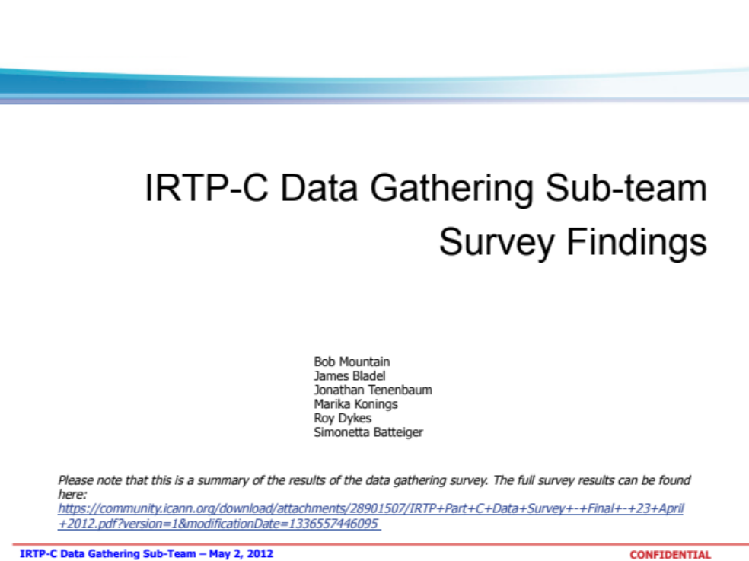
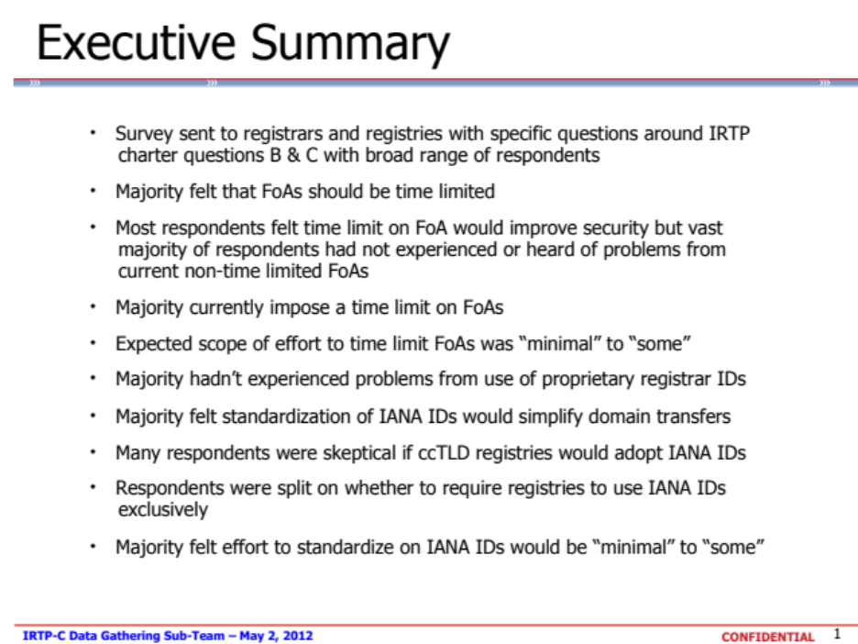
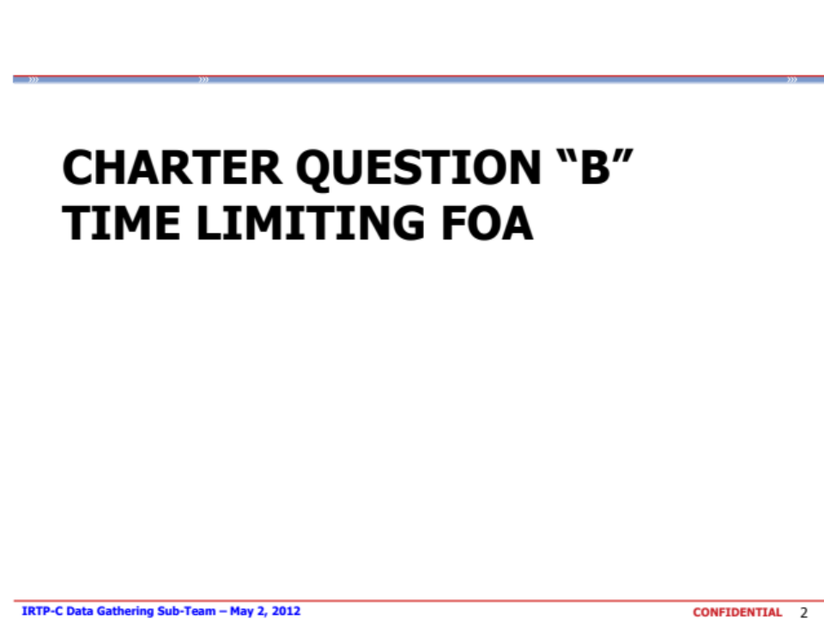
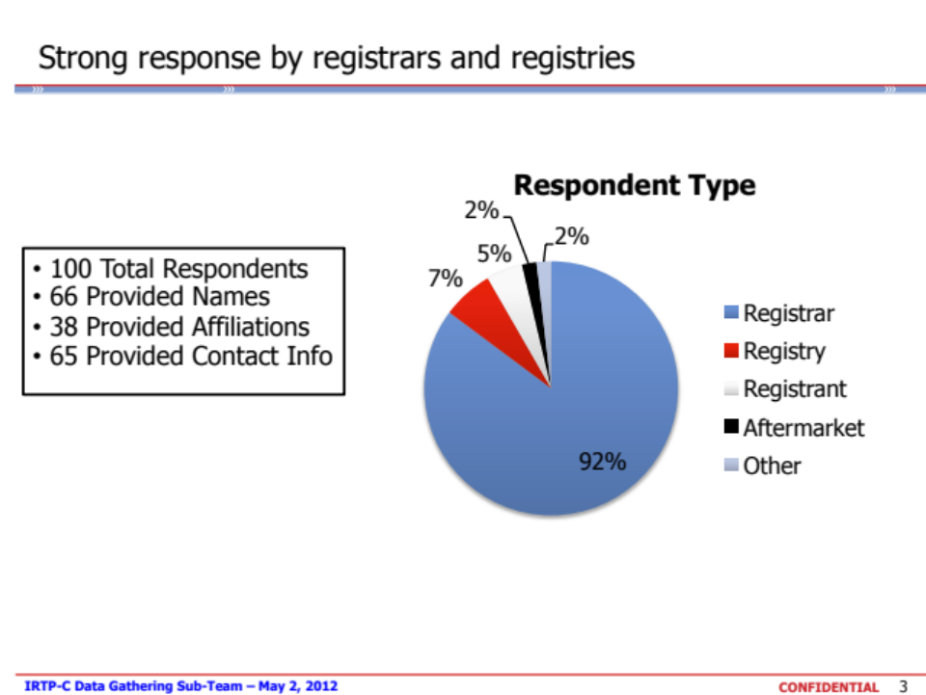
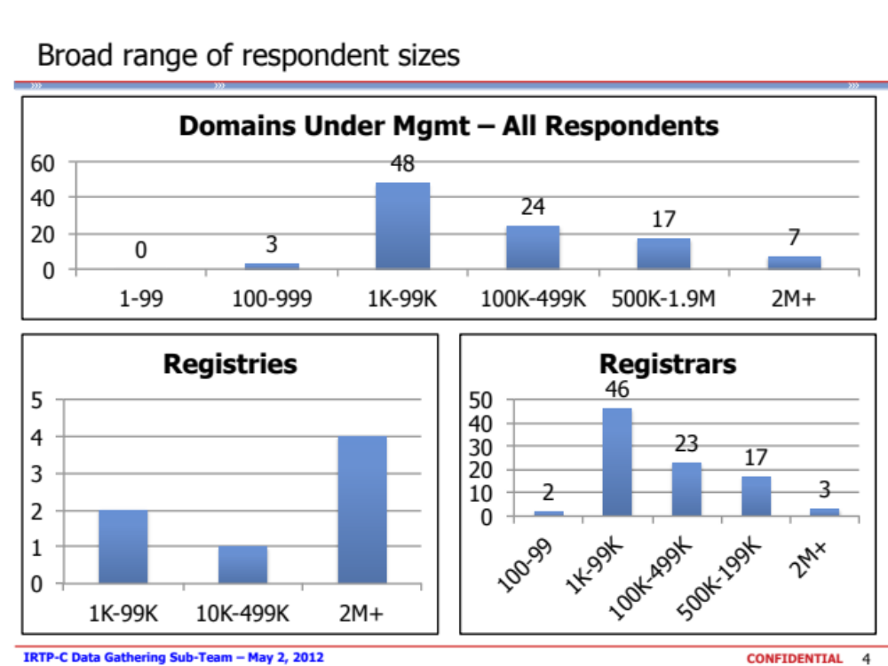

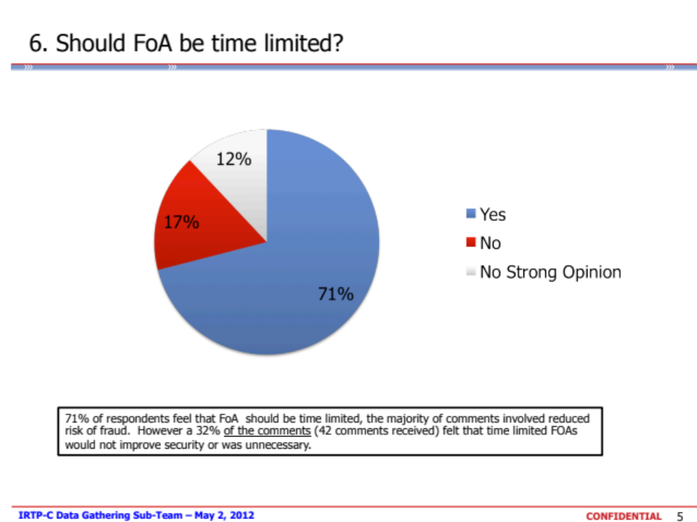
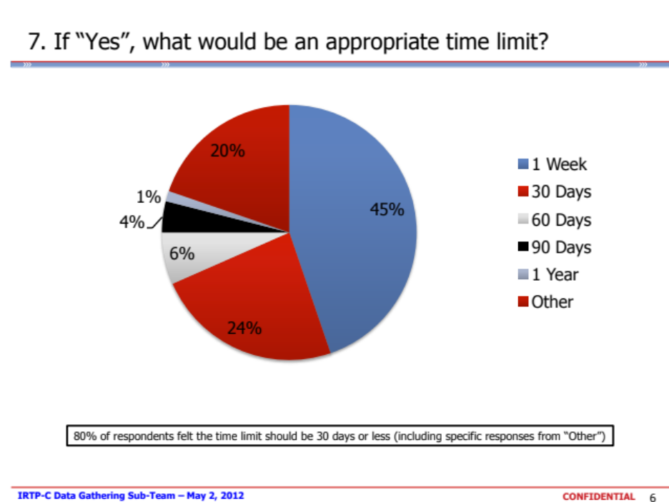
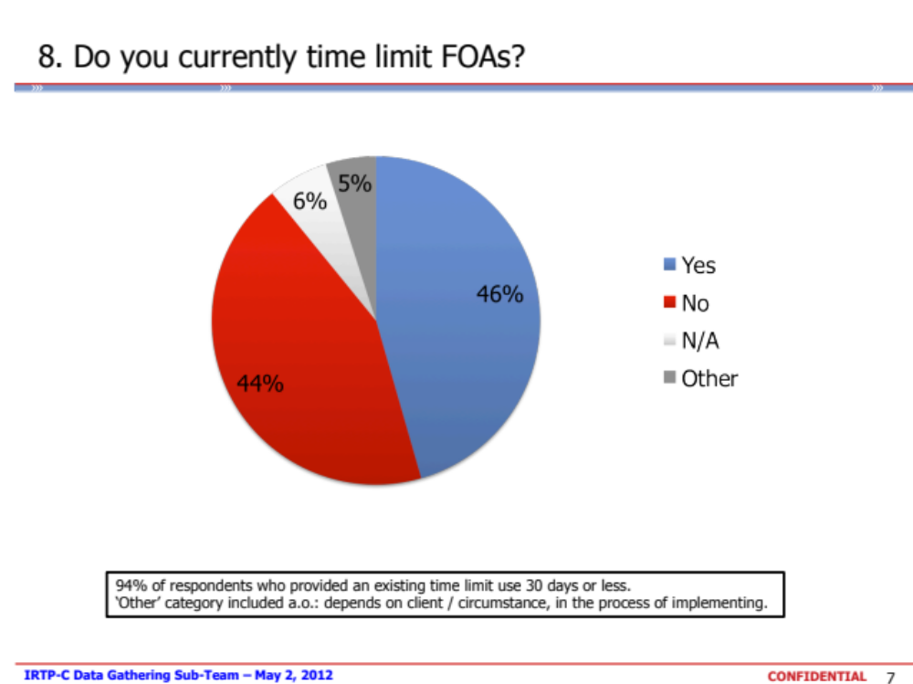
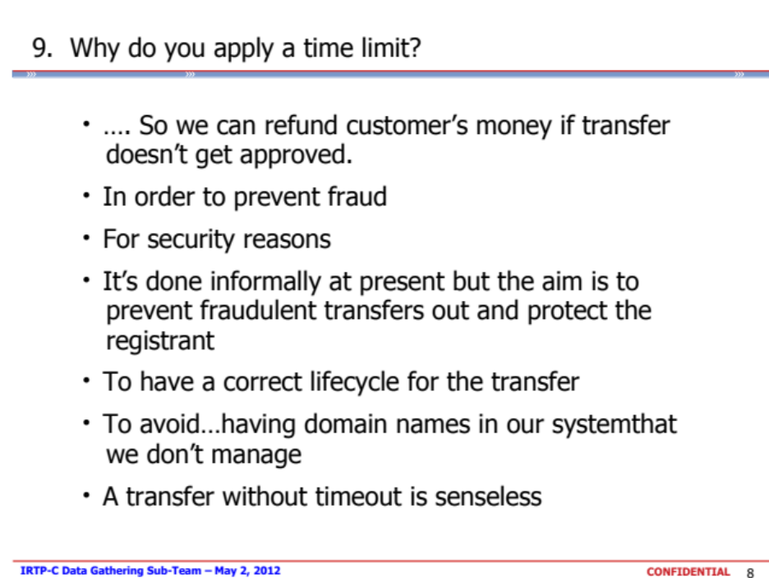
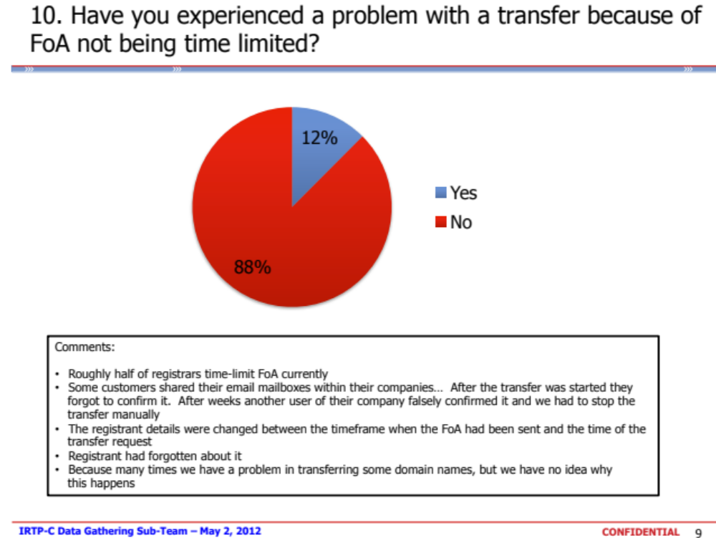
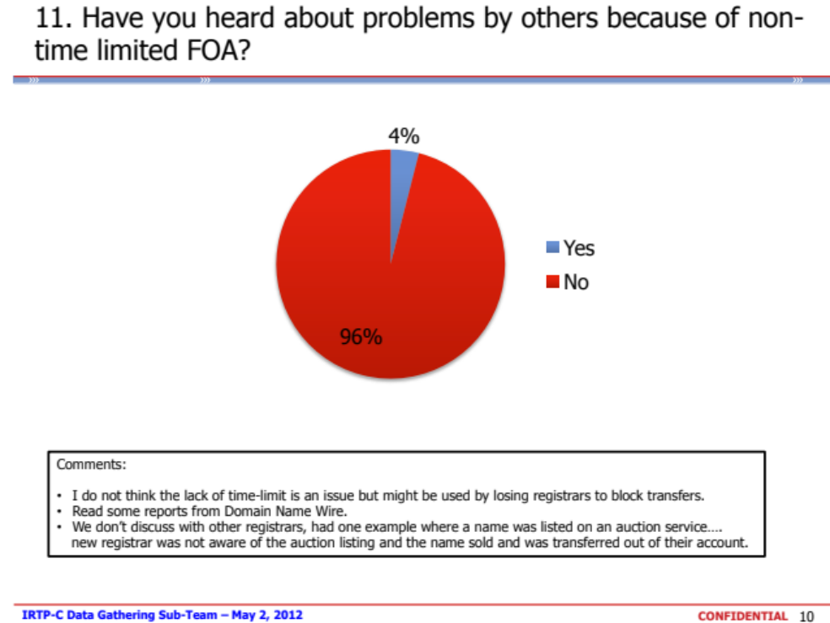
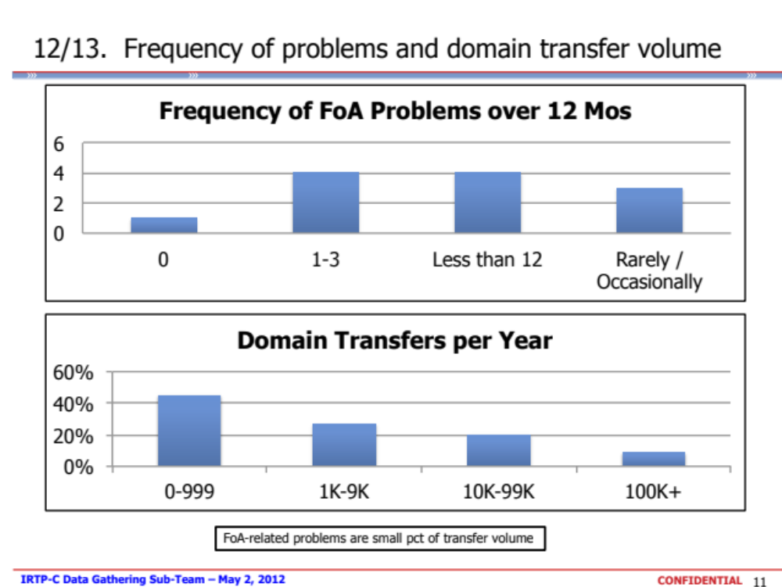
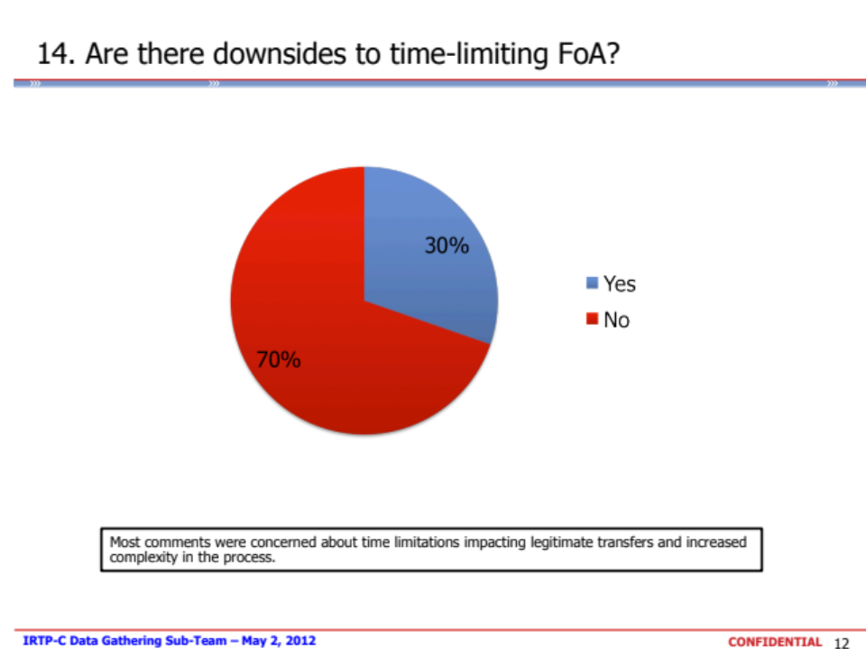
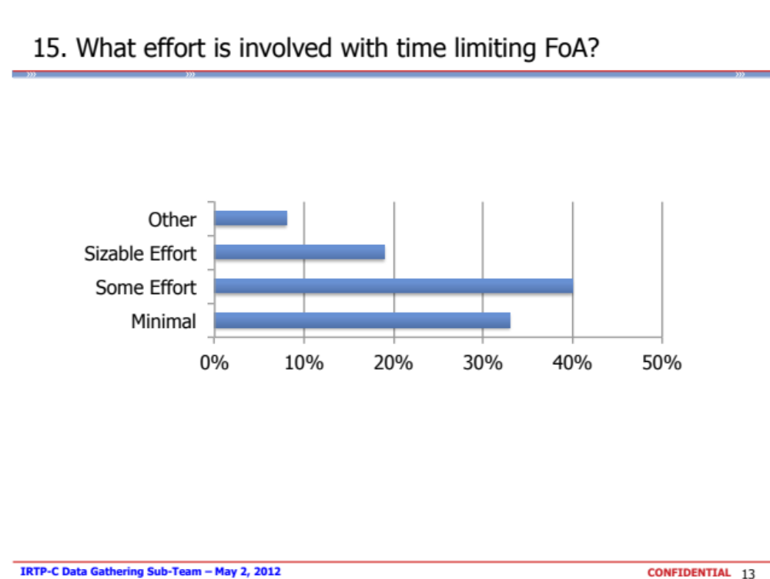
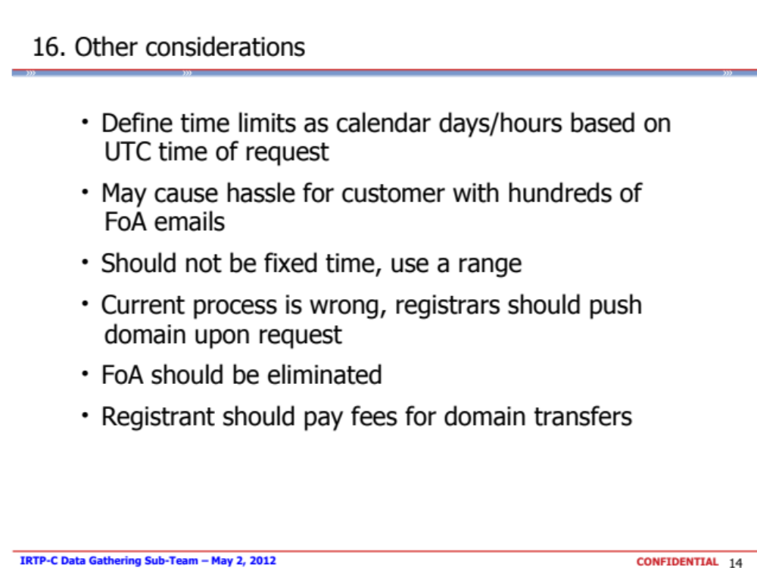
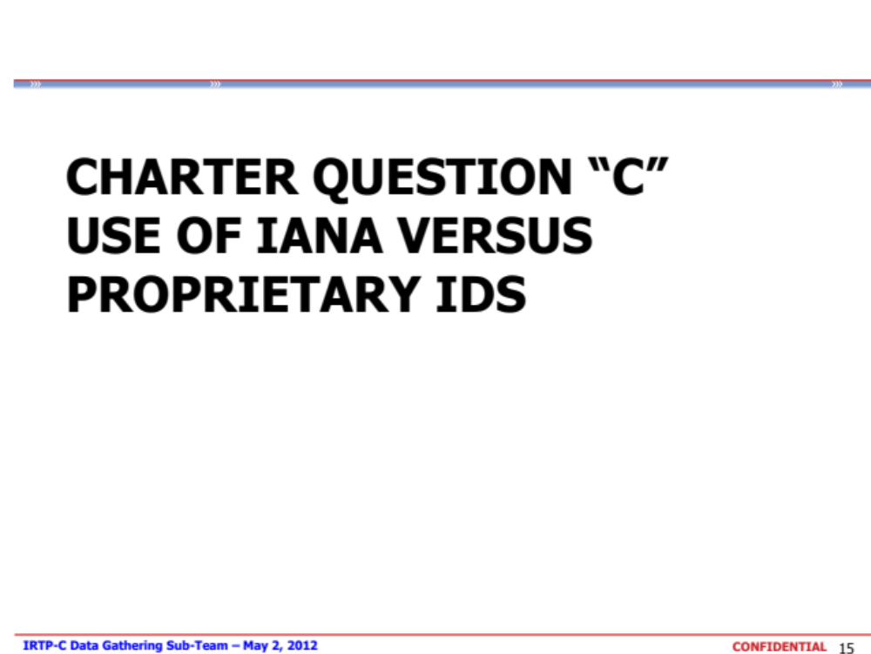
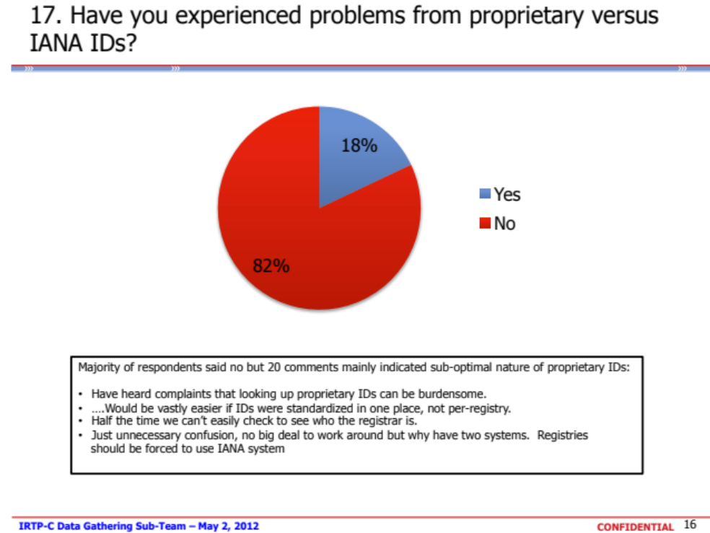
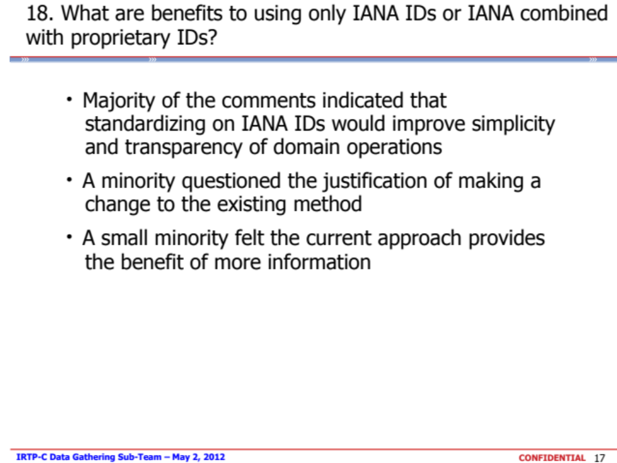
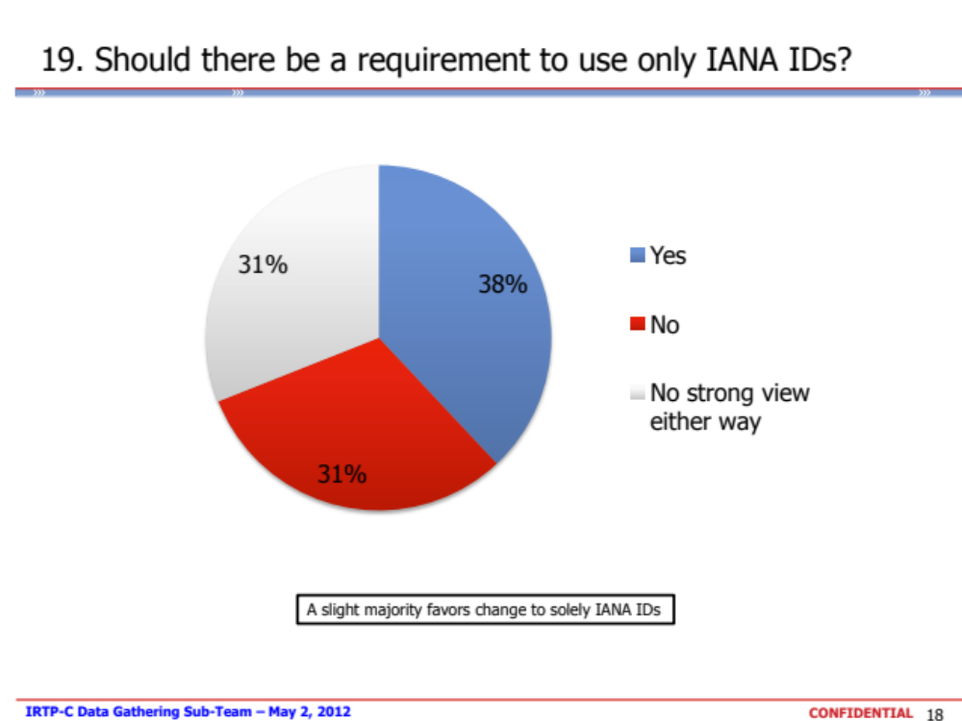
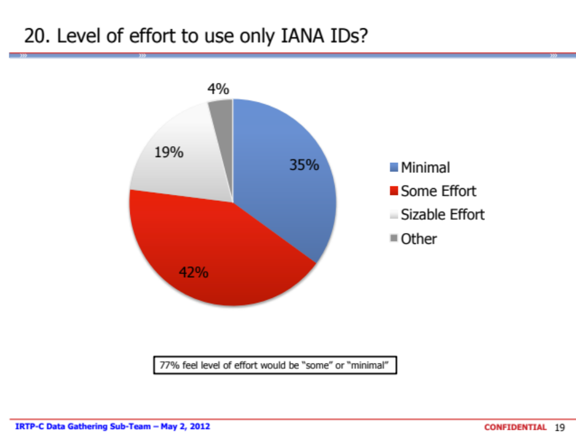
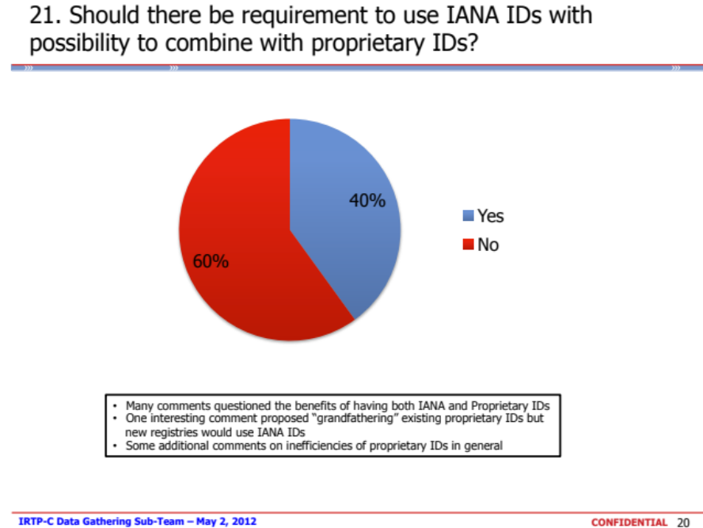
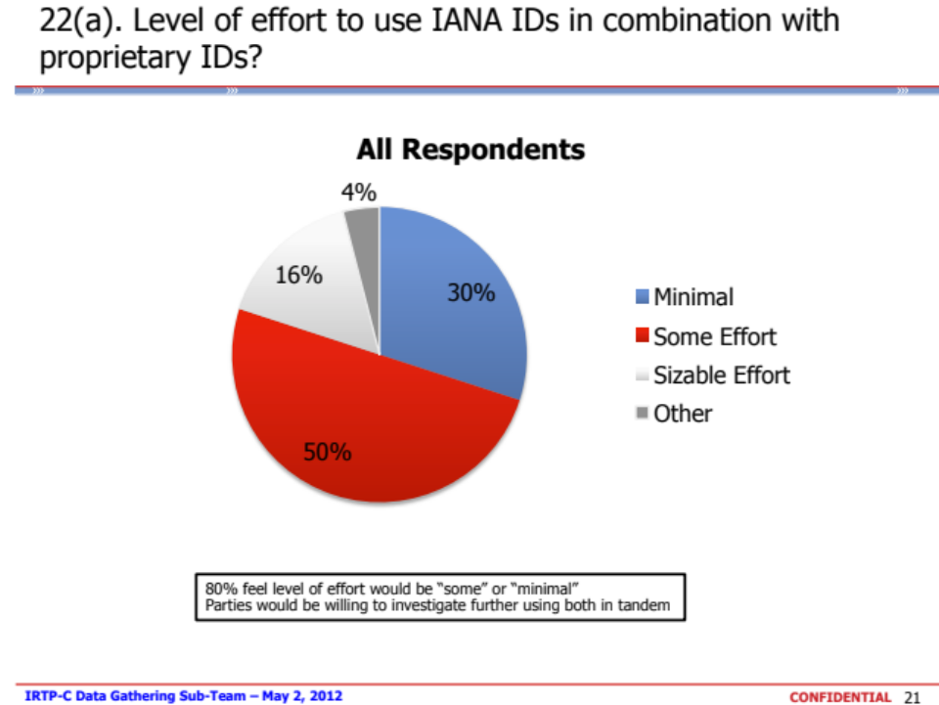
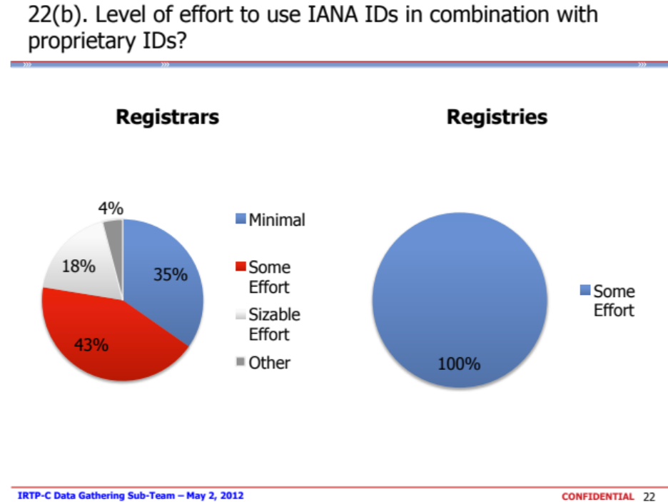
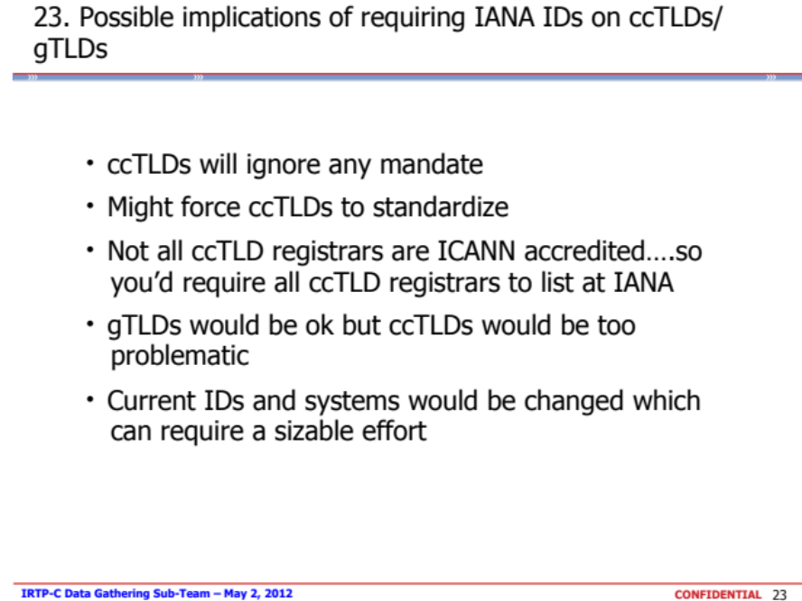
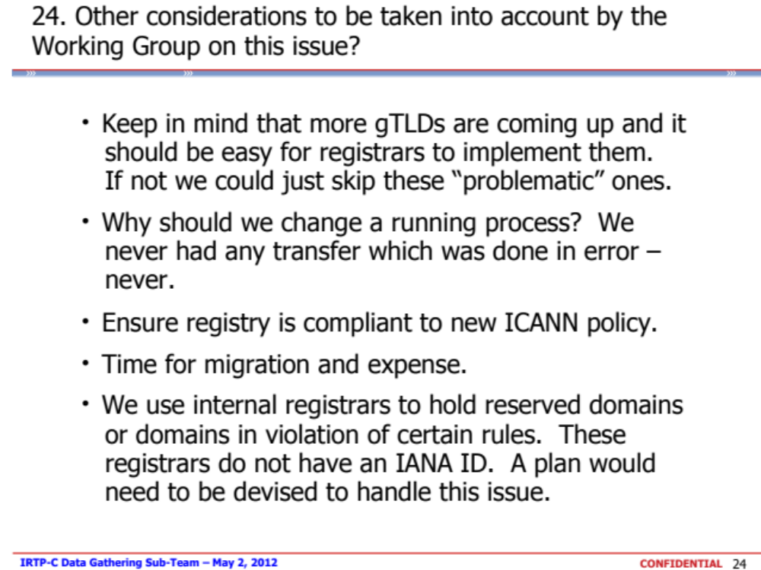

Annex E - STANDARDIZED FORM OF AUTHORIZATION | DOMAIN NAME TRANSFER (GAINING REGISTRAR)
An English version of this message is contained below.
<Insert translation of English version in preferred language of the registrant if known>
ENGLISH VERSION
Attention: <insert Registered Name Holder or Administrative Contact of Record as listed in the WHOIS>
Re: Transfer of <insert one or more domain names>
[OPTIONAL text: The current registrar of record for this domain name is <insert name of losing registrar>.]
<insert name of gaining registrar> has received a request from <insert name of person/entity/reseller requesting transfer>
[OPTIONAL text:] via <insert method of request e.g email address or fax>
[END OPTIONAL TEXT]
on <insert date of request> for us to become the new registrar of record.
You have received this message because you are listed as the Registered Name Holder or Administrative contact for this domain name in the WHOIS database.
Please read the following important information about transferring your domain name:
· You must agree to enter into a new Registration Agreement with us. You can review the full terms and conditions of the Agreement at <insert instructions for accessing the new terms and conditions, e.g. URL where the term and conditions can be found>
· Once you have entered into the Agreement, the transfer will take place within five (5) calendar days unless the current registrar of record denies the request.
· Once a transfer takes place, you will not be able to transfer to another registrar for 60 days, apart from a transfer back to the original registrar,in cases where both registrars so agree or where a decision in the dispute resolution process so directs.
If you WISH TO PROCEED with the transfer, you must respond to this message via one of the following methods (note if you do not respond by <date>, <domain name or domain names> will not be transferred to us.).
[NOTE: a registrar can choose to include one or more of the following in the message sent to the Registered Name Holder or Admin contact, and additional processes may be added with ICANN approval. The order in which options are presented is a decision for each registrar. Further,in addition to the options below, the registrar may choose to request the "Auth-Info" code from the Registered Name Holder or Administrative Contact]
[option 1] please email us with the following message:
"I confirm that I have read the Domain Name Transfer - Request for Confirmation Message.
I confirm that I wish to proceed with the transfer of <insert domain name> from <insert name of losing registrar< to <insert name of gaining registrar>."
[option 2] please go to our website, <insert URL of confirmation webpage> to confirm.
[Note: website to contain text as above, with the option to confirm or deny the transfer]
[option 3] please print out a copy of this message and send a signed copy to <insert fax or postal address details>
If you DO NOT WANT the transfer to proceed, then don't respond to this message.
If you have any questions about this process, please contact <insert contact details>.

Annex F – PRE-AUTHORIZED FORM OF AUTHORIZATION | DOMAIN NAME TRANSFER (LOSING REGISTRAR)
An English version of this message is contained below.
<Insert translation of English version in preferred language of the registrant if known>
ENGLISH VERSION
DOMAIN NAME TRANSFER
Attention: <insert Registered Name Holder or Administrative Contact of Record as listed in the WHOIS>
Re: Transfer of <insert domain name or list of domain names>
<insert name of registrar and/or name of reseller> received notification on <insert date of notification> that you have requested a transfer to another domain name registrar. If you want to proceed with this transfer, you do not need to respond to this message. If this transfer was unauthorized by you or you believe it was done in error, please contact us before <insert date> by:
[NOTE: a registrar may choose to include one or more of the following in the message sent to the Registered Name Holder or Admin contact, and additional processes may be added with ICANN approval. The order in which options are presented is a decision for each registrar]
[optional] send an email to <insert contact details>
[optional] send a fax to <insert contact details>
[optional] or please go to our website <insert URL of confirmation webpage>
[Note: website to contain text as above, with the option to accept or deny the transfer.]

Annex G - Case Studies

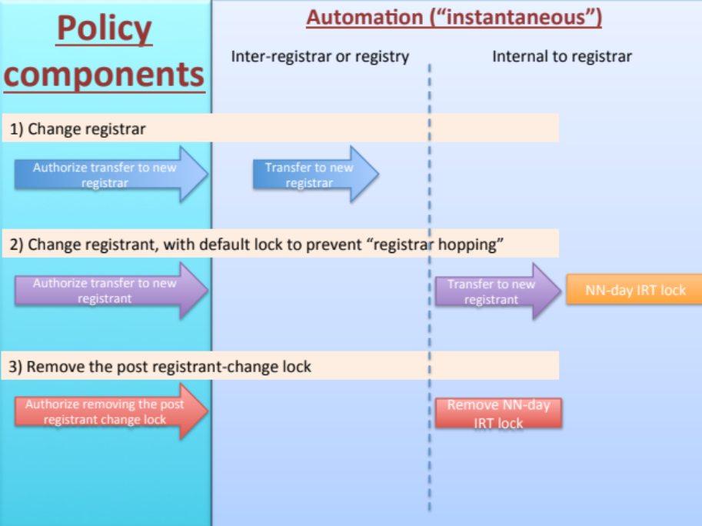
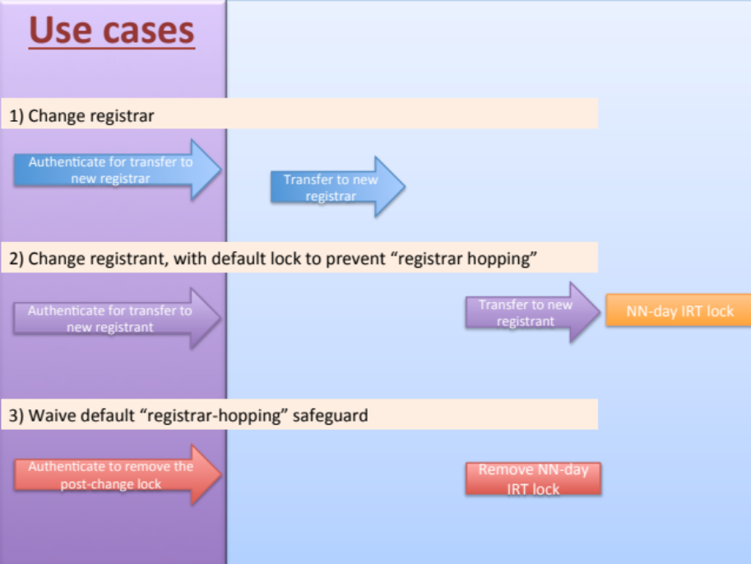
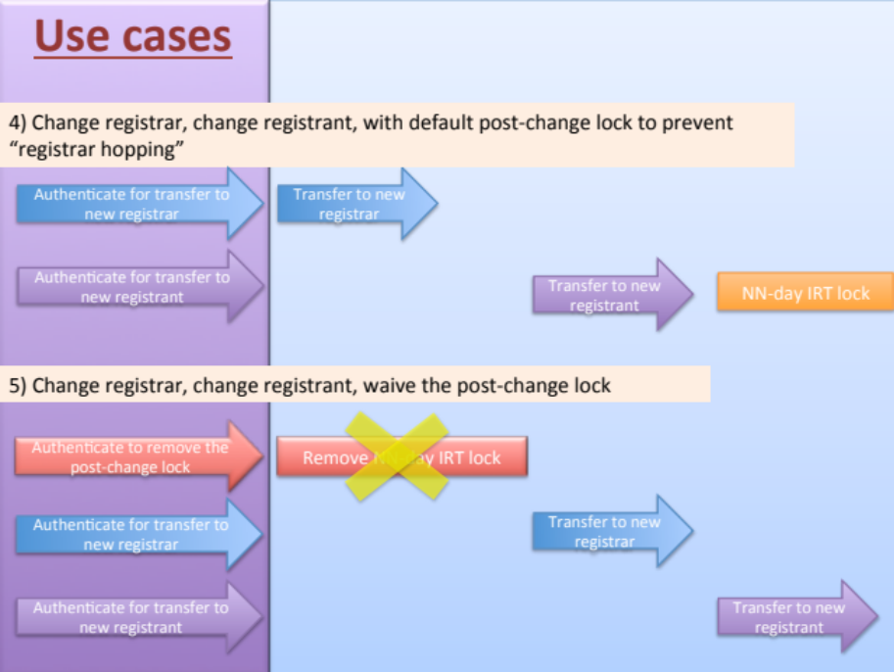

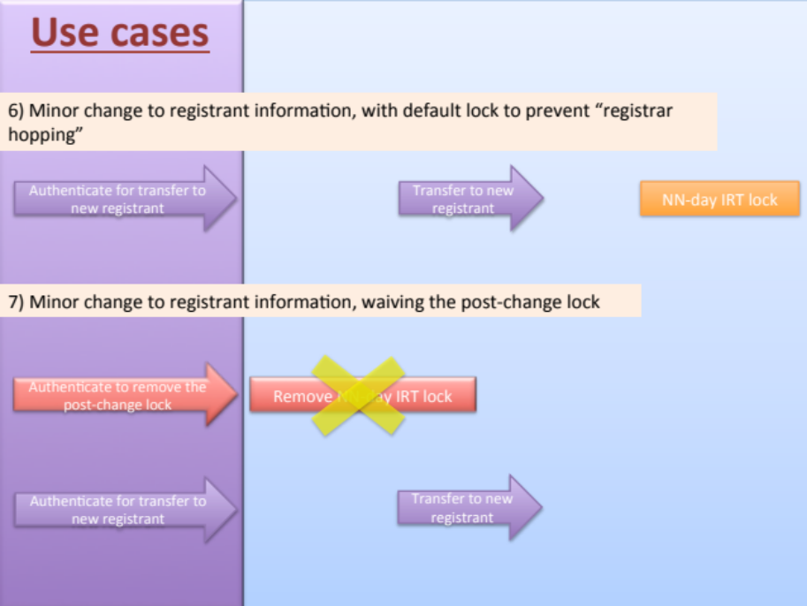

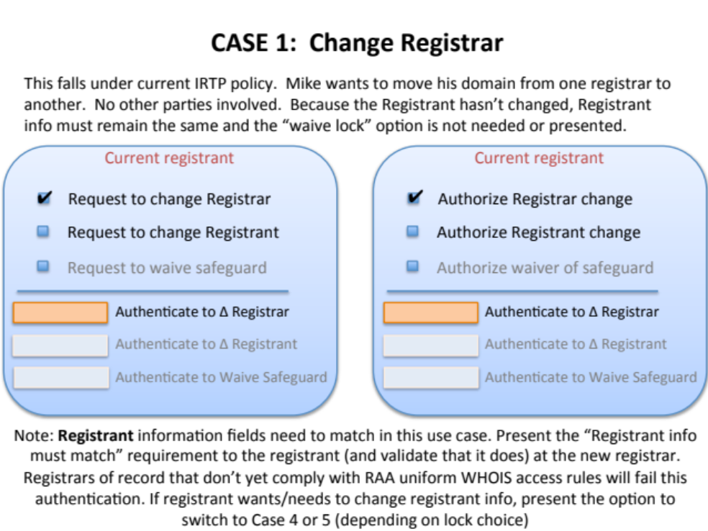

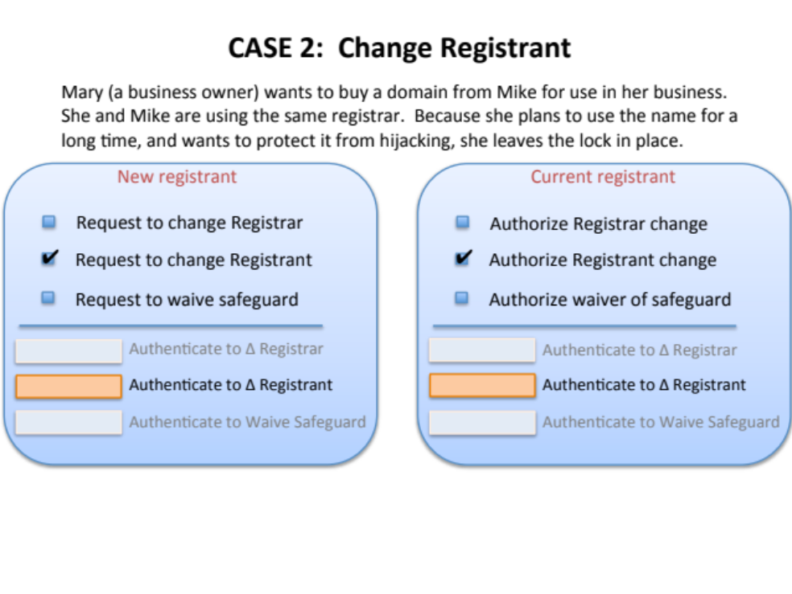

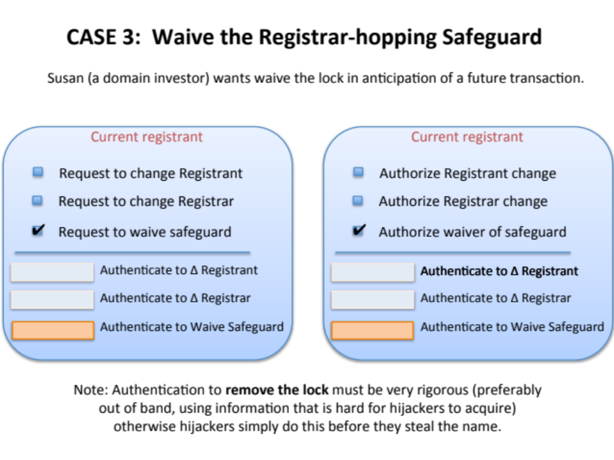

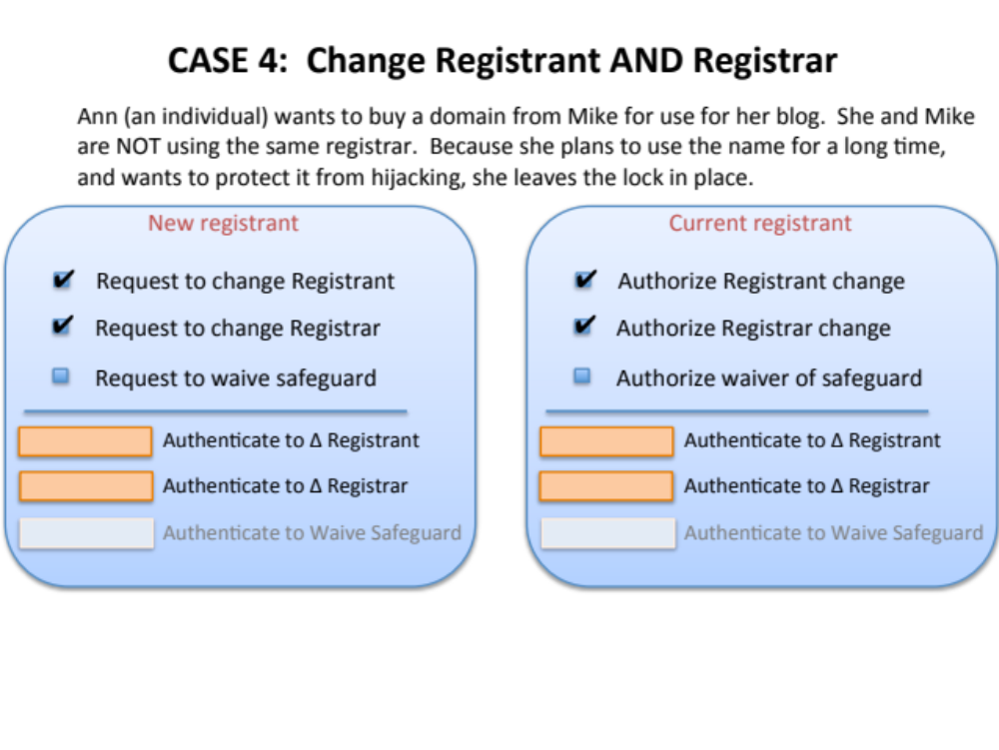
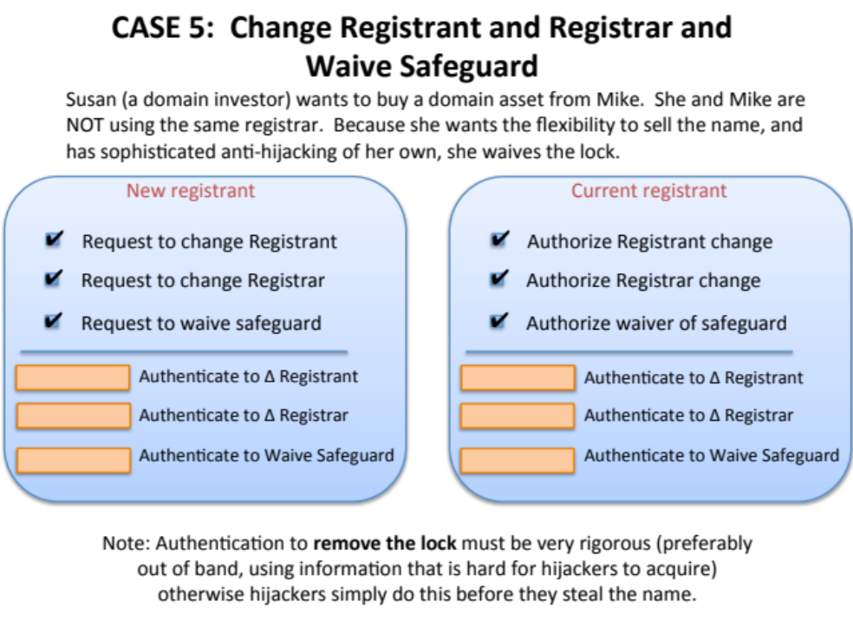

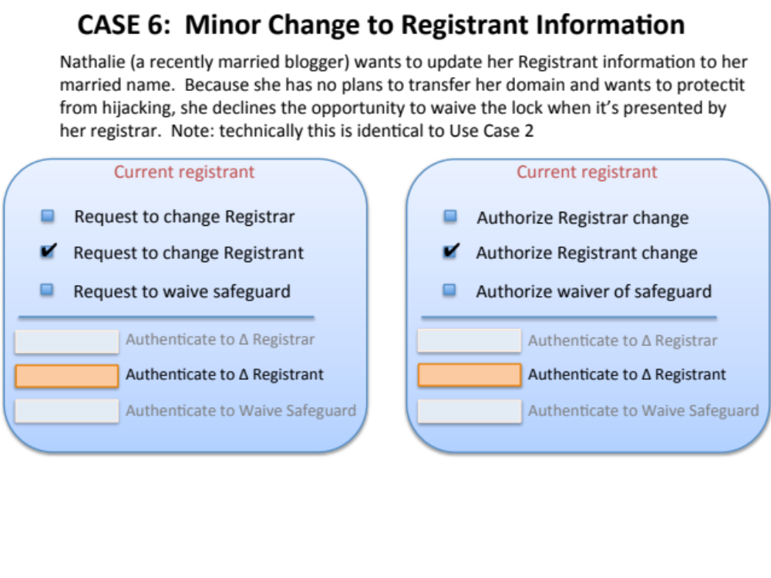
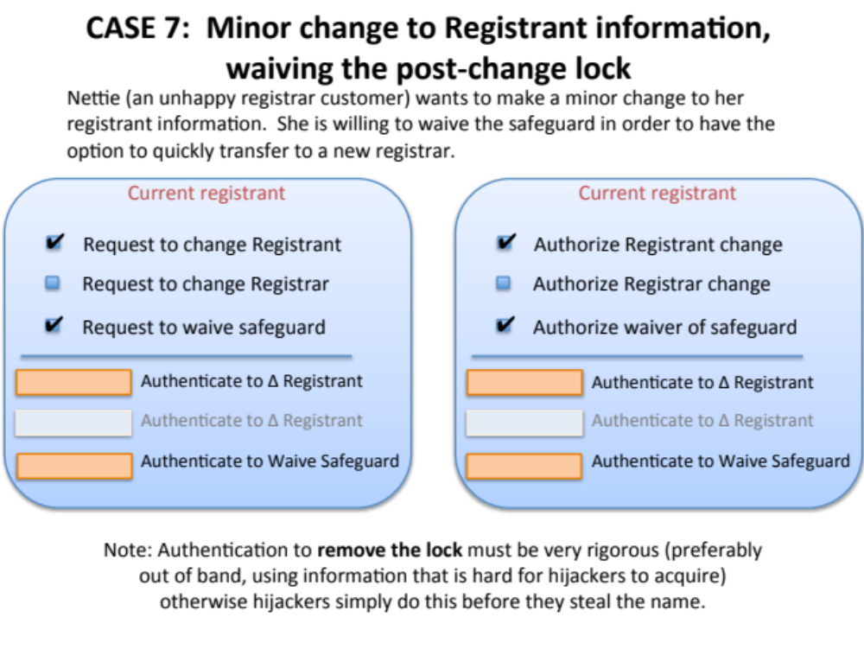

In the context of the change of registrant process, the term Registrant is identical to ‘Registered Name Holder’ as defined in the Registrar Accreditation Agreement (RAA).
Registrar of Record may deny a transfer request if ‘The transfer was requested within 60 days of the creation date as shown in the registry Whois record for the domain name’.
Registrar of Record may deny a transfer request if ‘A domain name is within 60 days (or a lesser period to be determined) after being transferred (apart from being transferred back to the original Registrar in cases where both Registrars so agree and/or where a decision in the dispute resolution process so directs). "Transferred" shall only mean that an inter-registrar transfer has occurred in accordance with the procedures of this policy’.
Multiple inter-registrar transfers of the same domain name registration in a very short period of time
Various registrars lock a domain name registration for a sixty-day period following a change of registrant to prevent hijacking and/or unauthorized transfer of a domain name registration, but this is a registrar lock, which is not linked to the IRTP.
Domain hijacking refers to the wrongful taking of control of a domain name from the rightful name holder (see http://www.icann.org/announcements/hijacking-report-12jul05.pdf).
Recommendation #4: The WG notes that the primary function of IRTP is to permit Registered Name Holders to move registrations to the Registrar of their choice, with all contact information intact. The WG also notes that IRTP is widely used to affect a "change of control," moving the domain name to a new Registered Name Holder. The IRTP Part B WG recommends requesting an Issue Report to examine this issue, including an investigation of how this function is currently achieved, if there are any applicable models in the country-code name space that can be used as a best practice for the gTLD space, and any associated security concerns. The policy recommendations should include a review of locking procedures, as described in Reasons for Denial #8 and #9, with an aim to balance legitimate transfer activity and security. Recommendations should be made based on the data needs identified in the IRTP Part B workgroup discussions and should be brought to the community for public comment. The WG would like to strongly encourage the GNSO Council to include these issues (change of control and 60-day post-transfer lock) as part of the next IRTP PDP and ask the new working group to find ways to quantify their recommendations with data.
It should be noted that the GNSO Council will consider shortly whether or not to initiate a PDP on the review of the UDRP. If a PDP is initiated and a PDP is initiated on IRTP Part C, co-ordination between the two efforts in relation to this specific issue (transfers as a result of UDRP proceedings) might be appropriate.
Registrants presumably file complaints directly with registrars and/or registries prior to escalating the issue to ICANN.
Changed from CBUC to ISPCP on 15 March 2012.
See ‘Transfers of a Domain Name to a New Holder’ (http://archive.icann.org/en/udrp/udrp-policy-24oct99.htm)
Based on the experience with the use cases, the WG concluded that even moderately experienced registrants struggle with this process today as it is considered difficult and confusing as it varies between registrars how a “change of control” can be conducted.
One such problems identified relates to the fact that bad actors are able to transfer the domain name to an unaware registrant without their knowledge, while the registrar / registrant may be held liable for any malicious activity that is conducted using that particular registration.
In the context of the change of registrant process, the term Registrant is identical to ‘Registered Name Holder’ as defined in the Registrar Accreditation Agreement (RAA).
See http://www.iana.org/assignments/registrar-ids/registrar-ids.xml for the most recent list.
In the context of the change of registrant process, the term Registrant is identical to ‘Registered Name Holder’ as defined in the Registrar Accreditation Agreement (RAA).
From the Final Issue Report: “the IRTP is widely used to affect a ‘change of control’, namely by moving the domain name to a new Registered Name Holder, in conjunction with a transfer to another registrar. For example, in the domain name aftermarket it is not uncommon to demonstrate control of a domain name registration through the ability to transfer the domain name registration to another registrar following which the registrant information is changed to the new registrant. Nevertheless, the concept of ‘change of control’ is not defined in the context of gTLDs”.

