Operations Steering Committee

GNSO Operations Work Team

Draft Proposal for GNSO Organizational Structure

ICANN Board Recommendation:

Determine what steps are needed to establish the role of the Council as a “strategic manager of the policy process.”

Proposal

The OSC GNSO Operations Work Team proposes for consideration that the Generic Name Supporting Organization (SO) – as a supporting organization – should establish separate organizational structures within the SO (1) to address its critical policy development and management functions; (2) to oversee “coordination and management” of the SO and (3) to supervise these activities.

Purpose

Consistent with the BGC’s recommendations, the purpose of the division of SO responsibilities is to ensure that appropriate individuals are selected on the basis of their particular skill sets to serve on independent bodies in representation of their respective constituency. The key principle that the Work Team is recommending is that there should not be overlap between the policy development and management functions of the SO and the administration and management of the SO.

Description

According to the ICANN Bylaws and the ICANN Board recommendations on GNSO improvements, the GNSO Policy Council (Policy Council) remains the essential and appropriate entity to oversee the management of policy development, ranging from the new functions of developing policy development mechanisms, to agreeing on the policies that will be sent forward to the Board.

The GNSO Operations Work Team proposes that a new sub-group should be created within the GNSO to take responsibility for the separate and unrelated set of functions that address the coordination of the constituencies for the purpose of ensuring administrative management. The overall administrative tasks of the SO should be simply defined as those that cut across the SO, that is, those that deserve coordination and shared planning. For example, while all constituencies should review and participate in both the strategic and operational/budget planning, this is a cross-cutting topic, not limited to policy development. A well-developed budget will include support for policy development, but not be limited to policy alone. This new sub-group would be comprised of officers (representatives) of the different constituencies designated/elected specifically for this purpose.

In addition, the Work Team proposes that a third, smaller body, the Executive Committee, should be created within the SO to supervise the coordination of the policy management group and constituency administration group. (See Figure 1: Recommended GNSO Structure)

Figure 1: Recommended GNSO Structure
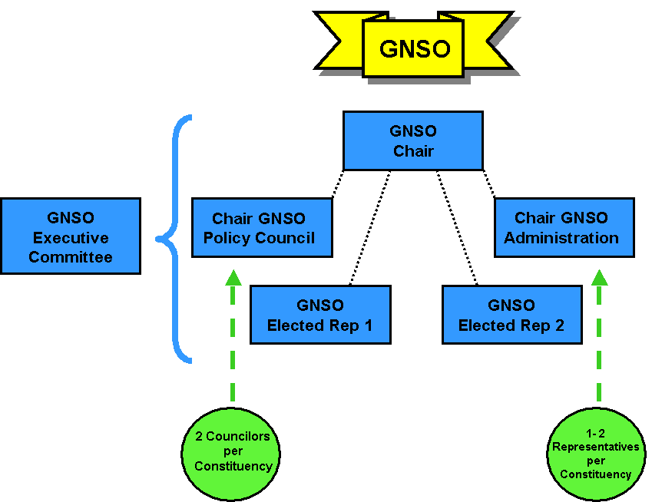

Background

Most GNSO constituencies, in recognition of the different functions to be performed in the “management of the constituency” have already taken the step of separating the function of the policy councilor from management of the constituency, in recognition of the different functions, and the differing expertise. Similarly, by separating the administrative functions from the Policy Council, the Council can focus its time, energy, and expertise on its core functions.

The proposal to separate the Policy Council from a focused administration management team and to provide for coordination through an Executive Committee would improve, strengthen, and enhance the ability of the SO to function as a contributor to ICANN’s overall mission and core values. It also would improve the ability of the Policy Council to focus its work and expertise on its essential assignment of developing policy related to generic top level domains; undertaking any interaction between the SO and the Advisory Committees related to Policy Development; and also deepening the pool and number of “leaders” within the SO, thus helping to strengthen the GNSO overall.

The following is a proposed description of each group:

Policy Councilors

Representing each GNSO constituency Policy Councilors would focus solely on policy development and policy coordination activities, including undertaking the needed outreach within their own constituencies and actively supporting the coordination of the Policy Council with other policy bodies within ICANN. As “managers”, Councilors would concern themselves with matters pertaining to what it takes to fully support Working Groups focused on DNS policy. Focused on process, Councilors would address matters such as succinctly framing the issues; scoping the work for the Working Groups; and identifying the need for economic analyses or not. Increasingly, it is recognized that there is a need for cross-collaboration and communication with other SOs and Advisory Committees, including the GAC and ALAC, regarding policy issues that emerge within the gTLD policy arena. The Policy Council should assume a greater oversight and responsibility for ensuring that there is cross SO coordination (not merely Policy Council/Chair exchange) on issues that are crosscutting in the policy arena. For example, this may include support of jointly planned Policy Forums at the early stages of issues exploration and study. In order to effectively manage policy development work, councilors would need to be close working “partners” with a sufficient number of SO-dedicated ICANN policy staff to ensure that PDP Working Groups are well-staffed, well-informed, and thorough in their documentation. This would ensure an efficient, transparent policy development process.

In addition, the Policy Council would consider and determine a means of studying and examining issues that need addressing, e.g., malicious use/abuse of domain names. This role would ensure that there is a suitable and well-supported issues analysis process; preparation of supporting and informational materials that are then made available widely for public comment; broaden education of the ICANN community about consequential issues as relevant; and would strengthen and deepen the understanding of issues, enabling solutions to be identified more rapidly, and explored thoroughly. Identifying solutions that are drawn from a basis of fact supports ICANN’s core mission and is the bridge to ICANN’s core principle of building consensus.

Examples of suggested Policy Councilor functions, restated, include:
- Policy development and coordination including:
  - Coordinating the activities of working groups focused on gTLD policy, including
    - Framing issues;
    - Scoping work; and
    - Considering the need for economic analysis.
  - Developing a synergistic relationship with SO-dedicated ICANN policy staff to ensure that PDP Working Groups are well-staffed, well-informed and thorough in their documentation;
  - Outreach within constituencies to gather those that are most well-versed in certain topics to participate on specific Working Groups;
- Ensuring cross-SO coordination on cross-cutting policy issues, including:
  - Initiating cross SO, jointly-planned Policy Forums on emerging issues; and
  - Supporting the collaboration of the Policy Council with other policy bodies within ICANN;
- Developing and maintaining an issues analysis process, including
  - Examining horizon issues that will need addressing; developing thorough informational materials to deepen understanding by the greater ICANN community.

Constituency Representatives

The overall administrative tasks of the SO should be simply defined as those that cut across the SO, that is, those that deserve coordination and shared planning. In order to expand the GNSO leadership while supporting the ability of policy councilors to devote their skills and expertise to the critically important functions related to GNSO Policy, ideally each constituency would designate two Constituency Representatives. Two Reps, as opposed to one, addresses time availability, spreads the load, and allows for participation other ICANN fora. Each GNSO constituency would designate/elect for this purpose Constituency Representatives who would represent the constituency and focus solely on the broader, more general coordination, administration and management activities of the GNSO. These responsibilities would include, but not be limited to, outreach, supporting a “program planning” function in support of ICANN face-to-face meetings; guidance on web site enhancement for the GNSO web pages, and general policies that cut across the SO, such as guidance on policies for ICANN support for travel reimbursement. Constituencies would establish their own selection process for these Constituency Representatives, and may designate their elected Constituency chair or choose to elect a separate representative for this function.

Examples of Constituency Representative functions include:
- Analyzing trends;
- Benchmarking policy implementation;
- Outreach to expand the ranks of all current and future GNSO constituencies;
- Travel reimbursement policy;
- Program planning for more effective ICANN face-to-face meetings; and
- Development of general operational or administrative policies that cut across the SO.

Executive Committee

The Executive Committee would supervise the coordination of the policy management group and constituency administration group. In order to ensure that there is reflection on the Policy Council’s priorities, the Chair or Vice Chair of the Policy Council, plus one elected representative of the Council would be invited to sit on the Executive Committee, ex officio. In like manner, the Chair or Vice Chair (ex officio) plus one elected representative of the Constituency Administration group would also serve on the Executive Committee to ensure that administrative prioritization is equally undertaken. This would provide for an Ex Comm made up of five representatives whose sole mandate is to provide supervision of GNSO activities.

Board Governance Committee (BGC) GNSO Review Working Group Report on GNSO Improvements: “Create a set of operating principles for the Council that will allow it to be the strategic manager of the policy development process rather than a legislative body.” p. 37, para. 1.

