Status: Draft
Version: 0.3
11/20/2009
Uniformity of Contracts
Sub-Team Recommendations

Registration Abuse Policies
Working Group
Issue:

Today, the Domain Name Space is experiencing a large degree of varying abuse that threatens the stability and security of the internet. The issues relative to abuse have taken center stage with respect to the ongoing efforts of expanding the domain name space. In December of 2008, a Working Group was formed based upon the GNSO Issues Report on Registration Abuse Policies. The objectives of the Working Group are to gather facts, define terms, and provide the appropriate focus and definition of the policy issue(s), if any, to be addressed, enabling the GNSO Council to make an informed decision as to whether to launch a PDP on registration abuse. One specific objective of the Working Group is to understand variance in contracts and agreements among the market participants and to understand if uniformity could enhance or improve the current market space relative to abuse.

Background:

To meet the challenge of the issue described above, a sub-team was formed within the Registration Abuse Policies – Working Group. This Sub-Team was tasked with the specific topic of contract uniformity relative to abuse as defined by the larger Working Group.

Uniformity of Contracts Sub-Team Charter:

The Uniformity of Contracts (UoC) Sub-Team charter is to conduct abuse dispersion research, identify issues with policy, and develops recommendations, if any, to fully appreciate the current state environment of ICANN sanctioned contracts and agreements, with consideration of the following:
- Understand if registration abuses are occurring that might be curtailed or better addressed if consistent registration abuse policies were established
- Determine if and how {registration} abuse is dealt with in those registries {and registrars} that do not have any specific {policies} in place
- Identify how these registration abuse provisions are {...} implemented in practice or deemed effective in addressing registration abuse
Additional research should be conducted to include the practices of relevant entities other than the contracted parties, such as abusers, registrants, law enforcement, service providers, and so on.

Uniformity of Contracts Sub-Team:

RAPWG Chair: | Affiliation:
Greg Aaron | RyC
Subteam Members: | Affiliation:
Mike Rodenbaugh (Council Liaison) | CBUC
Mike O'Conner | CBUC
Berry Cobb | CBUC
James Bladel | RC
Jeff Neuman | RyC
Marika Konings | ICANN
Margie Milam | ICANN
Gisella Gruber-White | ICANN

Uniformity of Contracts Sub-Team Timeline:

Date | Event
7/6/2009 | UoC Team Initiated at RAPWG Conference
7/9/2009 | UoC Team Formed & Initial Session Scheduled
7/13/2009 | UoC Meeting # 01 – Not Recorded
7/29/2009 | UoC Meeting # 02 – Not Recorded
8/13/2009 | UoC Meeting # 03 - Recorded
8/27/2009 | UoC Meeting # 04 - Recorded
9/9/2009 | UoC Meeting # 05 - Recorded
9/28/2009 | Registration Agreement (ra) Dispersion Matrix and Uniformity Research Presented to RAPWG
10/5/2009 | UoC Meeting # 06 - Recorded
10/24/2009 | ICANN - Seoul
11/17/2009 | Recommendations Report First Draft
11/18/2009 | UoC Meeting # 07 - Recorded
11/23/2009 | UoC Recommendations Report Delivered to RAPWG

ICANN Agreement Landscape:

The following diagram is meant to define scope and visually represent the relationships between parties and the contracts that bind them. Additionally, nested relationships between the agreements themselves are depicted.

Market Participants:
- ICANN
- Registry (Ry)
- Registrar (Rr)
- Registrant
- Hosting Provider
- Internet User

Agreements:
- Registry Agreement (RA)
- Registry Registrar Agreement (RRA)
- Registrar Accreditation Agreement (RAA)
- Registration Agreement (ra)
- Registrar Reseller Agreement (rra)**
- Terms of Service**
- Terms of Use**
- Terms of Agreement**
**Agreements typically not in scope of primary dispersion research

Dispersion Findings:

Code | Agreement | Dispersion Found? | Supporting Data | Appendix | Summary Comments
RA | Registry Agreement | Yes | GNSO Registration Abuse Policies Issues Report | 1 | Significant variance exists across the Registry Agreements. Some TLDs contain abuse provisions within the RA, while others contain the abuse provision in the RRA template nested within the RA. While others contain abuse language within Acceptable Use Policies or Terms of Agreement posted on their respective web site.
RRA | Registry Registrar Agreement | Yes | GNSO Registration Abuse Policies Issues Report | 2 | Not every Registry Agreement contains an RRA Template, and as such, is where the dispersion begins. The Registry Agreements that do contain an RRA, the templates appear to be consistent. However, they lack sufficient abuse definitions and indemnification language to combat abuse.
RAA | Registration Accreditation Agreement | Indirectly | 2009 RAA Gap Analysis | 3 | The RAA is a template agreement for each Accredited Registrar, and as such does not have dispersion. However, the RAA does not contain any provisions relative to abuse definition, nor indemnification to sufficiently combat abuse.
ra | Registration Agreement* | Yes | UofC Dispersion Matrix  &  GNSO Registration Abuse Policies Issues Report | 4 | Across the sample of registrars used in the dispersion research, the structure of agreements did have many similarities, but significant dispersion across agreement titles, standard contract content, abuse content, and lack of abuse content did exist. The agreements themselves were often titled differently, ranging from Registration Agreements to Terms of Service, to Terms of Use, thus blurring scope with “Registration Agreements.” Lastly, location of the agreements on Registrar sites varied greatly.
rra | Registrar  Reseller  Agreement | na | na | - | These agreements were not reviewed for dispersion, but suspect great dispersion in how these agreements are structured
ToS | Terms of Service* | Indirectly |  | - | The use of this legal agreement does vary greatly across all industry participants. For the most part, these types of agreements are out of scope, however, some participants do label Registration Agreements as Terms of Service, and/or, Registration Agreement provisions became sub-sections within ToS agreements.
ToU | Terms of Use* | Not Directly |  | - | “ “
PP | Privacy Policy | na | na | - | none
AGv3 | Applicant Guidebook version 3 | na | na | - | Section within Agv3 relative to malicious conduct <out of scope for dispersion research>
 | * Registrars vary greatly in how agreements are titled

Conclusions & Guiding Principles:

Over the course of UoC meetings and research findings, reoccurring themes developed with consistent agreement leading to consensus and defined boundaries for recommendations that the sub-team created.

Dispersion & Consistency
- The UoC team acknowledges that uniformity does not exist among “RA, RRA, RAA and ra” agreements relative to abuse provisions, and the team is of the belief that increased uniformity is important for the marketplace and helps promote equal competition.
- While perfect uniformity is not realistic, it should be striven for when and where feasible.
- At the same time, the team also recognizes that lack of uniformity complicates mitigation efforts, but is not a predicate for abuse that we see today.
- If policies are consistent, then greater responsibility to enforce the policy consistently falls upon ICANN.

Abuse Provision Baseline (APB)
- The sub-team agrees that if any sort of uniformity in agreements is to be implemented, a minimal baseline of provision or language would be the best method to accommodate the various business models
- A lowest common denominator (minimum requirement) approach with abuse provisions is best and allows market participants to not be constrained by exceeding minimums in efforts to promote differentiation within the competitive landscape.
  - The team recognized the spectrum of abuse provisions can range from:
    - General language with broad powers to act against all kinds of abuse or
    - Specific language which can be limiting; and may not be adaptive to changing conditions
  - Finding the right balance of language that provides adequate authority to respond to abuse with adequate protection from lawsuits is required
  - A “One size fits all” kind of provision that can anticipate future or unknown abuses is the “Desired Model,” but the team does recognize variance among business types.
- Any APB should be clearly communicated and shared with market participants and that high degrees of transparency is required where participants choose to exceed any baselines or minimums that are established.

To Be Continued……
- The sub-team agrees that outcomes from any future and not yet determined Registration Abuse Policies PDP, will be long coming and that in the mean time it would be a useful thing for ICANN, Registries, and Registrars to develop abuse provisions and/or continue to enhance abuse provisions for their agreements with continued voluntary, proactive enforcement as necessary. Additionally, the team agrees that the investigation and deployment of best practices will be a great interim step until such a PDP is complete. “Let’s not let best stop us from getting better.”

Recommendations:

Recommendation 1: Create Abuse Provisions Baseline for Agreements
To meet the sub-team’s first guiding principle is to recommend that a portion of a greater Registration Abuse PDP be formed to develop a minimal baseline of agreement provisions regarding domain abuse. The Abuse Provision Baseline (APB) should include a broad definition of abuse combined with adequate indemnification to combat said abuse for the legitimate market participants.

An example of an APB is referenced in Appendix 5, at the end of this document. The example provided leverages language in use today by a few market participants, and it also includes definitional content created by the larger RAPWG. The example provided in Appendix 5 is just that, “An Example.” It is not meant to influence what the actual language of the APB should one be developed in a PDP.

The APB recommendation is tightly coupled to Recommendation 2, as it will influence the structure and content of the APB. Therefore the implementation of the APB may require a combination of solution paths. Not only should a PDP be considered, but leveraging the existing RAA Working Group activities and the RSEP processes should also be considered to ensure blanket coverage across all agreements.

Level of Consensus:
___Unanimous consensus position
___Rough consensus position (a position where a small minority disagrees but most agree)
___Strong support but significant opposition

WG Members in Support:
- Name 1
- Name 2

Minority view(s):
Minority statement goes here.

WG Members in Support:
- Name 1
- Name 2

Recommendation 2: Deployment Scope Definition & Implementation
The UoC team agrees and recommends that deployment of a consensus built APB should cover all agreements within the span of ICANN control (RA, RAA, RRA, ra). While each agreement has different objectives, provisions and parties, the model of the APB should be at a generalized level to accommodate business model differences.

The reason for this recommendation being separate from Recommendation 1 is to prevent a failure or disagreement in scope deployment from the APB itself. As an example, the consensus may form the deployment scope to only include RAAs.

As referenced in Recommendation 1, implementation of the APB may require a combination of solution paths. Not only should a PDP be considered, but leveraging the existing RAA Working Group activities and the RSEP processes should also be considered to ensure blanket coverage across all agreements.

Level of Consensus:
___Unanimous consensus position
___Rough consensus position (a position where a small minority disagrees but most agree)
___Strong support but significant opposition

WG Members in Support:
- Name 1
- Name 2

Minority view(s):
Minority statement goes here.

WG Members in Support:
- Name 1
- Name 2

Recommendation 3: Consistent & Dependable Channel to Report Abuse
This recommendation is most likely out of scope for the Uniformity of Contracts Sub-Team. However, in the spirit of uniformity around our discussions of dispersion in agreements, it became clear that there was no known uniform or global method to report abuse. Therefore, this recommendation is more of a suggestion to the larger RAPWG in that this team should review the “current state” for reporting abuse and the viability of developing a consistent and uniform way for the Internet Community to submit abuse complaints.

A model for reference is the Internet Crime Complaint Center (IC3), http://www.ic3.gov/default.aspx

Level of Consensus:
___Unanimous consensus position
___Rough consensus position (a position where a small minority disagrees but most agree)
___Strong support but significant opposition

WG Members in Support:
- Name 1
- Name 2

Minority view(s):
Minority statement goes here.

WG Members in Support:
- Name 1
- Name 2

Recommendation 4: Development of Best Practices to Combat Abuse
The ICANN method is consensus driven, bottoms-up approach to policy development that in many ways is reactionary and slower to respond to market conditions. To separate Policy Development from Execution, the recommendation is asking market participants to take a voluntary and proactive approach to combating abuse.

The indisputable success of PIR (.org) & Affilias (.INFO) efforts should be commended. Further, the practices should be studied, bundled, and packaged for use by all legitimate market participants. Therefore and because the RAP PDP could be a long time coming, a formalized case study should be commissioned on PIR & Affilias to develop a set of best practices that all market participants can begin to voluntarily execute. The best practice framework should consist of Contract Language, as well as, specific actions to combat the abuse and the deployment of the best practices should be leveraged any of the competency centers within the industry. Due diligence of cost and resource requirements associated with any implementation of best practice should be performed prior to execution.

Up until formal consensus policy changes are adopted by the industry, this recommendation is meant to act as a “best practice” in which market participants can volunteer to adopt this language in mitigating and preventing domain abuses.

Level of Consensus:
___Unanimous consensus position
___Rough consensus position (a position where a small minority disagrees but most agree)
___Strong support but significant opposition

WG Members in Support:
- Name 1
- Name 2

Minority view(s):
Minority statement goes here.

WG Members in Support:
- Name 1
- Name 2

Questions to Complete:

This section will be removed upon completion. The intent is to provide an inventory of items left open and to be considered in the final version of this recommendation report.

- Would we want this abuse provision baseline to be considered in new gTLDs?
  - Yes, ….
- What are the advantages and disadvantages of uniformity?
Role | Pros | Cons
Registrars
Registries
Registrants
First Responders
Criminals / Bad Actors
Law Enforcement
Victims

- Will it or can the abuse provision baseline, “APB” apply across all jurisdictions?
  - ???
- How do we determine which abuse agreement provisions experience the greatest success in combating abuse?
  - At this point, we don’t. This will require a high degree of detailed research and data acquisition across all market participants.
- What market conditions could or will occur with uniformity changes?
  - ???
- What are the side-effects or possible unintended consequences to uniformity?
  - ???
- If uniformity is the desired state how will the changes be monitored & enforced?
  - By ICANN Compliance Team and ????
- What are impacts to liability and changes to indemnification to uphold ICANN abuse provisions?
  - Indemnification provision is included in recommendation #1. Liability implications still remain a risk for false positives when taking action against abuse
- The group’s next task is to understand if registration abuses are occurring that might be curtailed or better addressed if there was more uniformity.
  - YES – if at the very least, a message will be sent that the community and ICANN is serious about mitigating and preventing abuse. But more importantly, consistent language in dealing with abuse better arms market participants to fight said abuse with adequate indemnification
- Greg A - Do all registrars have contractual language that allows them to suspend domain names for unacceptable and/or illegal activities? (I have occasionally had registrars claim that their local laws prevent them from suspending domains. Is this true? Are there registrars that are obligated by law to enter into arbitration or other procedures before they can suspend a domain name? It would be interesting to learn if registrars in some jurisdictions do not have the right to set and enforce relevant contractual terms of service at their discretion.)
  - Certainly the dispersion found among various types of agreements shows that not all registrars contain the necessary provisions that provide adequate indemnification. Further research is required to gain adequate visibility at a jurisdiction level.
- Greg A - Are there major abuses that are not addressable under the various registrars' contracts? (Any glaring holes?) For example, do they allow suspension of maliciously registered phishing and malware domains? Do your recommend that some registrars' contracts or ToS be more explicit about what they consider abusive?
  - ???
- Greg A - If one has a Terms of Service in one's contract, it does not mean that one must apply or enforce it. In other words: a registrar will suspend a domain if and when it wants to. (Court orders etc aside.) Is the issue that a registrar does not have the authority, or is the issue that the registrar does not exercise it? Can ICANN require a party to suspend a domain name?
  - ???
Appendices:

Appendix 1 – Registry Agreement (RA) Dispersion:

Refer to the GNSO Issues Report on Registration Abuse Policies
Section 4 - Provisions in Registry Agreements relating to abuse
Pages 11 - 29
http://gnso.icann.org/files/gnso/issues/registration-abuse/gnso-issues-report-registration-abuse-policies-29oct08.pdf

Appendix 2 – Registry Registrar Agreement (RRA) Dispersion:

Refer to the GNSO Issues Report on Registration Abuse Policies
Section 4 - Provisions in Registry Agreements relating to abuse
Pages 11 - 29
http://gnso.icann.org/files/gnso/issues/registration-abuse/gnso-issues-report-registration-abuse-policies-29oct08.pdf
RRA Templates are contained within the RA and hence the analysis is combined with appendix 1.

Appendix 3 – Registrar Accreditation Agreement (RAA) Dispersion:

Because the RAA is template driven, a quick inventory of Registration Abuse Types (as defined by the RAPWG) was conducted within the RAA template instead of a formal dispersion study. Two RAAs exist. A version from May 2001 existed until the most recent May 2009 version was released. With over 80+% adoption rates by Registrars to the May 2009 version, it was the only RAA reviewed for dispersion.

http://www.icann.org/en/registrars/agreements.html

The May 2009 RAA does contain provisions that align with abuse types defined by the Working Group. These include WhoIS, UDRP, and Privacy language. However, the latest RAA does not contain any language relative to take-down, conduct & use, abuse definitions, and indemnification to protect parties from taking action against abuse.

In parallel to the RAPWG, a Working Group to enhance the RAA is underway. It is the UoC’s intent to share any recommendations that appear to align with RAA WG actions. Based on the latest presentations from ICANN Seoul, WG members have already identified gaps around Malicious Conduct, Cybersquating, Privacy/Proxy Services, and complete information disclosure with Affiliates & Resellers.

Appendix 4 – Registration Agreement (ra) Dispersion:

Refer to the GNSO Issues Report on Registration Abuse Policies
Section 5 - Provisions in Registration Agreements relating to abuse
Pages 30 - 37
http://gnso.icann.org/files/gnso/issues/registration-abuse/gnso-issues-report-registration-abuse-policies-29oct08.pdf

Registration Agreement (ra) Dispersion Study

An evaluation of publicly available online agreements (Domain Registration Agreement, Universal Terms of Service, etc..), from a representative sample of registrars was performed to determine the degree of variation among agreement provisions relative to abuse. This evaluation, essentially, is an inventory of sections within the registration agreement. It attempts to quantify “current state” for the purpose of providing a visual representation of dispersion.

By review of the various registration agreements, sections began to naturally form in to forty or so categories in which the registration agreements could be inventoried. For each of the 22 Registrars, from the representative pool, an Excel spreadsheet was used to track the binary existence of each agreement category. If a category was found, the spreadsheet would be incremented accordingly, and if the section was relevant to abuse, the corresponding agreement language was pasted in to the spreadsheet. If no section was found, the category requirement was not met, nor was it incremented.

It should be noted, that this was not a compliance exercise, and as such, all results shared are anonymous. The representative sample of registrars is based on % market share of held registrations per webhosting.info as of June 2009. Within that sample, a general guiding principle for selection of the 22 registrars was the top, middle, and bottom market participants. This sample of 22 Registrars makes up approximately 59% of total market share. Additionally, the sample also attempts to gain representation across varying countries.

The actual spreadsheet and presentation reports can be found at the UoC Wiki Attachments section:
https://st.icann.org/reg-abuse-wg/index.cgi?uniformity_sub_team
RAPWG-UofC_Dispersion_Matrix_09152009.xls
RAPWG-UofC_Report_09152009.pdf

The diagram here shows a screen shot of a Registration Agreement (ra) on the left. Each red arrow points to a defined section within the agreement. On the right side of the diagram are the categories that formed from the inventory. Those labeled in the blue boxes pertain to the abuse types within scope of the RAPWG.

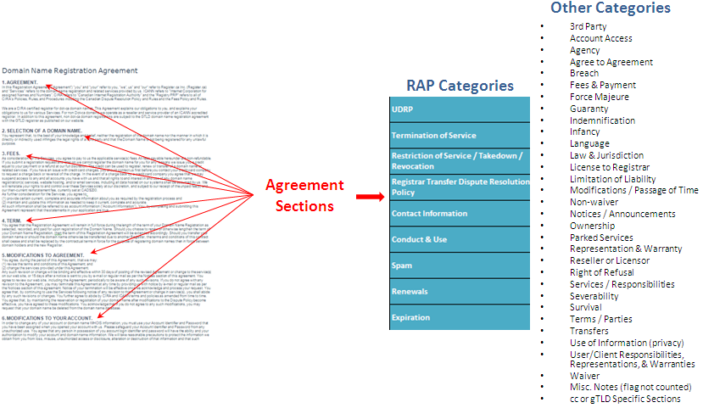

This screen shot represents the entire spreadsheet used to inventory Registration Agreement sections across the 22 Registrars. The zoom here is at 10%. This screen shot also includes those categories not relevant to abuse, and as such will not show pasted language from the agreement.

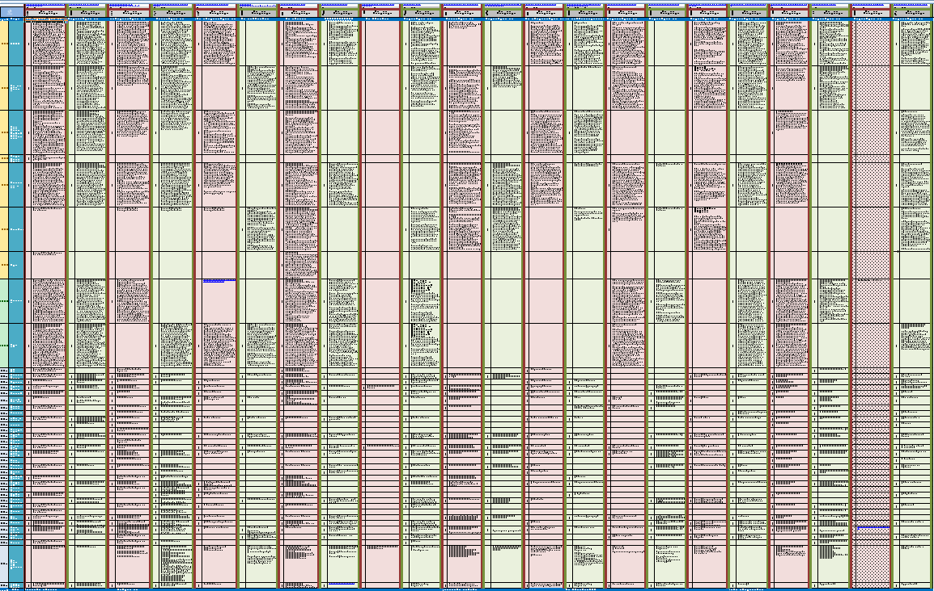
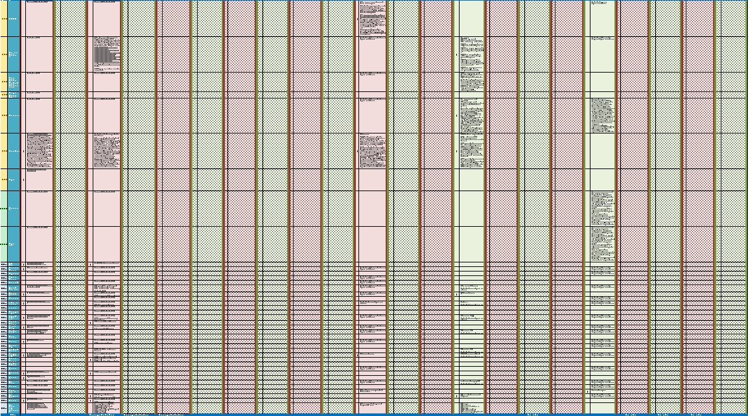
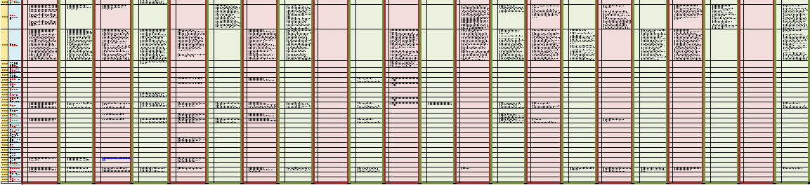
This screen shot represents a summary view of the previous spreadsheet. The legend is listed below, but basically the variance between the green and yellow coloring depicts the dispersion found within agreements relative to abuse. The gray section to the right provides “hit rate” percentages of agreement sections by region and overall. Please refer the UoC Wiki for the actual reports to zoom in and gain a clearer understanding.

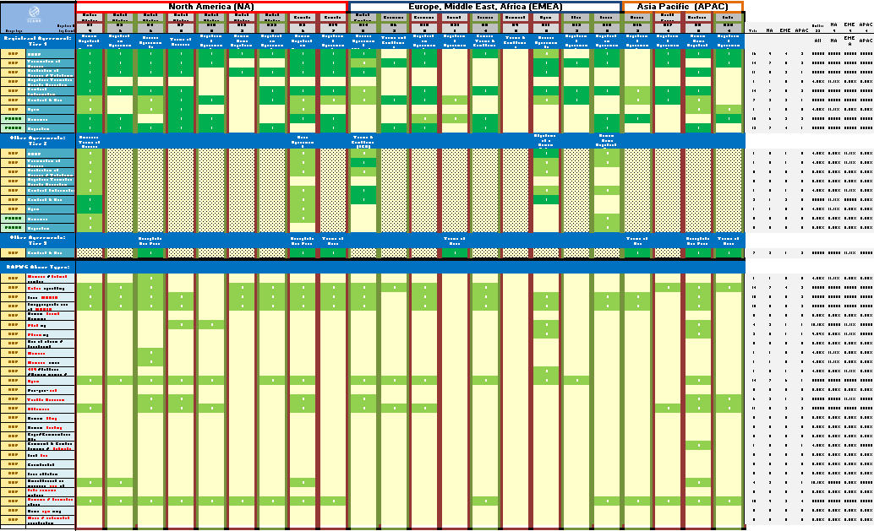
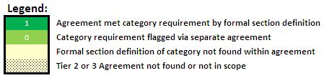

The chart below provides a different view at the dispersion across Registration Agreements. The Y Axis represents the number of categories where the agreement satisfied the formal section definition requirements while the X Axis represents registrars by region, sorted highest to least (left to right).

This chart represents categories with the greatest achievement of section definition.

Appendix 5 – APB Example:

Definition of Abuse
  - Abuse is an action that: --- (source: RAP – WG Definition; DRAFT Only!)-----
    - Causes actual and substantial harm, or is a material predicate of such harm, and
    - Is illegal or illegitimate, or is otherwise considered contrary to the intention and design of a stated legitimate purpose, if such purpose is disclosed.
  - Domain abuse creates security and stability issues for the registry, registrars and registrants, as well as for users of the Internet in general. <Registry> defines abusive use as the wrong or excessive use of power, position or ability, and includes, without limitation, the following: --- (source: .info Domain Anti-Abuse Policy)-----
    - Illegal or fraudulent actions;
    - Spam: The use of electronic messaging systems to send unsolicited bulk messages. The term applies to e-mail spam and similar abuses such as instant messaging spam, mobile messaging spam, and the spamming of Web sites and Internet forums. An example, for purposes of illustration, would be the use of email in denial-of-service attacks;
    - Phishing: The use of counterfeit Web pages that are designed to trick recipients into divulging sensitive data such as usernames, passwords, or financial data;
    - Pharming: The redirecting of unknowing users to fraudulent sites or services, typically through DNS hijacking or poisoning;
    - Willful distribution of malware: The dissemination of software designed to infiltrate or damage a computer system without the owner's informed consent.
    - Examples include, without limitation, computer viruses, worms, keyloggers, and Trojan horses;
    - Fast flux hosting: Use of fast-flux techniques to disguise the location of Web sites or other Internet services, or to avoid detection and mitigation efforts, or to host illegal activities. Fast-flux techniques use DNS to frequently change the location on the Internet to which the domain name of an Internet host or name server resolves. Fast flux hosting may be used only with prior permission of Affilias;
    - Botnet command and control: Services run on a domain name that are used to control a collection of compromised computers or "zombies," or to direct denial-of-service attacks (DDoS attacks);
    - Distribution of child pornography; and
    - Illegal Access to Other Computers or Networks: Illegally accessing computers, accounts, or networks belonging to another party, or attempting to penetrate security measures of another individual's system (often known as "hacking"). Also, any activity that might be used as a precursor to an attempted system penetration (e.g., port scan, stealth scan, or other information gathering activity).

Indemnification - --- (source: .info Domain Anti-Abuse Policy & .org RRA - 3.6 Additional Requirements for Registration Agreement/3.65)-----
- Pursuant to the RRA, <Registry> reserves the right to deny, cancel or transfer any registration or transaction, or place any domain name(s) on registry lock, hold or similar status, that it deems necessary, in its discretion; (1) to protect the integrity and stability of the registry; (2) to comply with any applicable laws, government rules or requirements, requests of law enforcement, or any dispute resolution process; (3) to avoid any liability, civil or criminal, on the part of <Registry>, as well as its affiliates, subsidiaries, officers, directors, and employees; (4) per the terms of the registration agreement or (5) to correct mistakes made by <Registry> or any Registrar in connection with a domain name registration. <Registry> also reserves the right to place upon registry lock, hold or similar status a domain name during resolution of a dispute. Abusive uses, as defined above, undertaken with respect to <TLD> domain names shall give rise to the right of <Registry> to take such actions under RRA in its sole discretion.

