GNSO WHOIS Technical Requirements Survey
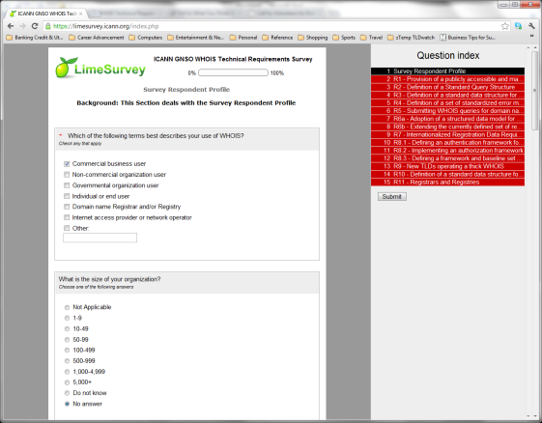
The Generic Names Supporting Organization (GNSO) Council's WHOIS Survey Working Group (WSWG) invites the Internet community to participate in a survey designed around an inventory of WHOIS technical components. The survey aims to measure the level of support for various technical requirements outlined in the WHOIS Service Requirements Report, as requested of ICANN Staff by the GNSO Council. The survey consists of 15 sections around 11 technical requirements, and it will be made available until 31 October 2012. Afterwards, the WSWG will produce a final report and deliver it to the GNSO Council toward the end of 2012. The report will describe the results of the survey and any agreed upon recommendations by the WG for the GNSO Council’s consideration concerning WHOIS. Survey attributes are as follows:
- Survey Availability Date: 13 September 2012
- Survey Address: https://limesurvey.icann.org/index.php?sid=71483&lang=en
- Survey Close Date: 31 October 2012, 23:59 UTC
- Survey Language: English only
The survey is lengthy and therefore the option has been made available to create an ID and return to the survey at a later time to complete it. The survey tool will save all answers completed from the time the survey was last accessed. It is important that if the participant leaves the survey before submission or creation of an ID, the session may time-out with increased of risk losing answers.
Many sections of this survey will require a high degree of technical skill around WHOIS. If the participant feels that they may not understand a question or not possess the technical knowledge to answer it appropriately, then the participant is welcome to skip the question and move on to the next one. If completing the survey for an organization, the participant may wish to engage more technical personnel to help complete all sections of the survey.
The WSWG appreciates your participation and the working group looks forward to sharing the final results with the community. Please feel free to inform others about the availability of this survey to assist the working group with maximum participation.
If questions arise about the survey or the tool, please contact the GNSO Policy Team at: policy-staff@icann.org.

