WHOIS Technical Requirements Survey
Final Report

STATUS OF THIS DOCUMENT
This Final Report explores the WHOIS Survey Working Group’s (WSWG) recommendations regarding a survey conducted about possible technical requirements of a future WHOIS service solution.

SUMMARY
This final report is published in response to a request from the GNSO Council pursuant to a resolution adopted on 6 October 2011 (see – Motion 8 at http://gnso.icann.org/meetings/minutes-council-06oct11-en.htm).
Table of Contents
1. Executive Summary 3
2. Objective and Next Steps 4
3. Background on WHOIS Technical Requirements 5
4. Survey Results Analysis 7
5. Working Group Recommendations 56
6. Next Steps 57

Executive Summary
1.1 Objective
- This report is published in response to a request by the GNSO Council for a report and analysis on a survey about possible technical requirements of a future WHOIS Service. The objective for the Working Group is to develop a set of proposed recommendations around the measurement of support of proposed technical requirements.

1.2 Background
- In May 2009 the GNSO Council asked ICANN staff to compile a comprehensive set of requirements for WHOIS that included known deficiencies in the current service and “any possible requirements that may be needed to support various policy initiatives that have been suggested in the past”.
- ICANN staff produced a report compiling an Inventory of WHOIS Service Requirements on 29 July 2010 and delivered the report to the GNSO Council. The report essentially distilled policy discussions and other activities, into technical requirements that would be necessary to correct deficiencies and implement various policy proposals.
- On 6 October 2011 the GNSO convened a Working Group to draft, implement, and analyze the results of a survey measuring the level of support for various technical requirements as outlined in the final Inventory of WHOIS Service Requirements Report of 29 July 2010.
- After eight months of drafting, the WG produced a draft version of the technical requirements survey and opened a public comment forum to solicit feedback from the community. All feedback was submitted through the draft survey itself as hosted by the open-source survey software of Lime Survey. After consideration of community input and the implementation of the Lime Survey software within the ICANN IT infrastructure, the survey was made available to the community on 13 September 2012.

1.3 Survey Results Analysis
- The survey consisted of 15 sections around the 11 technical requirements defined in the inventory report, and it was made available to the community until 31 October 2012.
- Survey Macro-level Stats (This report only considers the “Full Responses” in its analysis):
  - Total responses: 247
  - Full responses: 67
  - Incomplete responses: 180 (20 Saved, not submitted)

1.4 Working Group Recommendations
- Recommendation 1: Deliver the results of the WHOIS Technical Requirements Survey to the International Engineering Task Force (IETF) for their consideration in developing a new WHOIS protocol based on the RESTFUL platform (http://datatracker.ietf.org/wg/weirds/).
- Recommendation 2: Deliver the results of the WHOIS Technical Requirements Survey to the Expert Working Group on gTLD Directory Services, as formed by the ICANN Board in early 2013 (http://www.icann.org/en/news/announcements/announcement-14feb13-en.htm).
- Recommendation 3: Deliver the results of the WHOIS Technical Requirements Survey to the Thick WHOIS Working Group, as formed by the GNSO Council late 2012 (http://www.icann.org/en/news/announcements/announcement-14feb13-en.htm).

1.5 Next Steps
- The WSWG Working Group will send the Final Report to the GNSO Council. The GNSO Council is now expected to review and deliberate the WG’s Analysis and Recommendations at its next Council Meeting and take actions as appropriate, if any.

Objective and Next Steps
This report is published in response to a request by the GNSO Council for a report and analysis on a survey about possible technical requirements of a future WHOIS Service. The objective for the Working Group is to develop a set of proposed recommendations around the measurement of support on proposed technical requirements.

Background on WHOIS Technical Requirements
In May 2009 the GNSO Council asked ICANN staff to compile a comprehensive set of requirements for WHOIS that included known deficiencies in the current service and “any possible requirements that may be needed to support various policy initiatives that have been suggested in the past”. This effort was started given the wide community discussions about WHOIS service along with its history and capabilities to meet expansion demands like Internationalized Domain Names (IDN). ICANN staff produced a report compiling an Inventory of WHOIS Service Requirements on 29 July 2010 and delivered the report to the GNSO Council for their consideration. The report essentially distilled policy discussions and other activities, into technical requirements that would be necessary to correct deficiencies and implement various policy proposals. The report was not intended to define or suggest the policies or operational rules that should apply, but only a technical inventory of requirements that may address policy issues.

After deliberation by the GNSO Council, it was resolved on 6 October 2011 that the GNSO convene a Working Group of interested volunteers to draft, implement, and analyze the results of a survey measuring the level of support for various technical requirements as outlined in the final Inventory of WHOIS Service Requirements Report of 29 July 2010. The WHOIS Survey Working Group (WSWG) formed shortly after the GNSO Council resolution and drafted its charter instructing the WG to describe the results of a survey and recommendations for next steps for the GNSO Council’s consideration concerning the WHOIS service requirements.

After eight months of drafting effort, the WG produced a draft version of the technical requirements survey and opened a public comment forum to solicit feedback from the community. All feedback was submitted through the draft survey itself as hosted by the open-source survey software of Lime Survey. Each comment was reviewed by the Working Group and if adopted, the suggested change was incorporated into the final version of the survey. After consideration of community input and the implementation of the Lime Survey software within the ICANN IT infrastructure, the survey was made available to the community on 13 September 2012.

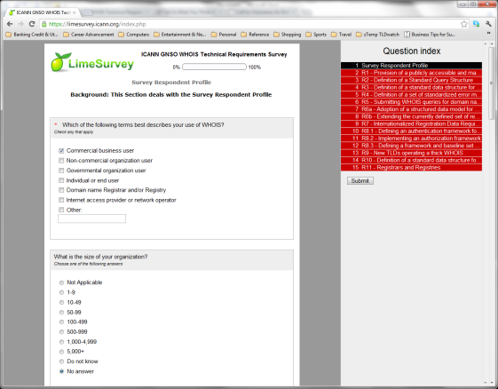
The survey consisted of 15 sections around the 11 technical requirements defined in the inventory report, and it was made available to the community until 31 October 2012. The survey was lengthy and therefore the option to create an ID and return to the survey at a later time was made available. Many sections of this survey required a high degree of technical skill around WHOIS and in some cases participants either did not complete the survey, only completed answers they felt they could answer leaving difficult ones blank, or they reached out to colleagues with technical skill to complete it. Statistics of the survey reach can be found in the next section, as well as, an analysis of service requirement results in the subsequent sections of this report.
Figure 3A: screenshot of the survey

Terminology and Conventions
- WHOIS protocol – refers to the elements of the (standard) communications exchange—queries and responses—that make access to registration data possible, as specified in RFC 3912.
- WHOIS Data – refers to the information that individuals or organizations (“registrants”) submit when they register a domain name. Domain name registrars or registry operators collect these data, and some of the data is made available for public display or for use by applications.
- WHOIS Service – refers to the service(s) offered by registries and registrars to provide access to (potentially a subset of) the Whois Data. ICANN Accredited gTLD registries and registrars are required by contracts to provide the Whois Services via both port 43 and through a web interface.

The terminology used in this document differs slightly from the SAC 051 terminology. Our rationale for deviation from SAC 051 terminology is because the WHOIS requirement survey and the subsequent efforts precede SAC 051, and change the terminology would lead to confusion.

Finally, by default the word “WHOIS” refers to WHOIS service.

Survey Results Analysis
4. 1 Survey Results Summary – Macro View
Total responses: | 247
Full responses: | 67
Incomplete responses: | 180 (20 Saved, not submitted)
Average interview time: | 38 min. 55 sec.
Median: | 25 min. 30 sec.

This report only considers the “Full Responses” in its analysis. While there was a large volume of incomplete responses, none of them were complete enough to include in the overall results without impacting certainty of the completed responses. Another consideration when reviewing the survey results should consider the significant “No Answer” responses. Given the size and complexity of the survey, the WG made the decision to not include logic within the survey that forced answers to complete any given section. The WG recognized that some participants may not have access to the knowledge to complete certain answers, and applying any restriction would only have decreased our completed participation rate.

To view the survey, a PDF can be found on the WSWG page:
http://gnso.icann.org/en/group-activities/active/whois-requirements
http://gnso.icann.org/en/issues/whois/whois-technical-requirements-survey-13sep12-en.pdf

4. 2 Survey Results Summary – Macro View
The following list is an extract from the Inventory of WHOIS Service Requirements report.
- R-1: Provide a publicly accessible and machine parsable list of domain names or IP locations of WHOIS servers operated by ICANN accredited registrars and gTLD registry operators and ccTLDs operators.
- R-2: Define a standard query structure that clients can implement and that all gTLD registries and ICANN accredited registrars will support.
- R-3: Define a standard data structure for WHOIS responses. The data structure would contain and uniquely identify the data elements that must be returned in a manner that assures there is no ambiguity across elements, correct syntax, and correct semantics.
- R-4: Define a set of standardized error messages and standard handling of error conditions. Examples of useful error messages include queries exceeding the limit, no records found, unable to process query, etc.
- R-5: Allow users to submit not only domain names as arguments to search functions but other registration data elements as well.
- R-6a: Adopt a structured data model for WHOIS data that provides extensibility and changeability properties. Employ a formal data schema language such as XML to describe the characteristics of the structured data.
- R-6b: Consider extending the currently defined set of registration data elements to include: alternative forms of contact than the contacts currently collected; information that discloses the history or “pedigree” of a domain; and additional registration service provider contact information.
- R-8.1. Define an authentication framework for WHOIS that is able to accommodate anonymous access as well as verification of identities using a range of authentication methods and credential services.
- R-8.2: Implement an authorization framework that is capable of providing granular (per registration data object) permissions (access controls).
- R-8.3: Define a framework and baseline set of metrics that can accommodate future policy development for auditing of WHOIS access.
- R-9: All new TLDs should operate a thick WHOIS. Consistent with these recommendations for future WHOIS, new or legacy registries should consider evolving to a thick WHOIS.
- R-11: Registrars and registries should provide and publish abuse point of contact information as an element of a domain registration record. There are several ways this could be supported; for example, registrars could populate the current sponsoring registrar contact information with an abuse point of contact rather than a general purpose business contact; alternatively, an abuse identifier that serves as an index into a publicly accessible table of abuse points of contact could

When reviewing each of the detailed results within the remainder of this report, each survey question that asked a yes/no question format will show the overall percentage result, and it will also include a “two proportion test” to measure statistical significance of the “yes” and “no” responses at a 95% confidence interval. This test determines whether two populations differ significantly based on a single characteristic. A “Z Test calculator” was used to make the calculation. Each survey question of the yes/no type will include the Z-Score and the p-value. Essentially, any instance where the p-value is greater than 0.05 the result can no longer be considered statistically significant. More general information about this statistical test can be found online.

4. 2 R0 - Participant Profile
In development of the survey, the WSWG felt it was important to gauge certain attributes about the survey participants as it may be a valuable reference in analyzing the various technical requirements. Such attributes that were measured include:
- Affiliation and size of the organization
- Country location
- Experience with registration of domain names
- General Purpose for accessing and using WHOIS Service

Summary of Results:
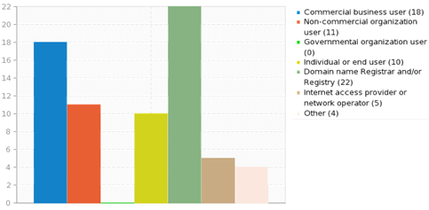
In review of the 67 completed responses, it appears that the participants ranged widely across affiliation and organization size. Commercial and non-commercial organization types of entities are well represented, in addition to the largest respondents belonging to contracted parties. Governmental organizations were the one entity type not represented among the participant pool. Location of the participants was another attribute tracked. 45% or 35 of respondents were from the United States, while the remaining was international. The second largest pool was from European countries.

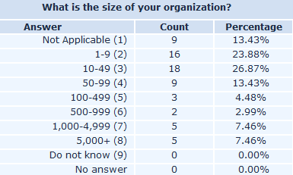
Organization size of the participants was predominantly organizations of 50 persons or less, however responses from medium and large companies did occur. Virtually all respondents had experience with registering both ccTLD and gTLD domain names. However, a little less than a quarter of them selected an answer of “Not Applicable.” It is difficult to specify the reason for why this answer was chosen. The general purpose of domain registrations, as answered by the respondents, was fairly balanced between commercial, non-commercial, and personal uses. 40 of the 67 entries or almost 60% selected “Commercial” with 42% and 39% selecting “Personal” or “non-Commercial” respectively.

Nearly 75% of the respondents access WHOIS services at least weekly; just over 60% accessing via “Direct server query access.” 30% or 20 of the participants accessed the services like Domain Tools or Registrar/Registry services via a web browser.

Participants were also asked what were the reasons or the most beneficial uses of WHOIS:
Answer | Count | Percentage
To determine if a specific domain name is unregistered or available (1) | 34 | 50.75%
To find out the identity of a person or organization responsible for a domain name or web site (2) | 54 | 80.60%
To support technical operations of ISPs or network administrators, including tracing sources of spam or denial of service attacks (3) | 31 | 46.27%
To identify the owner of a domain name for consumer protection or intellectual property protection purposes (4) | 27 | 40.30%
To gather names and contact information for marketing purposes (5) | 3 | 4.48%
To support government law enforcement activities (other than intellectual property) (6) | 8 | 11.94%
To monitor and manage groups of domains for self or on behalf of others (7) | 14 | 20.90%
Other | 7 | 10.45%
Other responses:
- To identify a contact address (preferably email) for the domain holder (I don't care about their "identity" merely their contact details)
- Investigation
- Transfers
- Check our WHOIS-service
- Scientific research about the Internet
- For Verification purposes
- To facilitate inter-registrar transfers
- To find IP address of name server

34% or 23 of the Respondents stated they maintain a WHOIS service as a Registrar, Registry Operator or a Regional Internet Registry. Over 80% of these responses stated that the service was custom developed in-house over using open-source solutions. The following names were listed as solutions used:
- mod_whois
- anadol
- internic.net
- Windows
- RIPE WHOIS
- net4 Whois server
- pwhois
- ATLAS
- whois.denic.de

4. 3 R1 - Provision of a publicly accessible and machine parsable list of domain names of WHOIS servers
The WHOIS Service Requirements report stated that no authoritative list existed of WHOIS servers although whois.nic.tld is a common naming convention. In today’s environment there is no easy way to determine the domain names and IP addresses for a given TLDs WHOIS services. Further, the report stated that a significant increase in gTLDs could contribute to this issue.

Requirement #1: This Section deals with the provision of a publicly accessible and machine parsable list of domain names or IP locations of WHOIS servers operated by ICANN accredited Registrars, gTLD Registry Operators, ccTLDs Operators and others.

Summary of Results:
The first question for this section asked if “The WHOIS Requirements Inventory identifies the need for a publicly-accessible and machine-parsable list of domain names or IP locations of current, operating Registry, Regional Internet Registry and Registrar WHOIS servers. Do you have a direct need for this list of WHOIS servers?” Only the 67 fully completed responses were considered:
Answer | Count | Percentage
No, do not have a use case for a list of WHOIS servers | 15 | 22.39%
No, use pre-existing WHOIS tools and libraries and thus don't directly need such a list | 11 | 16.42%
No, we would not use this list for the reason stated in the comment box | 1 | 1.49%
No, have written our own WHOIS clients and would not use such a list | 1 | 1.49%
Yes, have written our own WHOIS clients and would use such a list | 19 | 28.36%
Yes, we would use this list for the reason stated in the comment box | 12 | 17.91%
Comments | 13 | 19.40%
No answer | 8 | 11.94%
Free-form Responses:
- While we generally use the web interface today, it would be a convenience to have direct access for any future WHOIS client we may build.
- Sufficient for registry to publish its WHOIS server location somewhere on its web page
- I would use such a list to find a safe, authoritative server to reduce the risk of using a WHOIS server that was recording my queries and using them in some other way (like front-running)
- maintaining multiple private lists of servers will not scale when there are thousands of gTLDs.
- domain transfer registrant/admin email parsing for the gtld and cctlds that require we the registrar obtain email authorization to request a transfer
- I would very much like to create a custom Whois tool in order to more easily access this across the various territories my organisation operates.
- for making queries more easily
- It's critical that WHOIS information is accurate and traceable
- would query WHOIS location, but a list would be too static.
- Being able to easy identify what WHOIS servers handle a specific TLD.
- scientific research
- domain ownership verification, buying of domains, re-selling domains, website ownership verification, authentication purposes.
- We need the list of WHOIS servers in order to determine where to locate the contacts for a domain in order to perform an inter-registrar transfer of a domain.
- Enforce thin WHOIS starting at the well known anchor whois.iana.org. This server should provide the list and point down to the next server in the hierarchy.
- we do not need it atm, but might want to venture into WHOIS client land. and we also state the need for all those who maintain WHOIS clients.
- for locating owners to either buy a site or, if it's used for phishing or PPC purposes or similar, plus copyright infringement, so we can get in touch
- We would create a client if this list was created. Ideally, it would be distributed in XML or something similarly easy to adapt.
- we would build a client if such a list existed.

The second question of the section asked respondents to identify their favorite for WHOIS Service discovery. Name conventions, use of SRV records, and CNAME records were options to consider by the 67 participants.

The inventory of requirements suggests a number of possible approaches for WHOIS service discovery. Please identify your favorite:
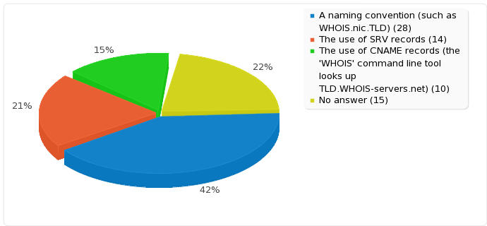
Free-form Responses:
- SRV records are probably a better choice for larger entites, however we would also be okay with a naming convention.
- Much less intrusive than other methods
- I prefer a naming convention because it would be easier for non-technical end-users to use.
- SRV records are already well deployed in the ccTLD world, avoid the need for "magic names" in the DNS, and support load balancing which will improve the quality of the service for the consumer.
- Anything you can do in javascript and with wget
- The resposability is with the owner of the information, and there's no name pollution.
- My number two would be the use of CNAME records.
- Please consider to support both domain name WHOIS and IP addresses/AS numbers WHOIS, as well as the case different organizations run each. Maybe whois.LIR.NIR.RIR.arpa for IP addresses/AS numbers?
- CNAME is too much information, all we are asking for is the name of the owner and his current residence and contact info, email will suffice.
- Enforce thin WHOIS starting at the well known anchor whois.iana.org. This server should provide the entries for the TLDs.
- SRV is the proper way to tie services to domain names that do not always directly point to hosts. The other suggestions are hacks.

In general, there is an even split of the survey results between those that support a centralized list versus those that would have no use, noting that a majority of those not supporting a list use pre-existing WHOIS tools and libraries.

4. 4 R2 - Definition of a Standard Query Structure
Requirement #2: This Section deals with the definition of a standard query structure that clients can implement and for which all gTLD Registries and ICANN accredited Registrars can support. A Standard Query refers to creating a consistent format/structure for asking a WHOIS service a question and it allows this service to consistently interpret the questions submitted.

Summary of Results:
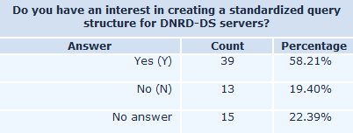
The first question for this section of the survey started by asking participants if they had interest in having a standardized query structure for WHOIS. 58% of the respondents supported a defined structure, and the result is statistically significant at 95% confidence interval (two proportion test, the Z-Score is 4.6091. The p-value is 0).

Participants were then asked to select options of what they considered the best proposed benefits of a standard query structure. Easier access (48) and greater accuracy (33) were the two most selected responses with easy access being classified by participants as the most important attribute of the four options.
Favorite Attribute
Available Attribute
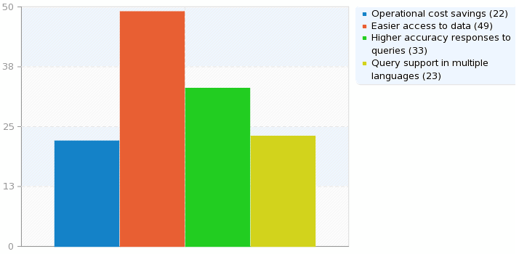
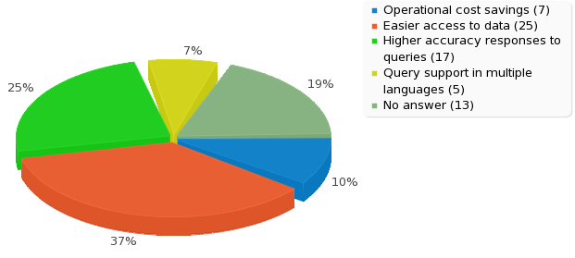

Survey participants were then asked:
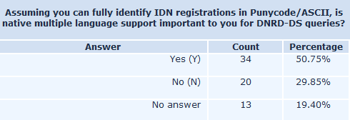

50.7% of the participants responded that it is important for WHOIS queries to offer language support. The result is also statistically significant with 95% confidence interval (The Z-Score is 2.4657. The p-value is 0.00676)
Lastly, survey participants completed a “Most Important (1)” to “Least Important (5)” scale about standardization of searchable WHOIS queries:
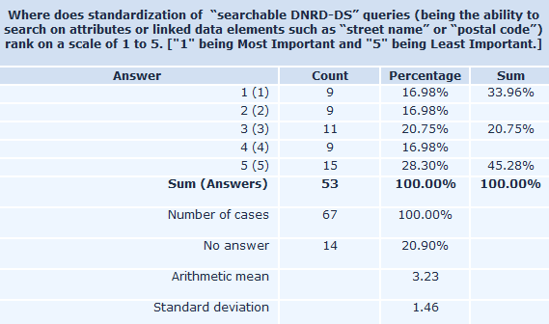

Ultimately the results of the survey show support for a standard query structure and that the standard should support native multiple languages. Such conclusions are consistent with findings in various SSAC documents (e.g. SAC 51); currently the Internet Engineering Task Force (IETF) who is working on a replacement protocol is defining a standard query structure.

4. 5 R3 - Definition of a standard data structure for WHOIS responses
As noted from the WHOIS Service Requirements report, WHOIS responses are generally unstructured creating challenges for interpretation and parsing. “Standard data structure” refers to a standard format or structure of information provided by a WHOIS service in response to a submitted query (question). Requirement #3 of the survey deals with the definition of a standard data structure for WHOIS responses. The data structure would contain and uniquely identify the data elements that must be returned in a manner that assures there is no ambiguity across elements, correct syntax, and correct semantics.

Summary of Results:
Participants were first asked whether they supported a standardized data structure for WHOIS responses. From the 67 responses, 55 stated they supported a standard data structure (statistically significant, two proportion test, z=8.3163, p=0.000). 48 of the 67 responses also supported a formal extension framework so that implementers of WHOIS can add additional data elements to the standard structure and schema for WHOIS (statistically significant, two proportion test, z=7.006, p=0.000). The results also showed, 47 of 67 that participants were equally supportive of a data structure that will allow for interpretation or output of WHOIS responses to non-English or non-Latin languages and scripts (statistically significant, two proportion test, z=7.6506, p=0.000).
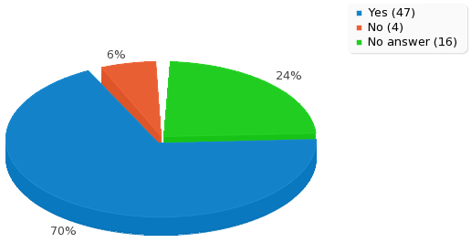
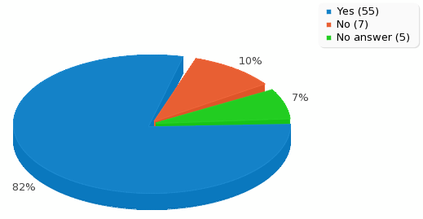
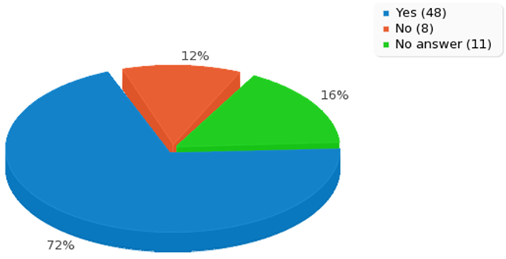
Responses non-English/Non-Latin
Formal Extension Framework
Standard Data Structure

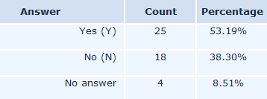
For those participants that selected “Yes” to supporting WHOIS responses in non-English, non-Latin scripts, participants were asked if the interpretation or output from WHOIS responses be based on localization of the client software. The comments diverge on this issue and not statistically significant (two proportion test, z=1.2954 p=0.0968). The results are displayed in the table to the right:
Non-English, non-Latin Script
Conversely, participants that answered “No” to supporting non-English, non-Latin scripts were asked to provide free-form reasons for why:
Free-form Responses:
- As a registrar we have already problems to read/understand some IDN. How should we read/verify a domainname's data if we cannot understand it (for example to ensure the WDRP)?
- standard
- As all sections of the RAA, WHOIS data should be required to be in English.
- not needed
- i think English is an Universal language.

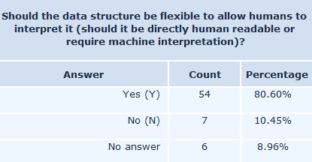
Next, survey participants were asked about humans interpreting the WHOIS output and whether program parcing should be allowed. In both cases, well over 70% of the responses indicated support with a statistically significant 95% confidence interval.
two proportion test z=8.1531, p =0.000
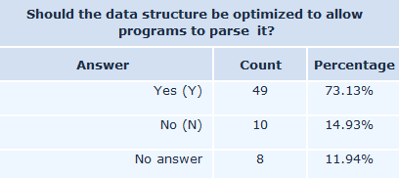
two proportion test z=6.7867, p =0.000

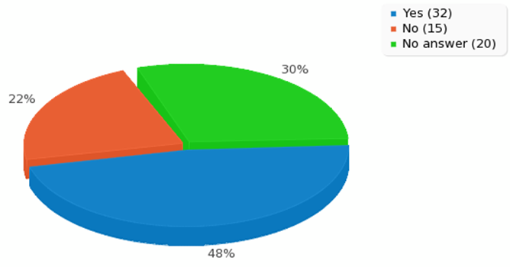
Lastly, Participants were asked whether the data structure should be XML based and if their answer was no to provide reasons or other possible solutions:
Should the data structure be XML based?
Free-form Responses:
- Plain text multiple formats
- While I don't entirely disagree with the use of XML, I think some other options should be avaliable. For example, a simple .csv format with first record field names could be a fine and simple format.
- I'm not in favor of machine-readable WHOIS - it will encourage spam
- json is better suited
- The current way registries do it is easy. Name value pairs like Registrant Name: Joe Smith
- XML has its advantages, but is complex. A WHOIS scheme should be as simple as possible. Imho.
- Allows Commercialization
- JSON is better.
- ewafds
- XML is heavyweight and inefficient, not sure what best alternative is.
- JSON, please
- XML is not human readable.
- We recommend JSON. The IETF WEIRDS working group has settled on JSON, and we support that effort.
- XML is hard to read. json plz?

two proportion test z=3.0775, p =0.00208
4. 6 R4 - Definition of a set of standardized error messages and standard handling of error conditions
The WHOIS Service Requirements Final Report noted that no standard set of error messages is defined for WHOIS servers, and WHOIS servers may handle errors differently. Requirement #4 of the survey dealt with the definition of a set of standardized error messages and standard handling of error conditions. Examples of useful error messages include number of queries exceeding the WHOIS server’s limit, no records found, unable to process query, etc.

Summary of Results:
Participants were asked about whether they support the use of standardized error messages as output from the WHOIS system. They were also asked to provide free-form examples of such error messages. 84% of the participants (statistically significant, two proportion test, z=9.0337, p=0.000) showed support for this technical feature.
Do you support the use of standardized error messages as output from the WHOIS System?
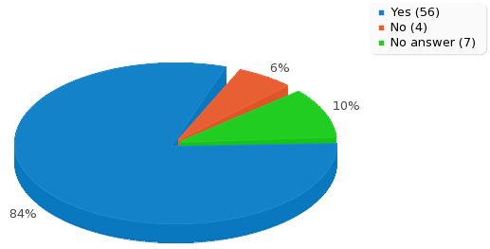
Free-form Responses:
- No records found
- 404
- Logically, there could be some data which may exist for the registrars only. Using an HTTP like set of responses for data may be helpful in understanding why certain data is unavailable.
- Query limit reached: please try your query again later
- - warning: more than one domain matches your search criteria - error: your search did not result in any matching domain names - error: your query contains invalid character - warning: too many results
- The WEIRDS group plan to use the existing HTTP error semantics. If these were backported to port 43 WHOIS that would be acceptable. If not, then a extensible "code plus message" would be acceptable.
- 404 domain not found
- Error 505 Domain Not Registered Here
- % ------------------------------------------------- % status: registered % -------------------------------------------------
- error 1 = common cause 1 error 2 - common cause 2 similar to email NDR or HTTP responses
- Character disallowed, incorrect tld, banned query (rate control)
- CGI The specified CGI application misbehaved by not returning a complete set of HTTP headers.
- No entries found for the selected source. No second-level domain. Invalid request. You have exceeded allowed connection rate. Sorry. Server busy.
- WHOIS data unknown, invalid or non-existent
- If HTTP, http codes are enough. Also for redirection, possibly data missing, or no authorized to get data.
- Standardized messages should be fields in JSON responses. Not language-specific
- sdc
- "you are mining the WHOIS database, please stop"
- Locked On Hold Deleted Redemption Period etc...
- Domain not found
- Similar to HTTP code: numeric code with basic explanation and series based on the high level number
- 404 domain does not exist
- incomplete command query not found query result - zero
- No record found matching &quot;Microsoft.com&quot;. Number of WHOIS queries allowed has been exceeded.
- % NOTFOUND: Entry not found. % DENIED: Access denied due to legal restrictions. % FUCKUP: System is down, sorry.
- not allocated server internal problem payment required
- No Record Found, Incomplete domain name entry, gTLD Not Found
- not found connection error
- No records found
- % No entries found for ...
- The approach that HTTP designers took to defining http status codes allows for future changes without disrupting existing clients. For example, each http status code belongs to a class signified by th
- The documentation should be available and the implementation should follow the documentation
- number of queries exceeding the WHOIS server's limit no records found unable to process query
- No idea what a standardized error message should be. Error messages should be clear and understandable and in case of an identical error identical.

Next, participants were asked if they supported the use of standardized handling of error conditions within a WHOIS system. 67% of the respondents (The Z-Score is 7.1448. The p-value is 0) indicated that they did support this feature.
Do you support the use of standardized handling of error conditions within the WHOIS System?
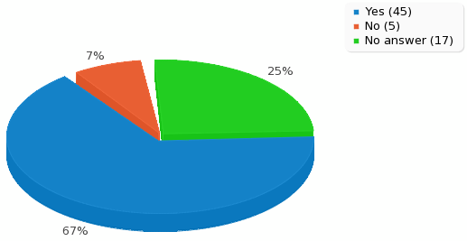
Free-form Responses:
- Server botnetted
- Well, you might want to banish robots from scarfing down WHOIS data without prior authorization.
- Query limit exceeded - message to user to try again later (This page is very confusing btw)
- - no results - too many results - invalid input - invalid formatting of input
- standard error codes such as 404 domain not found
- Service not available. Too many requests for your IP.
- The Expendables 2
- misspells, mistypes in upsatream parsed data, limits exploitation
- Same as above
- dxzdSc
- Data not found, the registry change. Domain offline
- uppercase lowercase sensitive WHOIS garbage in -out , encoding problems , end line character problem, partial domain or contact/host/name server information / WHOIS server is under load, default time
- inability to find queryd domain unable to validate domain WHOIS
- Quota exceeded. Language character set mismatch.
- What are error messages *within* a system?
- No Record Found
- Connection error
- The conditions and the messages overlap, so we would see the consistent handling of error conditions like queries for non-existent objects and queries for data that the client is not authorized for as

4. 7 R5 - Submitting WHOIS queries for domain names
Searching a WHOIS Service provided by Registrars or Registries is offered by searching the domain name data element only. The WHOIS Technical Survey Requirement #5 questions measured the interest of expanding search queries of WHOIS beyond the domain name (such as “Street” or “Registrar”). Survey respondents were also presented questions about expanded search options of language and technical capabilities to gauge significance of advanced services.

Summary of Results:
Of the survey respondent replies, 67 completed the section fully. Over 53% respondents indicated positive interest in advanced search options of WHOIS; whereas, nearly 30% stated it was unnecessary (statistically significant, The Z-Score is 2.8024. The p-value is 0.00512). Generally, there is interest to expand search options. However, considering only slightly more than half of the fully completed surveys answered “Yes” and nearly 30% answered “No”, advanced searching of WHOIS is not overwhelmingly supported.
Answer | Count | Percentage
Yes (1) | 36 | 53.73%
No (2) | 20 | 29.85%
Other | 8 | 11.94%
No answer | 3 | 4.48%
Free-form Responses:
- Commonly held domain names
- some data elements - e.g. location (broadly defineed, e.g. by city)
- could be interesting
- since WHOIS is used by agreesive and non compliant country registrys and registrars, I am limited on what information I would like to see made public
- not necessarily
- ip addr, as number
- On a limited basis and only allowed at the registry, not the registrar.
- For a limited number of data elements

The additional search capabilities most often requested were “Name Server,” “Contact Name,” and “Contact Email” respectively in second, third and, fourth of importance after Domain Name which, as noted above, is the only search capability commonly made available by registries or registrars today.. Other data elements, such as “registration dates” and “contact addresses” were equally weighted by respondents.
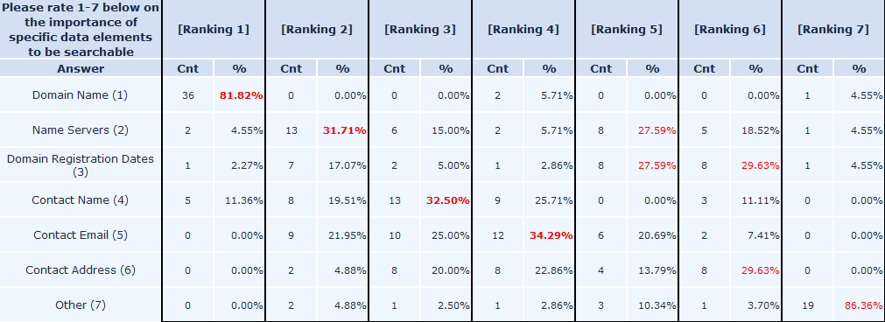
Other advanced search options indicate a general interest to expand beyond limitations of what is currently offered. When questioned if Boolean (AND, OR, NOT) search options were important, more respondents answered “Yes”. Respondents were also asked of interest to search WHOIS via wildcard (a wildcard is a character that may be substituted for any of a defined subset of all possible characters). However, results were split with a slight advantage to “no” on wildcard search. Over half of the respondents affirmed searching WHOIS in native language (non-ASCII) format is needed. There were a few qualifying statements by respondents that much of the advanced search options should be restricted to specific data elements and audience.
Non-ASCII
WILDCARD
AND, OR, NOT
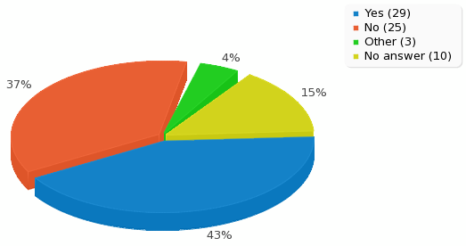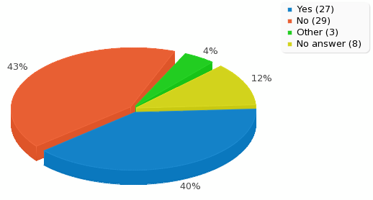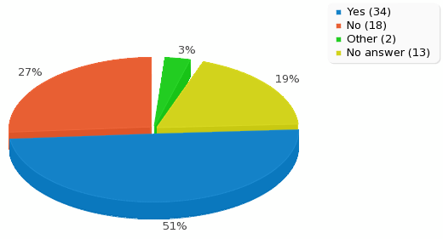
4. 8 R6a - Adoption of a structured data model for WHOIS data
The quality and accuracy of domain name registration data are essential attributes for maintaining a reliable WHOIS service. As noted from the Inventory of WHOIS Service Requirements report, the following characteristics were outlined:
- Accuracy – refers to the quality of the domain name registration data where privacy, deception, lack of corroboration and user error likely contribute to inaccuracy
- Applicably – determines whether or not the data collected and displayed are useful or relevant to the user or querying applications where a future WHOIS model accommodate extensibility and changeability
- Currency – refers to a cycle of time in which the domain name registration is maintained and kept current

Requirement #6a of the survey dealt with the adoption of a structured data model for WHOIS data that provides extensibility and changeability properties. It employs a formal data schema language such as XML to describe the characteristics of the structured data. Properties also give the ability of the WHOIS data model to evolve from current data elements to new data elements while maintaining the integrity of the original data structures.

Summary of Results:
The first survey question of this section asked the 67 respondents about the need for data being extensible with near 60% mostly agreeing or strongly agreeing.
In order to improve the WHOIS service capabilities, we need for data to be extensible:
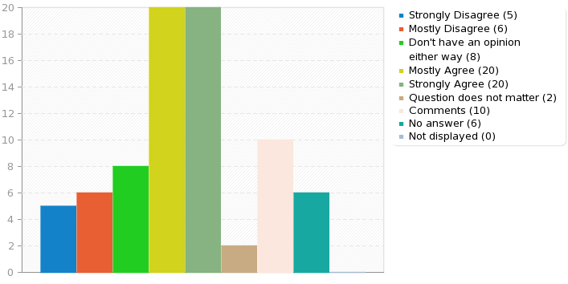
Free-form Responses:
- I'm very concerned with data mining and privacy. Extensions and standardization may make it easier to mine the Whois.
- There should be a common standard that can be adopted by all name registries. Since ccTLDs have different requirements than gTLDs, the standard should be extensible with a minimal set of required fields.
- WHOIS needs are essentially the same now as they were 15 years ago
- EPP has a fixed data set. As long as people adhere to the EPP standard, the data set of the WHOIS can also be fixed.
- And XML could be hard to do. That is why JSON is better
- if search is allowed it will introduce many other issues. legit registrants will enter false info, for example, and bad actors will have each domain with different info
- extensible data about any EPP object will cover many legal platform mostly in case of CC TLD's
- extensibility help us make multiple queries which are easily recoverable from storage.
- Various legal systems require a variable set of information which needs to be provided at "impress" alike services. Such legal requirements change quicker than any programmer can adopt any software.
- Extensibility of the WHOIS service is essential to handle registry data that includes additional types of objects and additional attributes.
- Existing service is fine - too much dataprotection issues in different legislations

The second survey question of this section asked the 67 respondents about changing over time with 53% mostly agreeing or strongly agreeing.
In order to improve WHOIS capabilities, we need for the required data elements to be changeable over time:
Free-form Responses:
- People change, WHOIS will need to change
- Registration data may change over time, as points of contact are introduced or withdrawn (eg fax numbers). A historical example might be DS records which are a recent addition to registration data.
- No evidence of this over the past decade
- Another service to keep maintaining. As long as the purpose is really really useful.
- unfortunately if allowed, data elements will only be added, never removed. who uses fax numbers nowadays anyway?
- Bt backwards compatibilty is thorny
- so that name server and contact should be updated and correct in WHOIS response
- Various legal systems require a variable set of information which needs to be provided at "impress" alike services. Due to geographical differences the requirements vary. Using the thin WHOIS approach the required information can be collected and enforced locally.
- We agree that there's an advantage in being able to change which elements are required. Transitioning a required element to optional is reasonable, but collecting a new element or requiring an element that was previously optional will be difficult to coordinate even with broad agreement.
- Exisiting documentation should work

The remainder of this section of the survey asked the respondents a series of questions regarding the definitions of WHOIS, a standard model, responsibility for implementation, and mandating certain fields. In general, the results show the following:
- A formal definition for WHOIS data is needed
- A formal modeling language should be used to create a data model
- There was more support for IETF to define the model over ICANN
- Strong agreement that data collection techniques should insure that data is entered in a defined format
- Agreement that data collection techniques should allow for some fields to be made mandatory, mandatory fields are decided by Policy decision; but there was no support for all fields being made mandatory

Survey Question | Results
A formal definition of WHOIS Data is needed: | 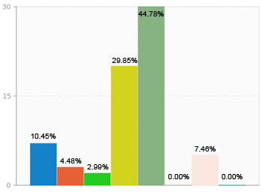
A formal modeling language such as XML should be used to create a data model for WHOIS: | 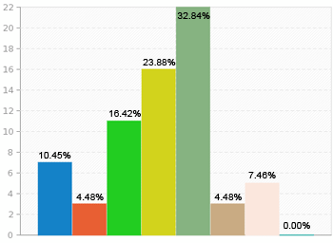
Work on such a model should be done by ICANN: | 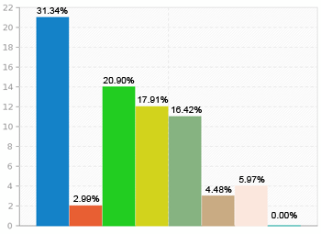
Work on such a model should include the IETF: | 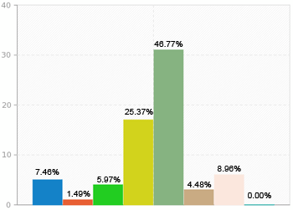
WHOIS data collection techniques should insure that data is entered in a defined format: | 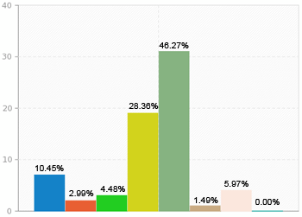
WHOIS data collection techniques should allow for some fields to be made mandatory, mandatory fields are decided by Policy decision: | 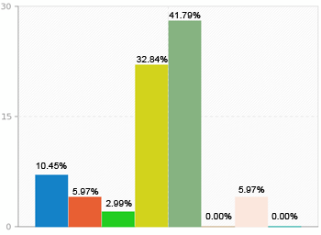
WHOIS data collection techniques should require that all fields be made mandatory: | 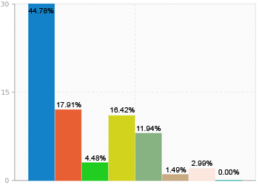

4. 9 R6b - Extending the currently defined set of registration data elements
The quality and accuracy of domain name registration data are essential attributes for maintaining a reliable WHOIS service. As noted from the Inventory of WHOIS Service Requirements report, the following characteristics were outlined:
- Accuracy – refers to the quality of the domain name registration data where privacy, deception, lack of corroboration and user error likely contribute to inaccuracy
- Applicably – determines whether or not the data collected and displayed are useful or relevant to the user or querying applications where a future WHOIS model accommodate extensibility and changeability
- Currency – refers to a cycle of time in which the domain name registration is maintained and kept current

Requirement #6b of the survey considered extending the currently defined set of registration data elements to include: alternative forms of contact than those currently collected; information that discloses the history or “Pedigree “of a domain; and additional registration service provider contact information.

Summary of Results:
This section of the survey asked the respondents a series of questions regarding a standard model. In general, the results show the following:
- Over half of the respondents disagree that a “one size fits all” model for WHOIS is sufficient for todays or future WHOIS needs.
- Most agree that it should be possible to include other forms of contact information for WHOIS
- Almost half agreed that it should be possible to collect contact information using a local address format for WHOIS also noting mixed results about including other forms of contact information such as Social Media.
- There are mixed results as to whether the history or “pedigree” of the domain, such as previous owner(s), is included or not.

Survey Question | Results
The current "one size fits all" model for WHOIS data is sufficient for today's WHOIS needs: | 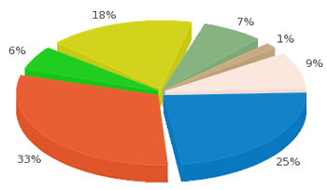
The current "one size fits all" model for WHOIS data is sufficient for foreseeable WHOIS needs: | 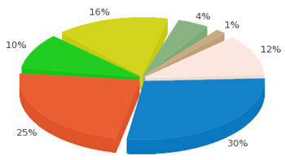
It should be possible to include other forms of contact information for WHOIS: | 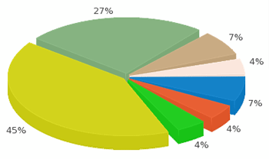
It should be possible to collect contact information using a local address format for WHOIS: | 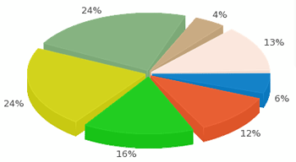
It is appropriate to include other forms of contact information (such as social media) as one method of WHOIS contact: | 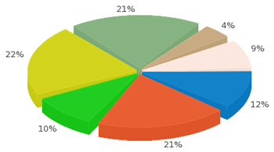
Information should be included on the history or “pedigree” of the domain, such as previous owner(s): | 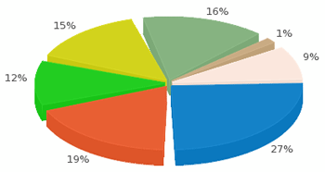
Any Historical or “pedigree" information, such as previous owner, should be restricted to a single previous owner: | 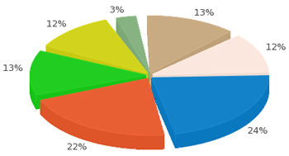

4. 10 R7 - Internationalized Registration Data Requirements
Requirement #7 reviews issues about how the current WHOIS protocol has not been internationalized. It has no mechanism for indicating the character set in use. Currently, IDN guidelines are sufficient for recording and displaying domain names; however, no standards or conventions currently exist that would make the WHOIS service more accessible to users whose local languages cannot be represented in USASCII7.

Summary of Results:
This section of the survey asked the respondents a series of questions regarding internationalization attributes of a standard model. In general, the results show the following:
- 60% agreed that WHOIS clients (both port 43 and web) should be required to accept a user query of domain name in either U-label or A-label format with 58% stating the display results do the same. The same percentage also supported variants of the IDN label be included.
- Only half of respondents agree that WHOIS services should return both A-label and U-label for a given IDN and its representations for nameserver names.
- 58% supported WHOIS services always make sponsoring Registrar information available in USASCII7, with 82% supporting WHOIS services always return the exact EPP27 status code for Registration Status.

Survey Question | Results
Should WHOIS clients (both port 43 and web) be required to accept a user query of domain name in either U-label or A-label format?  z=5.3586, p =0.000 | 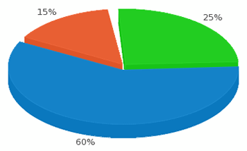
Should WHOIS clients display results of queries in both U-label and A-label for the domain names?  z=5.2017, p =0.000 | 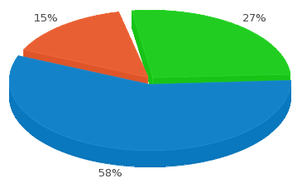
Should WHOIS responses include variants of an IDN label in the response as well?  z=5.1597, p =0.000 | 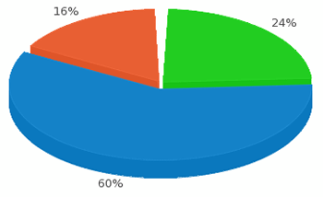
Should WHOIS services return both A-label and U-label representation for the given IDN domains queried?  z=5.3586, p =0.000 | 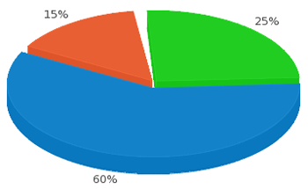
Should WHOIS services return both A-label and U-label representations for nameserver names (to the extent that such information is available)?  z=3.6034, p =0.00032 | 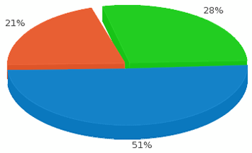
Should WHOIS services always make sponsoring Registrar information available in USASCII7?  z=5.0013, p =0.000 | 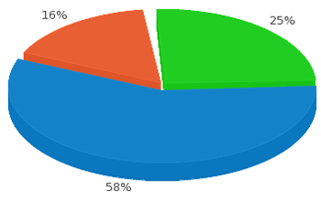
And if so, should WHOIS services always return the exact EPP27 status code for Registration Status?  z=6.2158, p =0.000 | 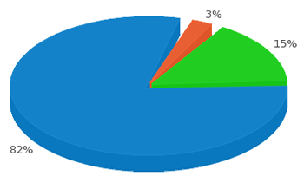

4. 11 R8.1 - Defining an authentication framework for WHOIS
The inventory of WHOIS requirements identifies a need for authenticating WHOIS users (whether a person or a computer system) in order to provide elevated access rights, and to rate-limit incoming connections to ensure the WHOIS service isn't overloaded.
- Elevated access rights means the ability to provide more extensive access to WHOIS data to a defined group of WHOIS users.
- Rate limiting means the technical challenges of using traditional source-based IPv4 rate limiting methods in IPv6 networks.

The current WHOIS, allows public access to registration data with limited, if any, authentication protocols. It is debated if greater controls to WHOIS should be implemented or not. Authentication protocols could benefit in managing who has access to the data, allow auditing of the access and enable segmentation of audience and data. There is an inherent cost of enforcing an authentication framework to manage the access controls and risk legitimate access to be hindered. This section of the WHOIS Technical Survey set out to define an authentication framework for WHOIS service that is able to accommodate anonymous access as well as verification of identities using a range of authentication methods and credential services, per Requirement #8.1.

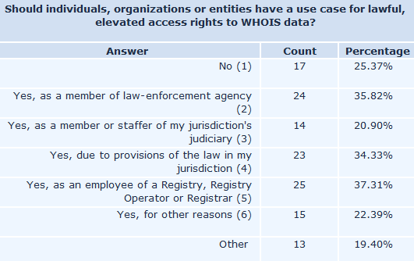
Summary of Results:
Survey participants were asked if access to WHOIS should have better controls. Over a quarter, 17 of 67, of the respondents indicated there is no need for elevated access. The balance, 40 participants or about 60%, agreed to allow elevated access to certain audiences for reasons based on their role and/or geographic location, due to privacy laws. The support for increased access controls is evident. The policy of authenticated access will need definition as the respondents clearly have varying positions of who, what and how controls are adopted.
Free-form Responses to Other:
- Statistical, non-invasive analysis
- Only in extremely narrow and well-defined circumstances, for certain kinds of verified law enforcement with established due process.
- commercial anti-abuse agents, brand managers
- to address staff changes that may no longer exist within an organization
- Policy dependent
- my own domainname or resource
- no special access for TM holders
- LAw enforcement as defined in rigourous review of this need
- companies verifying for contesting copyright and ownership rights
- Thin WHOIS allows to respect local law to define increased access to local servers.
- WIPO or other entitites who provide UDRP services
- so we can quickly, efficiently take action to protect our subscribers and customers; and so we can contact an owner directly with any queries of any kind..... why would you ask us to agree to having to pay someone else to do this for us? That only adds to cost and time - which must be passed on to the public - unfair for them.
- As an intellectual property enforcement professional

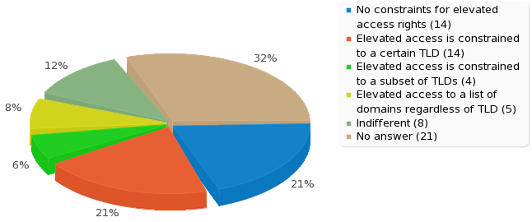
Although the question of who should have access based on need was widely disbursed in support, when questioned if controls around the Top Level Domain (TLD) are necessary, nearly 45% indicated they were indifferent or it was not necessary. That could be deciphered two ways. Either the access controls need to be broad-based not circumscribed; or, it is more relevant who is asking for the data than the data, and specifically TLD, itself.
If access rights to WHOIS were circumscribed please describe the constraints they should operate under.

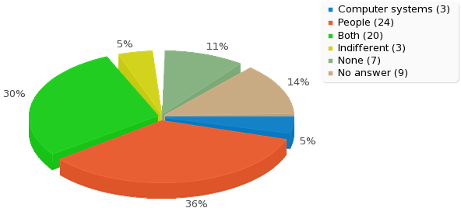
There was overwhelming support for type of access, security and rate limiting controls. Of the 67 respondents, over 36% chose elevated access rights should be granted to people (human-use) only. Another 30% agreed to people or computer access. But, less than 5% selected computer only elevated access rights. It is evident the respondents do not want automated elevated access.
Where do you see granulated access to DNRD-DS on a 1 to 5 scale of importance?

Many respondents indicated access to WHOIS should be secured. About 40%, however, indicated no preference or no answer. Those that did support secure access the majority, 35%, selecting SSL (secure socket layer) as the preferred method.
Describe your preferred approach for being authenticated/verified while engaging your elevated access rights, if you have one:

Free-form Responses:
- Most strict authentication possible
- SSL Cert and VPN are fine, private IP is moderately exclusionary
- this is an implementation detail and should not be a matter of policy
- otther certificate/authentication method
- combination of autn attributes like certs and ip addresses
- some form of certificate
- Using thin WHOIS the data is stored in the same country where the access should be granted. So local regulation applies. There is no global way.
- Identity federation, using personal client certificates or similar authentication
- pre-registration perhaps??
- Some form of PKI or adding a front-end application with user name / password authentication for this purpose

The most notable response to the survey was the tremendous support of rate limiting the access. Over 66% of the respondents confirmed rate limiting is required in an effort to manage the WHOIS service. Considering the low percentage of respondents agreeing to computer-only authenticated access and the high percentage of rate limiting controls, it is clear there is concern over automated processing and potential abuse.

Should the WHOIS Service provide rate limiting to ensure the system is not overloaded?
z=6.5219, p =0.000
Free-form Responses:
- rate limit to limit email harvesting
- hell yes
- by default with approved exceptions
- an implementation should not "fall over" due to load
- High limit prevents automation, but does not hinder lawful use
- Yes for third parties, no for registrars, registries and elevated access

4. 12 R8.2 - Implementing an authorization framework
Discussions of segregated access to WHOIS have been ongoing within ICANN. The approaches discussed have been varied. The common theme being restricting unfettered public access to WHOIS as is currently available. The goal is to gauge from the wider community support of implementing an authorization framework that is capable of providing segmented access.

Requirement #8.2: Implementation of an authorization framework that is capable of providing granular (per registration data object) permissions (access controls). For example, the ability to allow select WHOIS clients to access specific contact elements (such as law enforcement being able to see registrant contact phone numbers) is permitted.
- Registration data object - a described mechanism by which selected WHOIS users can have access to certain WHOIS data elements as set by the WHOIS services operator.

Summary of Results:
Survey respondents agreed, by over 58%, to a systematic, policy driven approach to segmented access to WHOIS. This could be segmented by access to specific WHOIS data elements or user segmentation to WHOIS. There were many statements that this needs to be driven by policy not protocol. Considering the strong support of segmented access, there was not a clear response to the degree of importance nor was it required in respondent’s jurisdiction. In conclusion, although survey respondents support implementing an authorization framework, further due diligence on the necessity of it is required.

Almost 60% survey respondents agreed WHOIS a permissioned based access should be standard operating procedure. The question positioned this to be determined, and governed, by policy. That statement was strongly supported in respondent comments.

Assuming these features are fully configurable and not mandatory to operate the system (but rather determined by policy), do you feel that WHOIS should have a standardized permissions framework for both WHOIS users (those querying the data) and for the data elements itself (meaning certain WHOIS users may see more or less data depending on their permission level – i.e. permission level A may see a registrant’s address but permission level C may only see the registrant’s name.)
z=4.5919, p =0.000
Free-form Responses:
- This "elevated access" idea is a very poor one. I'm against it.
- This question is so confusing that the results may not be reliable. I cannot answer it without knowing more about the policies behind the permissions framework
- registrars should have the permission needed. like .TEL private WHOIS and requiring retrieval of the admin email for transfers. can't get that with the current WHOIS lookup
- Heinrich Himmler
- In the IETF. Policy in ICANN, protocol definition in the IETF. Did I mention? Policy in ICANN, protocol definition in the IETF.
- Depends on requirements of law
- misuse can be averted. prior permission through a online mechanism should help
- This should be policy driven and not in the protocol.

Respondents were presented the position of enacting login mechanism for all WHOIS users, regardless if WHOIS services are open or anonymized. The results were inconclusive with nearly equal response in favor and against.

Do you believe that it would be technically and operationally useful to have all WHOIS users, even in open and anonymized WHOIS services have to make use of a login credential during the query process?
Free-form Responses:
- There should be no anonymous use of Whois where special access is given.
- There's a balance between securing the data and inconveniencing "normal" users -- I would envision an Anonymous class of users that have access to certain data (perhaps rate-limited) and Authenticated users that would have access to data based on their credentials (and perhaps NOT rate limited, again depending on credentials)
- Felix Dzerzhinsky
- Possibly.
- users who mine the WHOIS for email addresses and spam would then be known, as long as the logins are not anonymous. users (readers) of WHOIS need to identify themselves and be validated just as much as registrants (writers) have to do
- Thin WHOIS is operated on thousends of servers. Logins whould be a nightmare. For special access like "updates" oder "member access" a different interface, which needs authentication should be used.
- I want the WHOIS as public as possible. It is important to keep it open.
- Publicly available data should not require authentication.
- in case of proxy WHOIS usage.

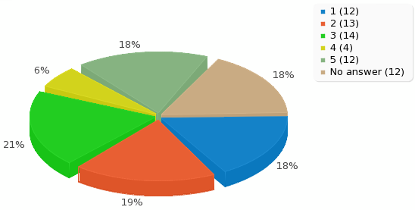
Although segmented access was strongly supported, when challenged to rank on importance, respondents ranked it nearly equally distributed between Most to Least, 1-5. The mean average was 2.84 between respondents. This indicates although access controls are supported, it is not a top priority by survey respondents.
Where do you see granulated access to DNRD-DS on a 1 to 5 scale of importance?

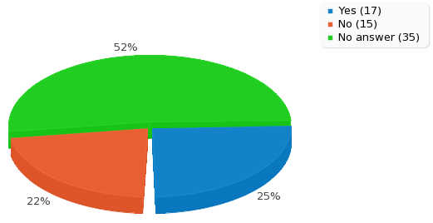
Local jurisdictions did not win out on claim of granulated access. Over 50% of completed responses had no answer. It is not relevant to local laws of the respondents. The survey either did not reach the audience with greater privacy laws in their jurisdiction or current services meet their needs for control of access to WHOIS.
Is granulated access to DNRD-DS data a requirement in support of local laws in your operating jurisdiction?

z=0.4052, p =0.6818
4. 13 R8.3 - Defining a framework and baseline set of metrics
With an authentication service in effect, it offers the ability to audit and report of access. Auditing could benefit many stakeholders. Managing the WHOIS Registrars and Registries can be improved by monitoring and regulating systems. Domain owners could benefit of auditing and reporting access to thwart potential hijackers. When segmented access is available, along with reporting and tracking, it is conceivable it can be abused or could create additional challenges to the very stakeholders protecting the consumers. Any framework needs to consider baseline set of metrics that can accommodate future policy development for auditing that meets the needs of all stakeholders.

Requirement #8.3: Define a framework and baseline set of metrics that can accommodate future policy development for auditing of WHOIS access.
- Auditing of WHOIS access means the ability to periodically review what users have accessed a given WHOIS service.

Summary of Results:
This survey section presented participants options to select data elements worth collecting if a metrics framework were in place. Most data elements received a healthy response to collecting data by the survey respondents of the completed surveys. It is evident there is interest and support for a framework that allows data collection, retention and tracking of WHOIS. Simultaneously, it needs to be recognized this could cause issues of security concerns. Any framework established will need to have a well-defined policy of method of access and use.
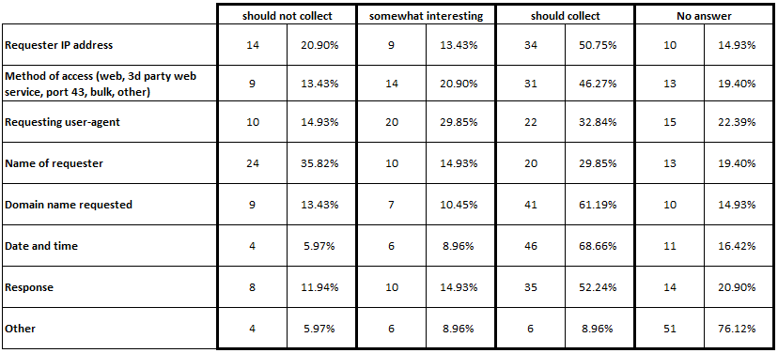
Survey respondents largely found most every data element presented was worth collecting for auditing and tracking purposes. The most supported elements to track were the domain name itself and the data and time it was queried. Both of those scored about 60% with an affirmative response to collect the data. The current WHOIS service inherently captures this data when queried. Putting in place an authentication system for this tracking is likely not necessary.

The one element with more “Should Not Collect” over “Should Collect” was the Name of Requestor, 36% to 30% respectively. In fact, Name of Requestor received the highest amounts of votes of “Should Not Collect” in this section of the survey.

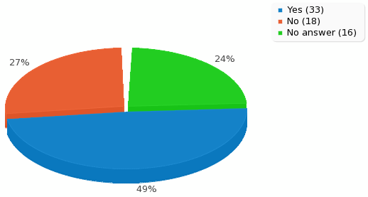
When survey participants were presented the question of privacy or confidentially concerns with collecting data, nearly 50% agreed. Respondents went on to comment that retaining information of requestor or requested data could encounter other data protection laws, depending on jurisdictions. It could also prove risky in investigative and security issues. A policy of data retention and controls along with strict constraints is necessary.
z=2.6688, p =0.00758
Does the collection or use of any of these elements raise privacy or confidentiality concerns?
Free-form Responses:
- Collecting Requestor information could reveal the domain registrant is a target and, if they could learn this information, could send them into hiding to evade legal action.
- GIven a WHOIS system with appropriate safeguards (not currently the case) those making a query should also have their identities protected, as should registrants.
- Data security issues
- I have much less trouble with collecting information about requesters than with requesters collecting information about registrants.
- IP address and name are personally identifiable information. Access to this information would need to be regulated by privacy law in many jurisdictions
- I envision a two-tier system, anonymous access and authenticated access. I would resist the idea of collecting personally-identifying information for anonymous access.
- IP addresses are personal data in some jurisdictions, but their collection is legitimate to help analyse usage and protect other personal data. Collection should be limited and data retained only for short periods.
- Peoples names are PII, other info may be
- there's alway privacy concerns when collecting large amounts of data from the public.
- any time personal information is gathered, that information falls into privacy compliance depending on the country and/or region. However, the need to caputer audit information is greatly needed
- Name of requester
- Who is (what entity) is requesting the information and why (for what purpose)?
- It is personally identifying information and therefore subject to all the same restrictions
- Personally identifiable information should be treated with the highest standard of privacy protection, such as EU data directive.
- Obviously, this auditing data should only be made available to those entitities with elevated access rights
- WHOIS output for public use, should only contain limited data. For Registry/Registrar and law enforcement purposes, it should contain all data in order for each party to be able to perform their duties. Public access should not display full data because marketers/spammers will simply use that data.
- to some, IP addresses are PII. can be managed with privacy-sensitive data-sharing framework.
- IP address Name of the requester
- Name is PII, IP sometimes is
- name and IP addresses does rise the privacy question. more importantly the domain requested will impact business choices for the stake holders.
- Collecting domain names might disturb the checks before registering a trademark. Fraudulent use of the (leaked) collected data can cause headache to the future trademark owner. Collecting IP addresses, client information and queried names raise interests of politics and marketing.
- spam, stalking,...
- For the security of the system,it is always appropriate we know whoever is using the system or using the WHOIS service.
- Name of requester raises privacy or confidentiality concerns
- ip address
- Several of these elements appear to fall within the definition of 'personally identifiable information ' (PII) or 'personal data' (PI) as defined in relevant data protecition laws and any use or collection of elements constituting PII or PI beyond the collection and use necessary to provide the service raises potential privacy and/or confidentiality concerns.
- It should be only used to improve performance
- Requester IP-Address Name of requester
- Aside from improving site performance (if this was web based) there is no reason to collect user information.

4. 14 R9 - New TLDs operating a Thick WHOIS
Requirement #9: All new TLDs should operate a thick WHOIS. Thick WHOIS is a WHOIS service operated by the Registry Operator that contains authoritative and full Domain Registrant information. The new gTLD Program adopted Thick WHOIS for all new gTLDs. Consistent with these recommendations for future WHOIS services, new or legacy registries could consider evolving to a thick WHOIS. However, room exists for some questions that might be beneficial to successful applicants, as well as the operator of the existing thick Registries and legacy thick Registries.

This item largely has been overtaken by events because of the terms of the new gTLD Applicant Guidebook and the proposed Registry Agreement whereby Thick WHOIS is a required service.
Further, a GNSO PDP has been initiated to address policy around a requirement for Thick WHOIS in all gTLDs. More information can be found at http://gnso.icann.org/en/group-activities/active/thick-whois.

Summary of Results:
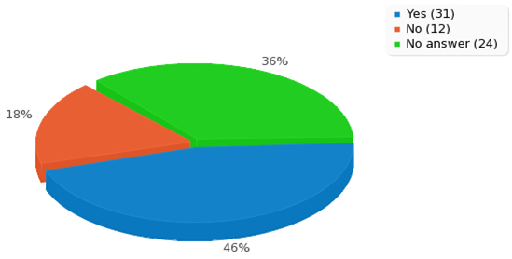
Respondents were first asked about standardized tools for migrating from a thin to a thick WHOIS service. 46% of the respondents indicated support for this, but an equally significant amount of respondents chose not to answer this question. More information is likely required to make a determination of action around this result.
Should standardized tools for Registries/Registrars be developed to move RDDS from a thin to a thick Registry?

z=3.516, p =0.00044
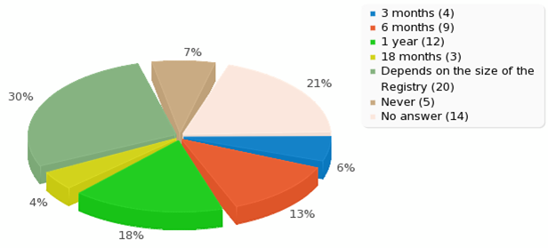
Lastly, respondents were asked about a timeframe for migration from a thin to thick model. The results are fairly distributed, but support mostly begins for six months to a year with a sizeable affinity for understanding the size of the registry to make that determination.
What is a reasonable timeframe for a legacy registry to move from thin to thick RDDS?

4. 15 R10 - Definition of a standard data structure for WHOWAS responses
Per the Inventory of WHOIS Service Requirements Final Report, “Once a domain name deletion request has been completed, the domain name is removed from the registry WHOIS service. This deletion occurs at the time the deletion transaction is processed for a domain name within the Add Grace Period, or for domain names that are deleted outside of the Add Grace Period, upon expiry of the Pending Delete period. The WHOIS data associated with the domain name is no longer readily available through WHOIS.”

Requirement #10: WHOWAS Service provides an automated capability for a customer (which may be either a Registrar or non-Registrar) to look up a domain name and receive a response with the registration history for the entire life of that domain name, which also includes the domain name, registration dates and Registrar of Record for each period of time. A WHOWAS service could be provided by all Registries.

Summary of Results:
This section of the survey, respondents were asked about their support for WHOWAS and the extensible data structure behind it. Six primary questions were asked with four sub-questions based on the respondent’s yes/no response. There appears to be general support for a WHOWAS service, however, each question had a significant response of “no answer”.

<Results can be found on the next page>
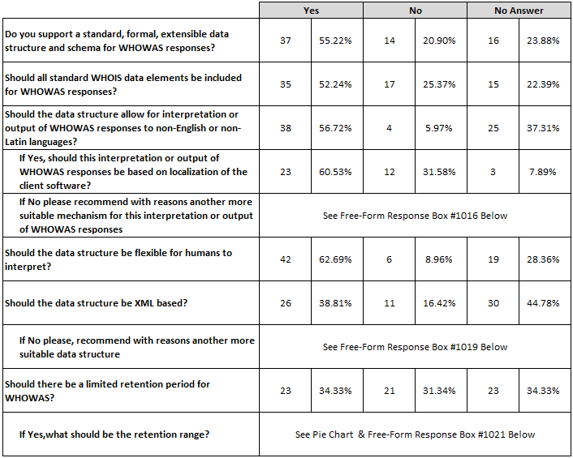
Free-Form Responses - #1016
- WHOWAS should be extremely limited in scope. WHOIS should implement the right to be forgotten.
- No, no automated tools.
- None
- Make them machine parsable and clients can translate it
Free-Form Responses - #1019
- Plain text multiple formats
- Same as earlier answer.
- No, no automated tools.
- Any structured format is acceptable (eg JSON). However, XML has some benefits such as schemas and XSLT, although these are not unique to XML. Just not ASN1 :-)
- json, please, same as WEIRDS
- None
- Again, JSON is easier and better
- Because there are other formats.
- JSON, please
- XML is not human readable.
- The data structure should not be only XML based but it should include also ASCII structure.

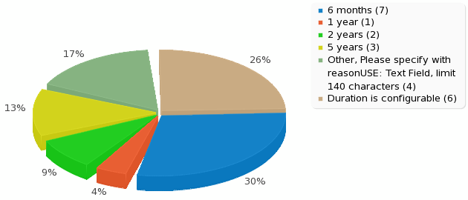
Free-Form Responses - #1021
- the lifetime of the previous registration, or 1 year, whichever is longer.
- 60 days
- for the duration of the registration, plus a few years
- Defined in RFC 1459
- is should be retained but not returned to the average user (user that are not law enforcement for example)
- more of balancing business interests and privacy/propriety
- 6 years or other local legal compliance
If Yes,what should be the retention range?
4. 16 R11 - Registrars and Registries
Recommendation R11 of the Inventory Final Report dealt with publishing an abuse point of contact as part of a domain registration record. Drawing upon this recommendation, the survey asked respondents whether it was important that this additional element be included in response to WHOIS queries to registries or to registrars. It also inquired about the main ways in which respondents expected to use the abuse point of contact, and about three alternative methods by which the abuse point of contact could be displayed. Among the 67 respondents who completed the survey, as many as 62 answered at least one question in this section.

Survey Requirement #11: Registrars and Registries should provide and publish abuse point of contact information as an element of a domain registration record. There are several ways this could be supported; for example, Registrars could populate the current sponsoring Registrar contact information with an abuse point of contact rather than a general purpose business contact. Alternatively, an abuse identifier that serves as an index into a publicly accessible table of abuse points of contact could be added to a registration record. These are further examples that demonstrate the utility of adopting an extensible data structure and formal schema.

Summary of Results:
In general, how important do you think it is that registries be required to include an abuse point of contact in results returned to WHOIS queries to that Registry?
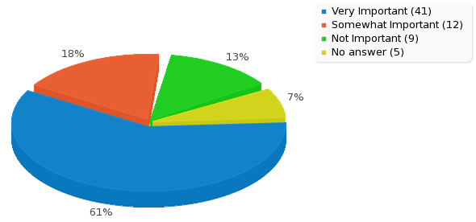
Respondents strongly supported inclusion of an abuse point of contact in WHOIS results, especially at the registry level. 61% of respondents considered this very important, and another 17% thought it somewhat important. While a majority indicated that all of the suggested potential uses for this information were at least somewhat important, the single most strongly supported use was for reporting suspected malicious activity associated with a domain name, with the least support for using the information to report technical problems associated with the domain name. Respondents strongly preferred adding abuse point of contact information to the current registrar or registry information included in WHOIS results, rather than either of the other methods suggested.
In general, how important is it that Registrars be required to include an abuse point of contact in results returned to WHOIS queries to that Registrar?

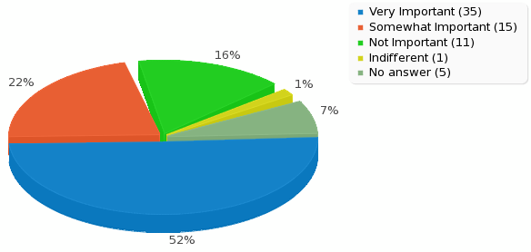
Abuse point of contact for registrar WHOIS: While slightly fewer respondents thought it was very important to include this information in WHOIS results from registrars, a majority 52% did think so. The 74% of respondents who thought this feature at least somewhat important in registrar WHOIS results approaches the 79% figure for registry WHOIS.

Most valuable potential uses: Clear majorities thought it at least somewhat important that abuse point of contact information be made available in order to report malicious activity associated with a domain name (80.6%), report false or inaccurate WHOIS data (68.7%), report violations of legal rights associated with the domain name (65.7%), or to report technical problems associated with the domain name (61.2%), as well as a catch-all response of making “general use of an abuse point of contact” with such data (71.6%). The highest single figure for a use deemed “very important” was (62.3%) for reporting suspected malicious activity; the lowest such figure (34.3%) was for reporting technical problems. It may be difficult to make meaningful comparisons among the different choices, since the uses were not specifically defined in the survey and may well overlap in the minds of some respondents. Only a handful of respondents (11.9%) answered that “other uses” not listed in the survey were very or somewhat important to them.

<<See chart on the next page>>
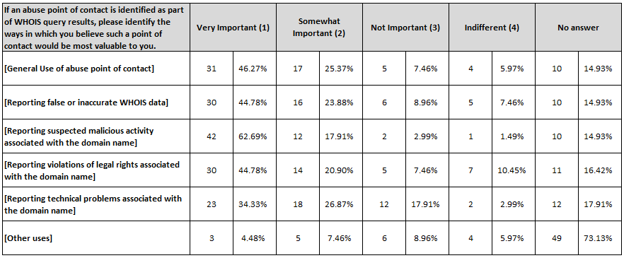

A Method of including abuse point of contact: A majority of respondents (55.2%) strongly preferred adding abuse point of contact information to the registrar or registry contact data currently appearing in WHOIS results. Including the “somewhat prefer” responses brings the positive total for this method over 73%, with only one-tenth as many respondents (7.5%) at all opposed to it. By contrast, only 35.8% stated any preference for including in WHOIS results a link to or index into a publicly accessible table of abuse points of contact. Substituting the abuse point of contact for the current contact information was even less popular, with only 22.4% of respondents expressing any preference for this option, which 17.9% of respondents strongly opposed. 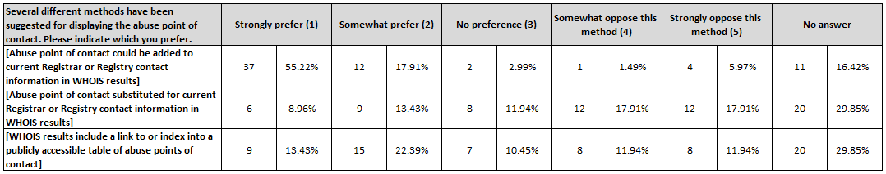

Working Group Recommendations
As noted, the results of this survey do not directly impact any GNSO Policies that may have been made with respect to WHOIS, nor does it directly affect any of the requirements for Registration Data Directory Services listed in the Registry Agreement and Registrar Accreditation Agreement.

In general there is broad support for the fourteen technical requirements as listed in the Inventory of WHOIS Service Requirements by ICANN staff in 2011. However, events that transpired since then have already taken many of the results of this survey into consideration or they are being implemented. For example, the Thick WHOIS WG, the Expert Working Group on gTLD Directory Service, and the IEFT Registration Data Services protocol efforts. As such, the results of this survey still may reinforce some of the actions regarding WHOIS by the other efforts.

Recommendation 1:
- Deliver the results of the WHOIS Technical Requirements Survey to the International Engineering Task Force (IETF) for their consideration in developing a new WHOIS protocol based on the RESTFUL platform (http://datatracker.ietf.org/wg/weirds/).

Recommendation 2:
- Deliver the results of the WHOIS Technical Requirements Survey to the Expert Working Group on gTLD Directory Services, as formed by the ICANN Board in early 2013 (http://www.icann.org/en/news/announcements/announcement-14feb13-en.htm).

Recommendation 3:
- Deliver the results of the WHOIS Technical Requirements Survey to the Thick WHOIS Working Group, as formed by the GNSO Council late 2012 (http://www.icann.org/en/news/announcements/announcement-14feb13-en.htm).

Lesson Learned 1:
- Future surveys from the GNSO should strongly consider associating or correlating the respondent profile with the answers that they provide. This insight may provide additional rationale for the overall results. However, privacy should be appropriately considered. This feature does exist within Lime Survey, but the results were only presented in raw response form and not a feature built within the tool itself. Analysis of results and construction of visual aids would require extensive effort to complete for this type of survey.

Next Steps

The WSWG Working Group will send the Final Report to the GNSO Council. The GNSO Council is now expected to review and deliberate the WG’s Analysis and Recommendations at its next Council Meeting and take actions as appropriate, if any.

GNSO Council Resolution on WSWG: http://gnso.icann.org/en/council/resolutions#20111006-1
WSWG Charter: http://gnso.icann.org/issues/whois/charter-wswg-06oct11-en.pdf
WSWG Public Comment: http://www.icann.org/en/news/public-comment/draft-whois-requirements-survey-30may12-en.htm
Z Test Calculator Website: http://www.socscistatistics.com/tests/ztest/Default2.aspx
Z Test Information: http://en.wikipedia.org/wiki/Z-test
Only one respondent who did not complete the survey answered any questions in this section, so the inclusion of incomplete responses would not change the results significantly.

