Bob Hutchinson’s proposed additions to the Interim Report of the Internationalized Registration Data Working Group.

Section 4.1
IRD WHOIS Language Support:
Support all official languages/scripts for registrant supplied data. [if these or similar language tables exist in the IDN TLD specifications, then we should reference/include them.]
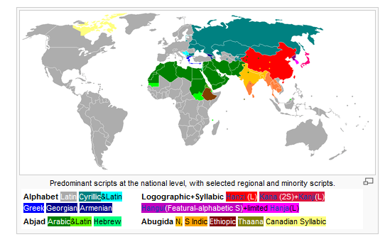
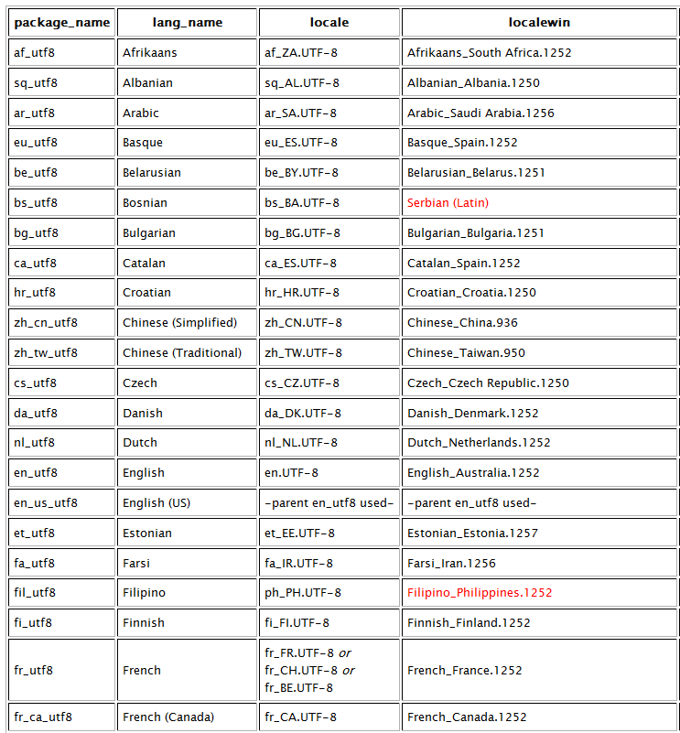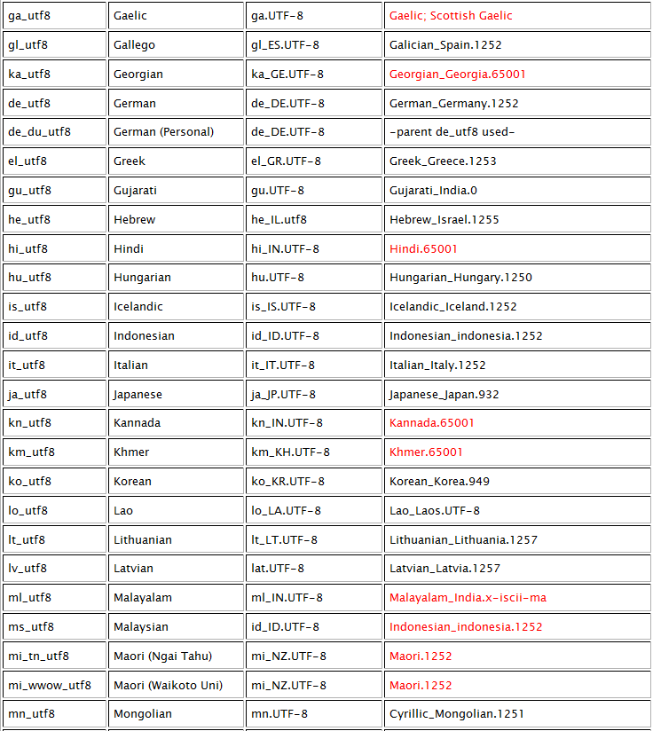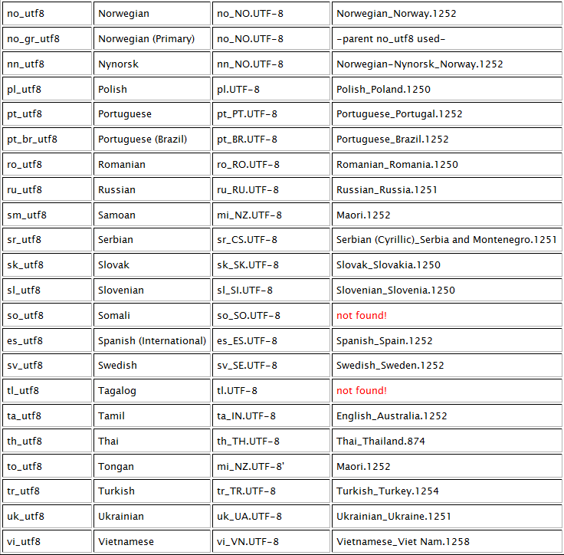
For each language, an IANA defined package enumerating the UTF-8 characters, legal within that language. Language reference identifiers[cross reference between IRD language ID and browser, Windows, UNIX etc] – TBD.
Language rules for WHOIS data:
- Registrant data is acceptable in every TLD in any language, but only one language per domain. Transliteration of registrant data into English pronunciation is required. Translation of place names; nations, city, and street names is optional.
- Registry and Registrar identification in ICANN approved form only [US English only]. Is not translated.
- Default language for Data Labels is US English. Labels defined by ICANN. Translation to other languages may be accomplished by string replacement – tables maintained by IANA.
Model 3 and 4 need to be updated with example/figures which reflect translation/transliteration.

End requested changes.

