January 14, 2013

By Email to “tmch-strawman@icann.org”
ICANN
12025 Waterfront Drive, Suite 300
Los Angeles, CA 90094-2536
USA

Re: Comments Regarding Limited Preventative Registrations and the Trademark Clearinghouse “Strawman” Solution

The American Advertising Federation submits these comments in support of the proposal for Limited Preventative Registrations (LPRs).
The American Advertising Federation is the unifying voice for advertising. Membership includes major advertisers, advertising agencies and the media as well as 40,000 advertising professionals in nearly 200 local advertising associations nationwide. A large percentage of these local members represent small business brandowners.
Defensive registrations are a huge burden on brandowners in the current internet environment, where there are only 22 gTLDs. In order to protect consumers and reputations, they are forced to acquire unwanted “defensive registrations” solely to keep these domain names out of the hands of those who would abuse them. Even in the current limited domain environment there are brandowners with hundreds or thousands of domain names in their domain portfolios – most of which are defensive registrations. These costs go straight to the bottom line, resulting in higher prices to consumers, less innovation, less money available for employee wages and bonuses, and/or decreased earnings. The burden is particularly hard on small businesses that have limited resources to invest in purely defensive registrations. The only winners when it comes to defensive registrations are the domain name registrars and registries.
LPRs are the only current or proposed RPM that will provide our members and their customers with long-term protection from false and misleading domain names and websites. Without LPRs, they will be forced to incur huge and damaging costs to register domain names they do not want in hundreds of new gTLDs, at prohibitive expense, to protect their consumers and their reputations.
We also support the "Strawman Solution" proposal currently being considered in connection with the roll out of the new gTLDs, but with reservations. For the most part, the Strawman proposal is helpful but does not go far enough. However, the Claims 2 process is too diluted to be of real value. Brandowners should not be asked to pay for a process where they receive no notice of the third party registration, and the third party receives no notice of the details of their claim – while this may appear to be an additional RPM, it will not provide our members with any meaningful protection. Instead, the Trademark Clearinghouse should continue in perpetuity without diminishing the protection it offers.
Thank you for your consideration of our views.
Respectfully submitted,

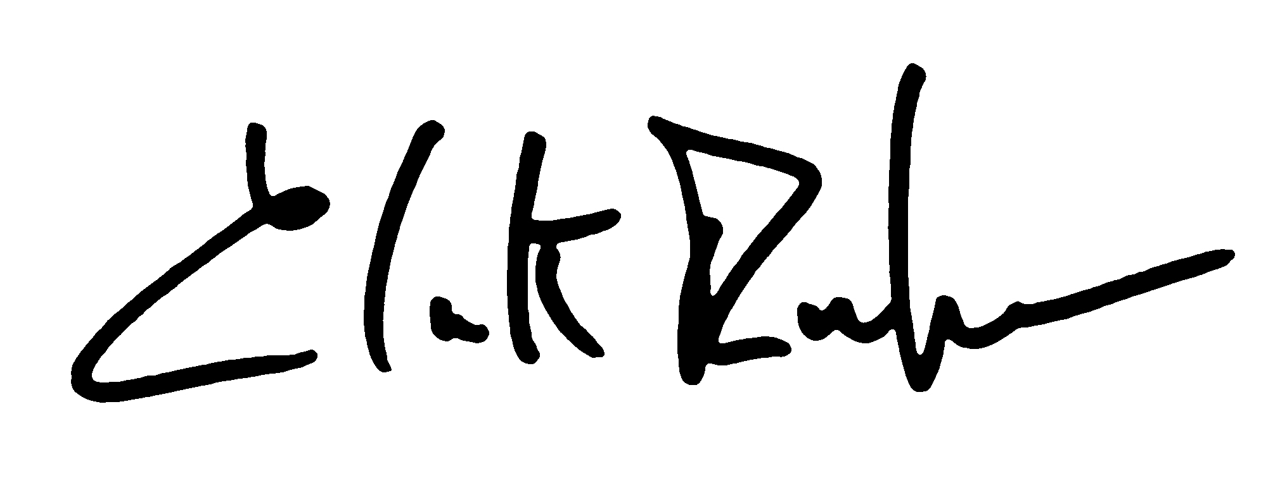
Clark Rector
Executive Vice President-Government Affairs

