March __, 2014

comments-sco-framework-principles-11feb14@icann.org

Re: Public Comment on a Proposed Review Mechanism to Address Perceived Inconsistent Expert Determinations on String Confusion Objections by the ICANN GNSO Business Constituency

The ICANN GNSO Business Constituency (BC) welcomes the opportunity to comment on the Proposed Review Mechanism to Address Perceived Inconsistent Expert Determinations on String Confusion Objections. While the BC appreciates the time and effort taken by ICANN in developing a string confusion objection review mechanism, we believe that significant improvements can be made to the process.

The Proposed Mechanism is Too Narrow as Currently Defined

The BC has repeatedly requested a broader appeals mechanism for new gTLD objections, in particular with respect to those involving singular and plural versions of the the same generic TLD strings. See e.g. Letters from Elisa Cooper to NGPC Regarding Plural and Singular Forms of TLD Strings (December 30, 2013 and October 22, 2013) (“We ask that ICANN publish more specific objective criteria used to judge string similarity, and then allow for an appeal system where applicants can challenge prior ICDR decisions on singular-plural TLDs based on this specific criteria”).

Other constituencies and individuals within the ICANN community have also expressed support for such an initiative:

The Internet Association, Letter from Michael Beckerman to Stephen Crocker Regarding Singular and Plural Versions of a String (December 10, 2013) (“[I]mplementation of an appeal system to challenge ICDR decisions will promote transparency in the process and ultimately result in more consistent decisions.”);

ICANN, New gTLD Draft Applicant Guidebook: Analysis of Public Comment (February 18, 2009) (“The guidelines should allow for a procedure to appeal a clearly erroneous DSRP decision,” and “No appeal opportunity is in clear conflict with common legal practice for organizations serving the public such as ICANN.”);

Intellectual Property Constituency, Comments Regarding “Draft Applicant Guidebook” For New gTLDs (December 15, 2008) (“Because the stakes may well be higher than in a UDRP proceeding, ICANN should consider providing an appeal procedure from decisions of the LRO panel” to “promote consistency of decision-making”).

In light of this strong community sentiment in favor of a broader appeals process, the BC is disappointed with the limited scope of the present review mechanism proposed by ICANN. We continue to believe that a more comprehensive review is necessary for singular/plural string confusion objections and thus reiterate the following standing requests to ICANN:

1. Publish any evidence considered by expert panels, arbitration providers, and ICANN staff in its evaluation of string confusion determinations; and

2. Publish more specific objective criteria used to judge string similarity, while creating a broader appeal system to allow parties to challenge prior ICDR decisions on singular/plural TLDs.

In advocating for a broader appeals mechanism for singular/plural objection proceedings, we first wish to challenge the NGPC’s rationale that the only situation which merits additional review is the one where objections were raised by the same objector against different applications for the same string, resulting in a different outcome. While that particular scenario is indeed problematic, such parameters are crafted too narrowly to encompass the flawed process in which an early ICDR panel somehow came to the conclusion that .HOTEL and .HOTELS were not confusingly similar, while the clear pattern in later rulings pertaining to singular and plural strings has been directly contrary to that finding, as illustrated by the chart below.

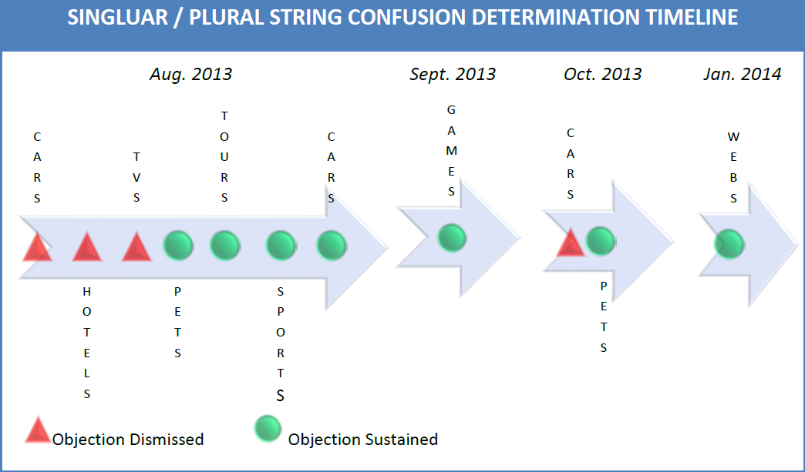

In other words, given the relative uniformity of the substantive issues common to all singular/plural string confusion proceedings, it is important that ICANN consider these results to be “inconsistent rulings,” whether or not they were brought by the same objector. Moreover, the BC urges ICANN to consider the .CAR(S) and .CAM/.COM decisions as a symptom of an imperfect process, as opposed to mere outliers that can be addressed through discrete reexamination. Indeed, as set forth in the BC’s prior communications on this subject, it is not simply the fate of the specific strings at stake, but the credibility of ICANN as an organization and its entire new gTLD program. It is also especially important that ICANN work on perfecting the underlying process and standardizing its position on singular/plural generic strings while it has the opportunity to do so, given the potential implications for future new gTLD rounds.

As set forth in the BC’s letter to ICANN of December 30, 2013, a formal and uniform review system to deal with singular/plural TLDs could be modeled after the precedent set by the Extended Process Similarity Review Panel (EPSRP) for IDN ccTLDs, and need not prejudice registry operators whose strings were not the subject of a string confusion objection (e.g., the .CAREER(S) strings). If ICANN determines that a separate public comment process is necessary in order to address the framework principles of a potential review mechanism for all ICDR decisions on singular/plural TLDs, the BC is supportive of initiating this additional public comment period.

Both Losing Objectors and Applicants Must Have Standing to Appeal.

Fundamental principles of fairness and due process dictate that both parties in a dispute have an equal right to appeal an unfavorable determination. Yet, the present language vests appellate discretion solely with “Losing Applicant[s],” creating an impermissible presumption that the rights of gTLD applicants are given more weight than the rights of objectors. In order to remove this presumption and in the interests of equity, the BC urges ICANN to allow both losing objectors and applicants to have standing to appeal the results of an inconsistent ICDR decision. As set forth in the previous section, the BC interprets “inconsistent decisions” to broadly encompass all string confusion proceedings involving singular and plural versions of the same generic string.

Only Arbitrators with Relevant Experience are Qualified for the Appeals Panel.

It is possible that many of the inconsistencies in the string confusion objection determinations were caused in part by the appointment of arbitrators lacking relevant experience with ICANN and the new gTLD program. In order to avoid a repeat occurrence of these issues, the BC proposes that any review or appeals panel be comprised entirely of arbitrators with specific demonstrated experience in new gTLD program string confusion objections. To the extent that any arbitrators also have some degree of experience in the relevant target industries, such as the automotive (e.g., for .CAR/CARS) or hospitality industries (e.g., for .HOTEL/HOTELS), such qualifications would also be preferable.

As a final matter, we urge ICANN to set a distinct time frame on reaching a decision on the handling of inconsistent string confusion proceedings. The fact that there is still ongoing uncertainty with respect to the treatment of singular/plural TLDs and their corresponding contention sets is problematic for businesses and users who must plan their strategic engagement with these TLDs and with ICANN in general. Thank you for your consideration of these comments.

4.3 Extended Process Similarity Review Panel Function The Extended Process Similarity Review Panel (EPSRP) can be called on to perform a second and final confusing similarity assessment of the requested IDN ccTLD string if: (1) The DNS Stability Panel, in performing its string similarity review, deems the string to be invalid; and (2) if the requester seeks review by the EPSRP within three months of ICANN’s notification of the DNS Stability Panel’s determination.

