March 18, 2016

Proposed Implementation of GNSO Thick Whois Consensus Policy Requiring Consistent Labeling and Display of RDDS (Whois) Output for All gTLDs

United TLD Holdco, Ltd, trading as Rightside Registry supports the alternative framework proposed by Google Inc. in its comments on Thick Whois/RDAP Implementation.

We agree that the consistent display requirements in the Thick Whois Policy could be better implemented as follows:

- Having registries include the Registrar Abuse Contact Email and Phone Number in their Whois Outputs;
- Keeping the Reseller Field Optional for both registries and registrars; and
- Having Registries continue to display only one expiration date (the registry expiration date).

Considering that Google’s proposed alternative would condense the timeline for the remaining thin registries to transition to thick as well as show fields that are currently only required in the registrar output within the registry output, registrars should not be required to implement RDAP. Pending policy development work that is applicable to RDAP, registries (and registrars that optionally implement RDAP) should be free to develop their own operational practices for RDAP and be encouraged to share their findings and experiences to inform future policy development work.

Sincerely,

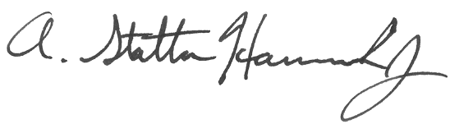
- Statton Hammock, Jr.
Vice-President, Business & Legal Affairs
Rightside Group Ltd.

