July 2, 2014

Ms. Karen Lentz
Internet Corporation for Assigned Names and Numbers (ICANN)
Washington, D.C.

VIA ELECTRONIC TRANSMISSION

Re: WHOIS Requirements and National Law Conflicts

The Software & Information Industry Association (SIIA) welcomes the opportunity to comment on the Review of the ICANN Procedure for Handling Whois Conflicts with Privacy Law (“Whois Conflicts Review”).

SIIA is a trade association representing the software and information industries. It consists of over 800 member companies, ranging from start-ups to some of the largest and most recognizable companies in the world. Many SIIA member companies have facilities, operations, and/or employees in multiple countries, and most do business internationally. All of them depend upon the stable, secure, reliable operation of the Internet in order to run their businesses successfully, and some even provide core software and services that support the Internet itself.

One of SIIA’s primary missions is to protect the intellectual property of member companies, and advocate for a legal and regulatory environment that benefits the entire industry. Consistent with these goals, for over 25 years SIIA’s Intellectual Property Protection Division has conducted a comprehensive, industry-wide campaign to fight software and content piracy. This campaign is premised on the notion that one must balance enforcement with education to be effective.

Copyright and trademark infringement, fraud, deception, and similar abuses by some participants in the DNS ecosystem are an enormous and ongoing problem faced by SIIA member companies and their customers around the world in the software and information industries. It follows that SIIA and its members have a significant interest in many of the issues raised by ICANN in the Whois Conflicts Review. Because the questions in the Whois Conflicts Review are primarily focused on obtaining the views of registrars and registries (not SIIA members), for clarity and efficiency SIIA has chosen to provide a more general response to the issues raised by the Review. We plan on responding in more detail with the filing of reply comments. Thus, our silence as to specific questions should not be interpreted as signaling an SIIA position or lack of interest on those matters.

Access to Whois data is extremely important for enforcement against copyright piracy and trademark infringement. The investigation of virtually every case of piracy involves the use of Whois data. For example, when an investigator seeks to determine who is responsible for a website where infringing activity is taking place, a review of the Whois data for the domain name which resolves to that site is usually the first step. This data is essential not only to law enforcement, but it is also relied upon by private parties (including copyright and trademark owners), whose independent enforcement of their rights allows legal authorities to conserve resources. When piracy is associated with a particular IP address, Whois enables an investigator to identify the ISP or other entity to which the IP address was initially assigned, and also to learn of sub-allocations to other providers, though rarely, if ever, to the end-user. Whois provides greater transparency, so that end users know more about the parties with whom they are interacting online. In this way, publicly accessible Whois promotes the healthy growth of e-commerce, including but not limited to e-commerce in works protected by copyright.

We continue to urge that ICANN policy continue to make the preservation and accessibility of Whois data a priority and that any actions by ICANN reaffirm its policy of reliable, accurate, publicly accessible and timely Whois Data. We are concerned that many of the questions raised in the Whois Conflicts Review may weaken the contractual obligations of registrars and registries to provide access to Whois data. We would oppose any change in these obligations that would allow these parties to avoid their existing obligations regarding Whois access and urge that if any newly created exceptions are deemed to be warranted that they be narrowly tailored and be available only in exceptional and existing cases.

We therefore urge that any alteration in the existing Whois conflicts procedure abide by the following principles:

- For purposes of transparency and accountability, these contractual obligations must be equally and fairly applied to all registrars and registries.

- Exceptions to the provision of Whois data be granted only where “a registrar or registry can credibly demonstrate that it is legally prevented by local/national privacy law or regulations from fully complying with applicable provisions of its ICANN contract regarding the collection, display and distribution of personal data via WHOIS.” See 2005 GNSO council resolution.

- No relaxing of existing Whois contractual obligations should occur unless a sufficient record of exceptional and existing conflicts is established (in this regard a legal opinion should not be sufficient unless it is linked to an existing controversy)

Thank you in advance for considering SIIA’s comments.

Regards,

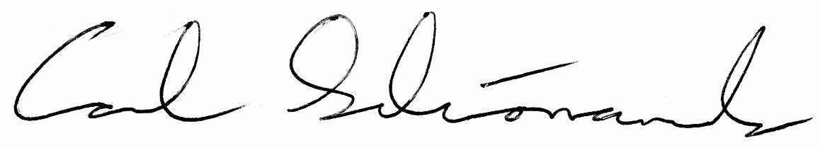

Carl Schonander
Senior Director, International Public Policy
Software & Information Industry Association

Cc: Ken Wasch, President and CEO
Mark MacCarthy, Vice President for Public Policy

