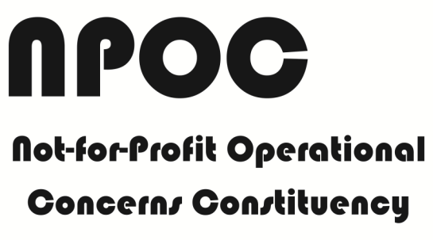

2012 Annual Report 2012

An Internet Corporation for Assigned Names and Numbers (ICANN) Constituency within the Non-Commercial Stakeholders Group (NCSG), a part of the Generic Names Supporting Organization (GNSO).

www.npoc.org

Table of contents

Message from the Chair 3
Main NPOC Activities at 2012 ICANN Public Meetings 5
ICANN 45 Public Meeting, October 14-18, 2012 5
ICANN 44 Public Meeting, June 24-29, 2012 6
ICANN 43 Public Meeting, March 11-16, 2012 6
NPOC activities at 2012 Internet Governance Forum (IGF) in Baku 7
NPOC Highlights of Policy Comments submitted to ICANN and ICANN committee participation 8
Membership Report 9
Communications Report 9
Financial Report 10
The road ahead: NPOC activities in 2013 11

Message from the Chair

“Approved as a new Internet Corporation for Assigned Names and Numbers (ICANN) Constituency at ICANN's Board Meeting in Singapore on June 24, 2011, the Not-for-profit Operational Concerns Constituency (NPOC) was 18 months old when calendar 2012 came to an end.
This is the first annual report ever and covers calendar year 2012.
I first take this opportunity to recognize the outstanding work done by Debbie Hughes from the American Red Cross and Amber Sterling from the Association of American Medical Colleges in bringing about the creation of NPOC, the very first new Constituency of ICANN since its inception in 1998. It was a work of giants, a battle for inclusion and respect, and endless volunteering days and weeks. We warmly thank Debbie and Amber for this outstanding achievement.
NPOC was managed by an interim Executive Committee until the very first elections were held in 1Q 2012. I wish to thank NPOC Colleagues for electing me as Chair and also wish to thank my colleagues Lori Schulman, Klaus Stoll and Eduardo Monge for their early and endless support and volunteering, as well as sharing their expertise at key moments, and despite holding down full time jobs. Special mentions go to Amber Sterling for continuing Executive Committee duties, this time as an elected Officer, despite her double duty of holding a full time day job and going to Law School at night. Finally, thanks to Marie-laure Lemineur, Cintra Sooknanan, Poncelet Ileleji and Olévié Kouami for coming onboard in 2012. The Latin America, Caribbean and Africa regions are now starting to be represented in the running of NPOC Affairs.
Special thoughts go to Lori Schulman from ASCD from and Judy Branzelle from Goodwill Industries International who could not assume their duties fully as expected for reasons beyond their control. This crippled NPOC's capacity to fully participate in the work of the Non-Commercial Stakeholders Group (NSCG)-Policy Committee. The 2013 elections and an increasing NPOC membership will hopefully see more Domain Name System (DNS) policy and policy impact interests, and participation emerge within NPOC.
NPOC was present at ICANN 43/44/45 meetings in San José, Prague and Toronto, respectively, as well as at Internet Governance Forum (IGF) 2012 meeting in Baku and organized a number of well-attended quality events, summarized in the Program Committee Chair Report below. Thanks to ICANN Travel Support, PIR.org and the Global Knowledge Partnership Foundation, additional NPOC Executive Committee members could participate.
Integrating NPOC with the NCSG continues to be a challenge despite unresolved legacy and teething issues from the time the creation of NPOC. I can say with some degree of assurance and optimism that the NCSG-Executive Committee (NCSG-EC) meeting in Toronto was an inflexion point and inter-stakeholders' group issues are now starting to be addressed in both substantive and relational terms. NPOC continues to work with the Non-Commercial Users Constituency (NCUC), in the interest of building the NCSG and ICANN with the understanding of mutual respect and cooperation in accordance with Standards of Member Behavior (see https://community.icann.org/display/gnsononcomstake/NCSG+Charter). We look forward to strengthening ties and trust, notably starting at the Los Angeles inter-sessional meeting of the Non-Contracted Parties House of the Generic Names Supporting Organization (GNSO) in January 2013.
NPOC membership has expanded and diversified in 2012. The Membership Committee Chair Report below gives the highlights.

Alain Berranger
Chair, NPOC

Main NPOC Activities at 2012 ICANN Public Meetings

ICANN 45 Public Meeting, October 14-18, 2012

NPOC held two sessions at the ICANN 45 Public Meeting in Toronto, Canada:

- “The Multi-stakeholder model from the NGO´s perspective” a NPOC Workshop held on October 17th, 2012. Presentations, reference materials and transcripts are available at:

https://community.icann.org/display/gnsocouncilmeetings/Multi-stakeholder+process+from+the+NGO+perspective+Toronto+2012-10-17

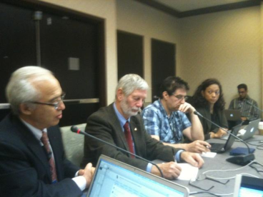

http://toronto45.icann.org/meetings/toronto2012/transcript-msp-ngo-17oct12-en.pdf

- NPOC´s Constituency Meeting was held on October 16th, 2012. This meeting`s presentations, reference materials, audiocasts and transcripts are available at:

https://community.icann.org/display/gnsocouncilmeetings/NPOC+Toronto+Meeting+2012-10-16

http://audio.icann.org/meetings/toronto2012/npoc-16oct12-en.mp3 (Audiocast)

http://toronto45.icann.org/meetings/toronto2012/transcript-npoc-16oct12-en.pdf (Transcript)

ICANN 44 Public Meeting, June 24-29, 2012

NPOC held one event at ICANN 44 in Prague, Czech Republic on June 26, 2012 entitled "The impact of the internet and e-Fundraising on Notforprofits and NGOs" with panel participation by Angie Graves, President, Worldwide Electronic Broadcasting Group, and Kiran Malancharuvil, Associate Attorney, Silverberg, Goldman & Bikoff, LLP.

- Presentations, transcrips and audicast are available at http://prague44.icann.org/node/31703

ICANN 43 Public Meeting, March 11-16, 2012

NPOC held two events at ICANN 43 in San Jose, Costa Rica.

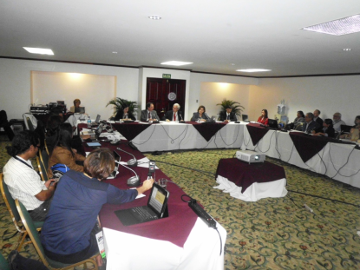
- A NPOC Constituency meeting and presentation entitled “Not-for-Profit Operational Concerns Constituency (NPOC). The Newest ICANN Constituency. Vision, Mission and Priorities” held on March 13, 2012 with panel participation by representatives from the American Red Cross, Strategy XXI Century, National Academy of Science of Costa Rica, Council for the Promotion of Competitiveness, Omar Dengo Foundation, and members of NPOC Interim Executive Committee.

http://costarica43.icann.org/meetings/sanjose2012/transcript-npoc-13mar12-en.pdf

- A NPOC Launch Cocktail held also on March 13, 2012 made possible through the kind support of our sponsors such as PIR.orgm Global Knowledge Partnership, Omar Dengo Foundation and Schulman Legal Services PLLC.

NPOC activities at 2012 Internet Governance Forum (IGF) in Baku

With the support of ICANN, three members of NPOC´s Executive Committee attended the Internet Governance Forum from November, 6th to 9th that took place , 2012 in Baku, Azerbaijan. Cintra Sooknanan, NPOC Vice-Chair, Marie-laure Lemineur, Chair of the Program Committee and Poncelet O. Ileleji, Vice-Chair of the Program Committee organized and delivered a side session titled "Why is the participation of the social sector in the Internet Governance important for everybody?” with in collaboration with the Global Knowledge Partnership Foundation.
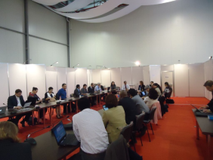
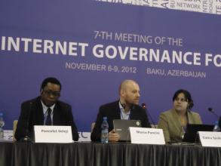

The quality of the presentations provided in-depth and varied perspectives from the panelists who represented the private, academic and the not-for-profit sectors, on the role, relevance, benefits and extent of the social sector and non-profits in Internet Governance. There was also a significant amount of interaction with the audience.

Transcript of the side session is available at:
http://www.intgovforum.org/cms/2012-igfbaku/transcripts

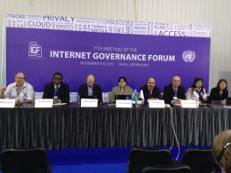

NPOC Highlights of Policy Comments submitted to ICANN and ICANN committee participation

NPOC members are active participants of the following ICANN Committees:
- Supporting Organization (SO) - Advisory Committee (AC) New generirc top level domain (gTLD= Applicant Support Working Group (JAS-WG), represented by Cintra Sooknanan of Trinidad y Tobaggo Internet Society Trinidad & Tobago Chapter and Alain Berranger, Chasquinet Foundation.
- ICANN Finance Ad Hoc Working Group represented by Eduardo Monge, Omar Dengo Foundation, and Alain Berranger, Chasquinet Foundation.
- Standing Committee on GNSO Improvement Implementation by Alain Berranger, Chasquinet Foundation.
- Inter-Registrar Transfer Policy (IRTP) Part C Policy Development Process Working Group by Alain Berranger, Chasquinet Foundation.
- IGO / INGO Protection Policy Development Process Working Group by Poncelet Ileleji, and Alain Berranger, Chasquinet Foundation.
- GNSO Working Group (WG) on Thick WHOIS, represented by Marie-laure Lemineur of the Center for Study, Analysis and Training in Human Rights (CECADH).

Membership Report

Communications Report

The Communications Committee`s work during 2012 was aimed at maintaining the efficient exchange of information between the NPOC, its members, the NCSG and the ICANN community.

Public distribution and communications lists currently available to NPOC, which are archived and available to NPOC members and the ICANN community are the following:

  - NPOC Voice mailing list http://forum.icann.org/lists/npoc-voice/
  - NPOC Executive Committee list http://forum.icann.org/lists/npoc/

The Communications Committee also managed the content of NPOC`s web site at www.npoc.org, provides inputs to ICANN staff and edits NPOC`s web pages on the ICANN community Wiki at https://community.icann.org/display/NPOCC/NPOC+Home as well as makes contributions to NPOC`s presence at the ICANNwiki web page at http://icannwiki.com/index.php/NPOC.

NPOC also launched its twitter page at https://twitter.com/NPOC_ICANN during the days previous to NPOC`s activities at the ICANN 44 Public Meeting in Prague in June with the purpose of sharing and promoting NPOC and NPOC-members´ activities and to disseminate DNS and internet governance related issues.

Financial Report
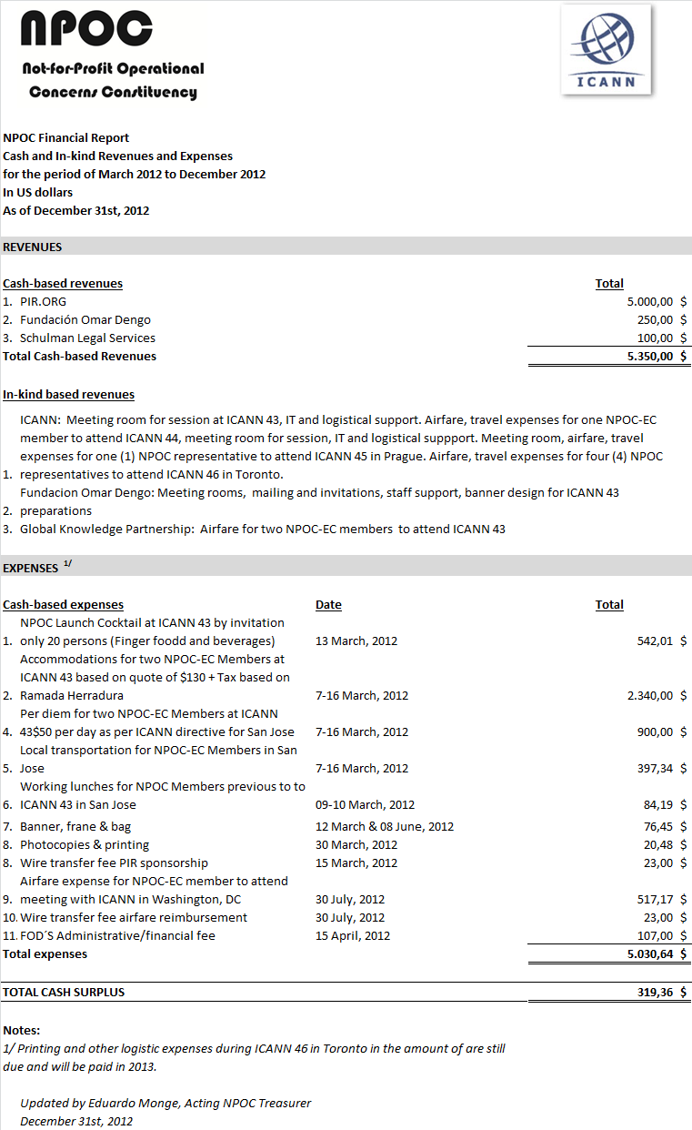

The road ahead: NPOC activities in 2013

Launching of NPOC`s outreach plan

Towards the second half of 2012, NPOC worked on the preparation of its outreach plan. As a result of this work in early in 2013, NPOC will present its outreach plan with the objective is for non-governmental organizations (NGOs) and not-for-profits (NFPs) to increase their understanding of ICANN’s mission to supervise the core technical functions of the Internet–names, numbers and protocols, as well as of related Internet governance issues. NGOs/NFPs recognize that Internet governance implies that a wide range of sectors, globally and locally engage in defining the rules and norms that shape the Internet and that these issues have an impact on their daily operations, notably for programming, learning, training, communications and fundraising.

This strategy will be implemented through partnering and knowledge sharing with other organizations that hold the same vision and have common interests: Webinars, Workshops, Panels, Publications, and Membership Recruitment Events.

